

Course: CYB304
IT Security Forensics
(Canadian Context)
Lab 9: VIRTUAL MACHINE FORENSICS, LIVE ACQUISITIONS, AND NETWORK FORENSICS
Instructor:
Muhamma Saleem

Student Name: Olushola Enoch Bayode
Student ID: 23077087
Section: 3rd Semester

Hands-On Project 11-1

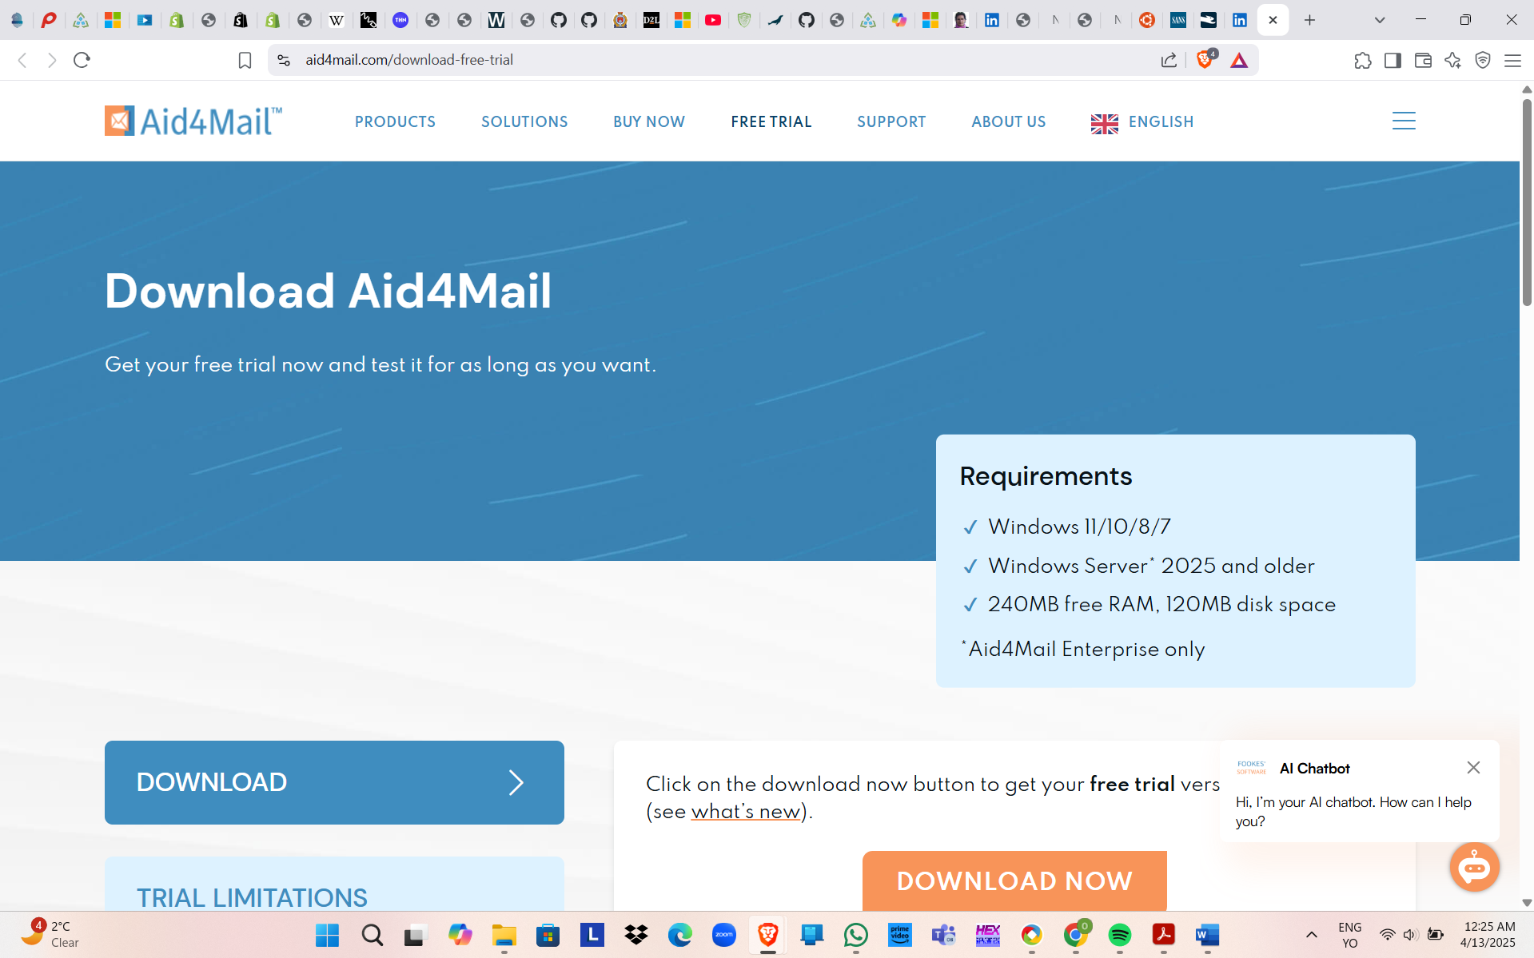
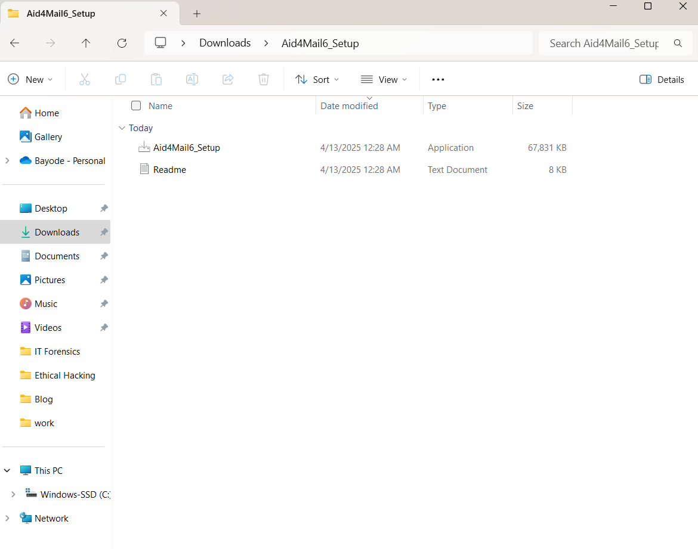
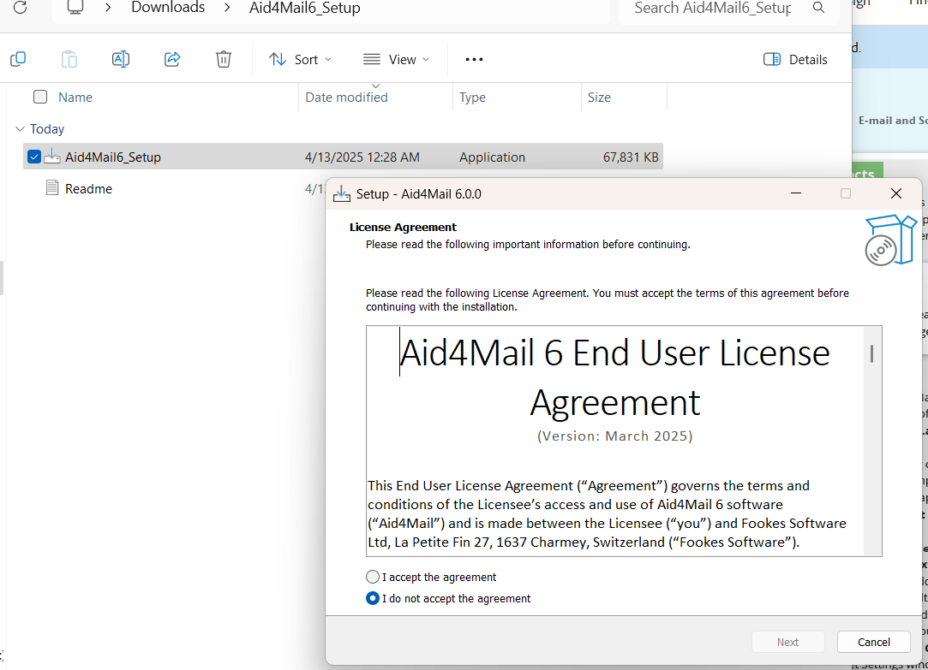
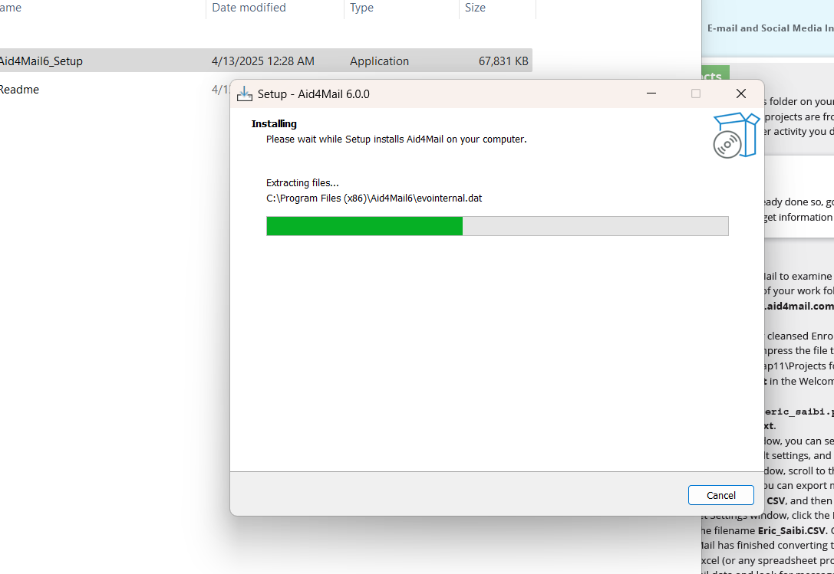

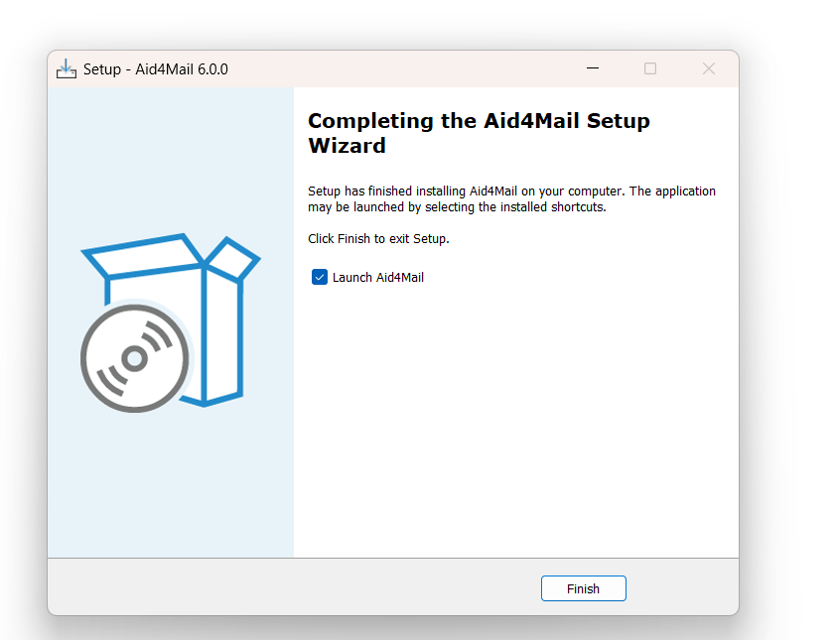
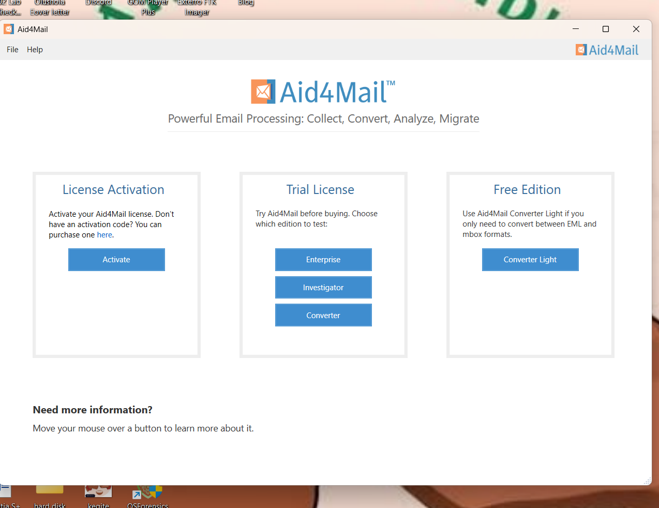

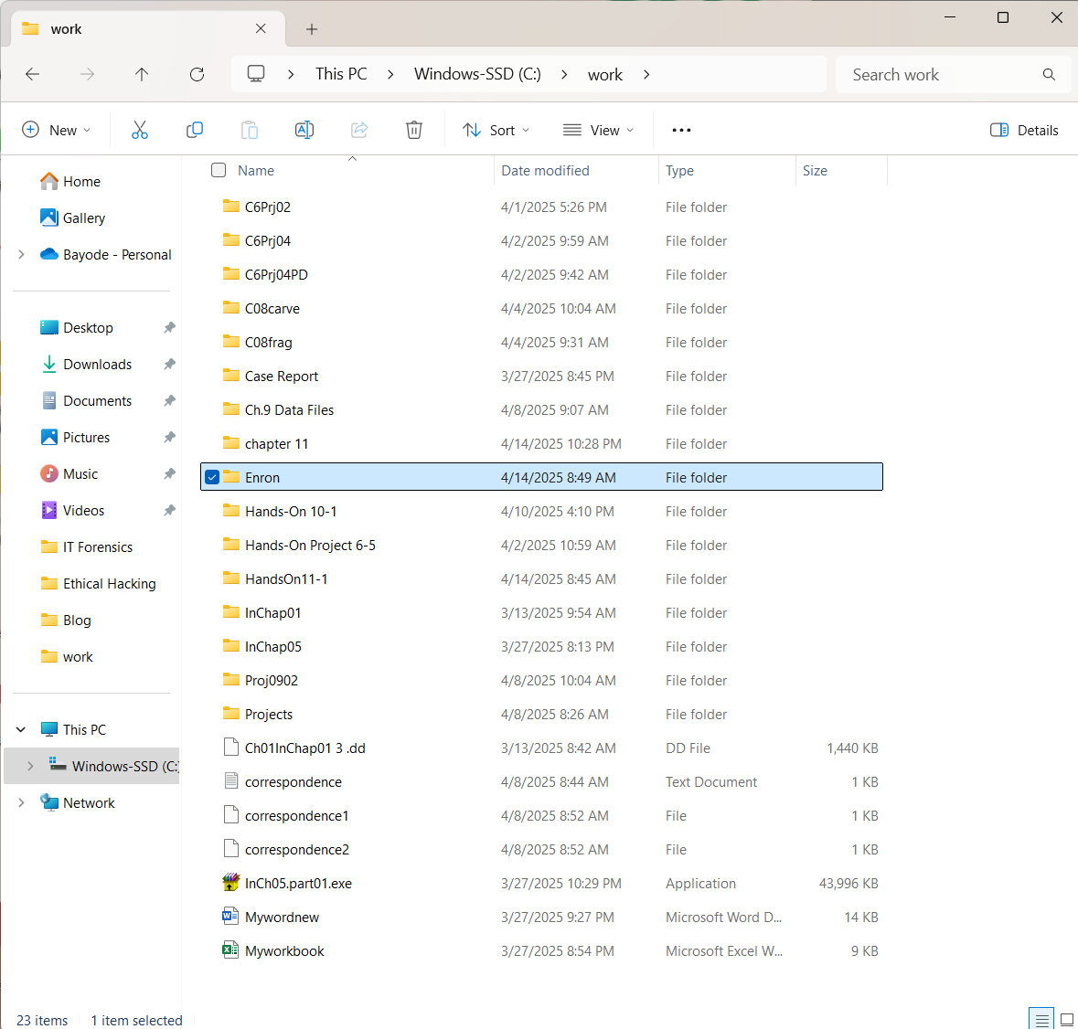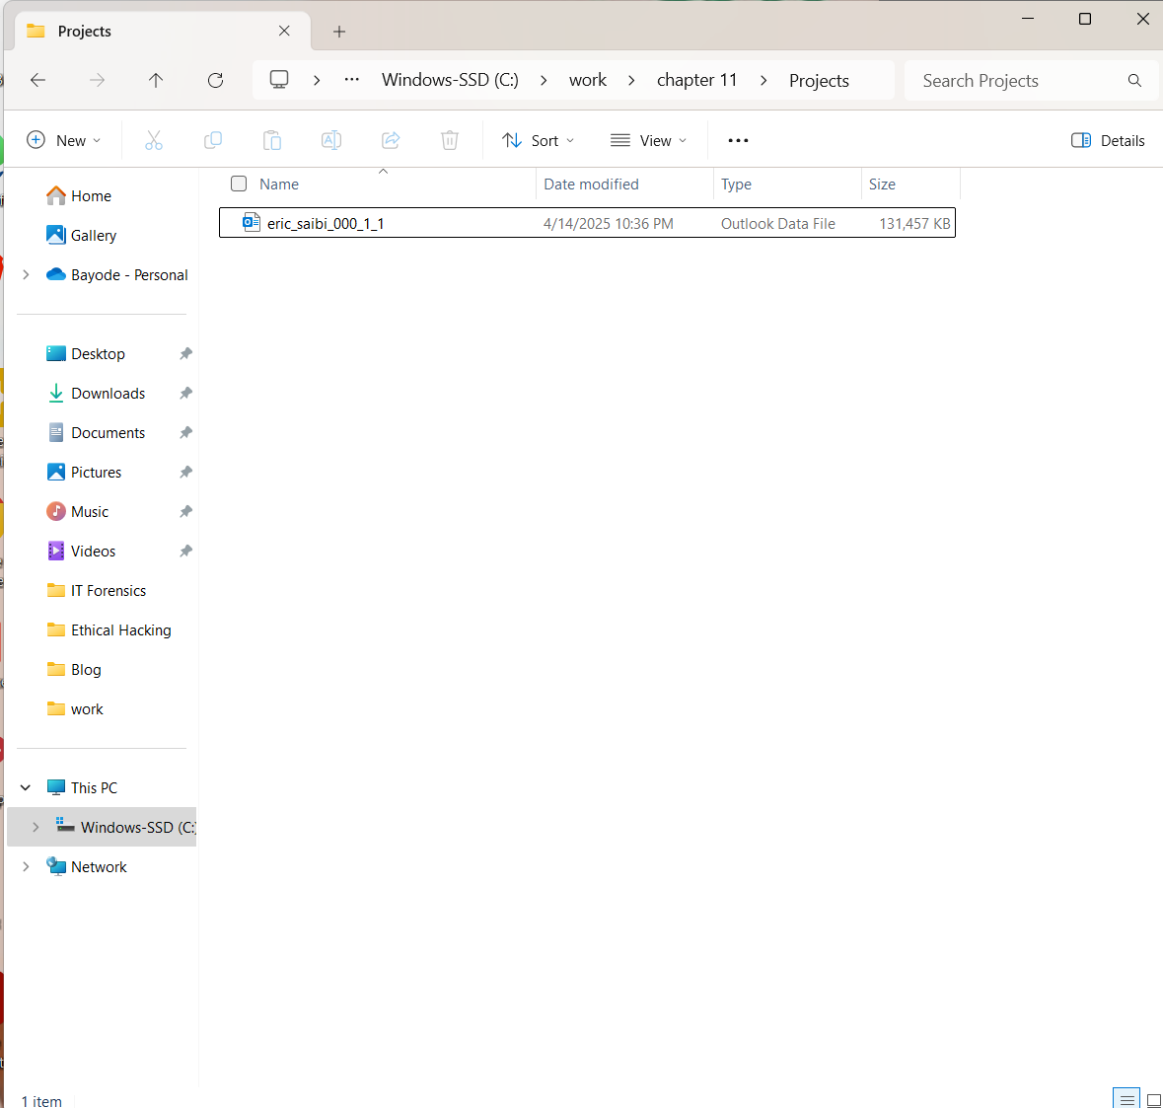
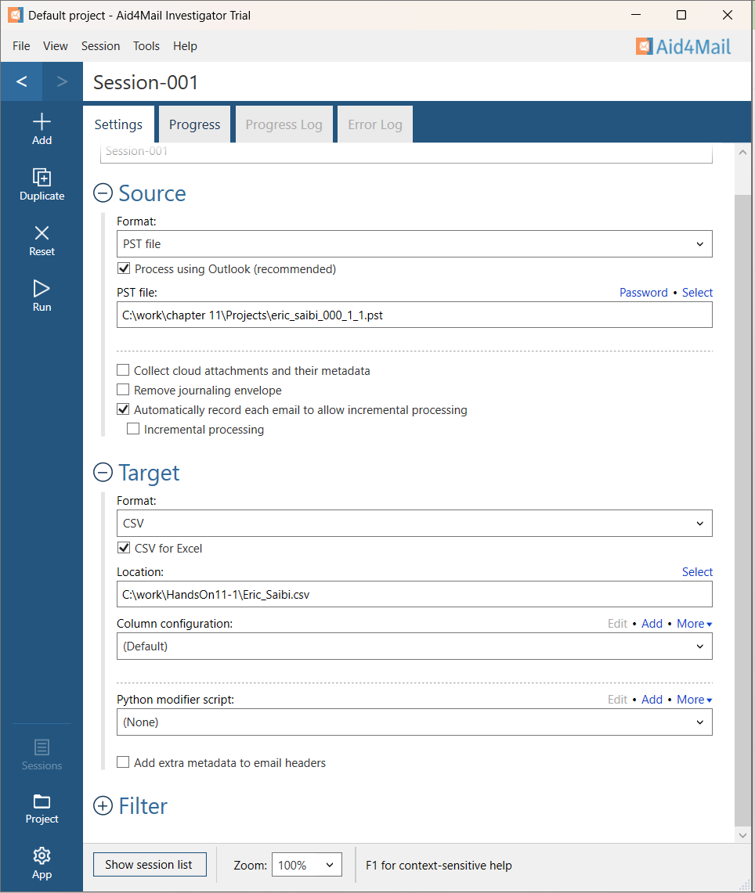
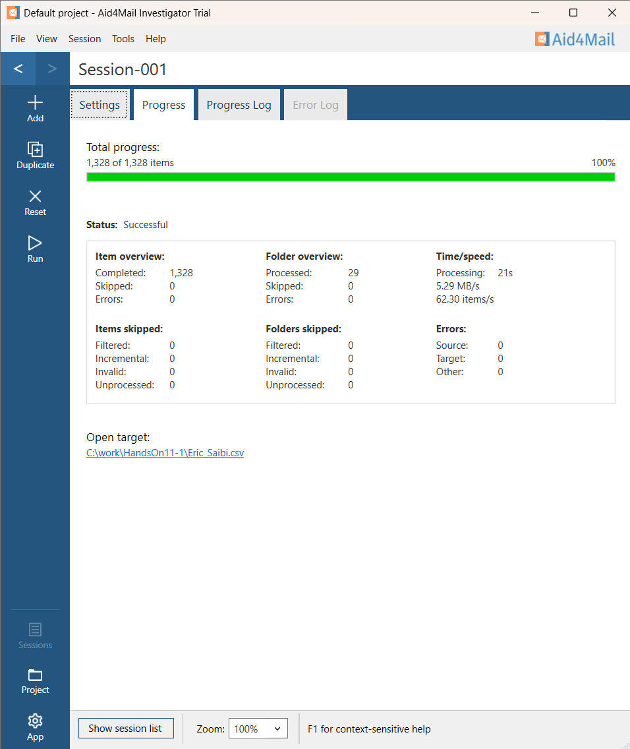
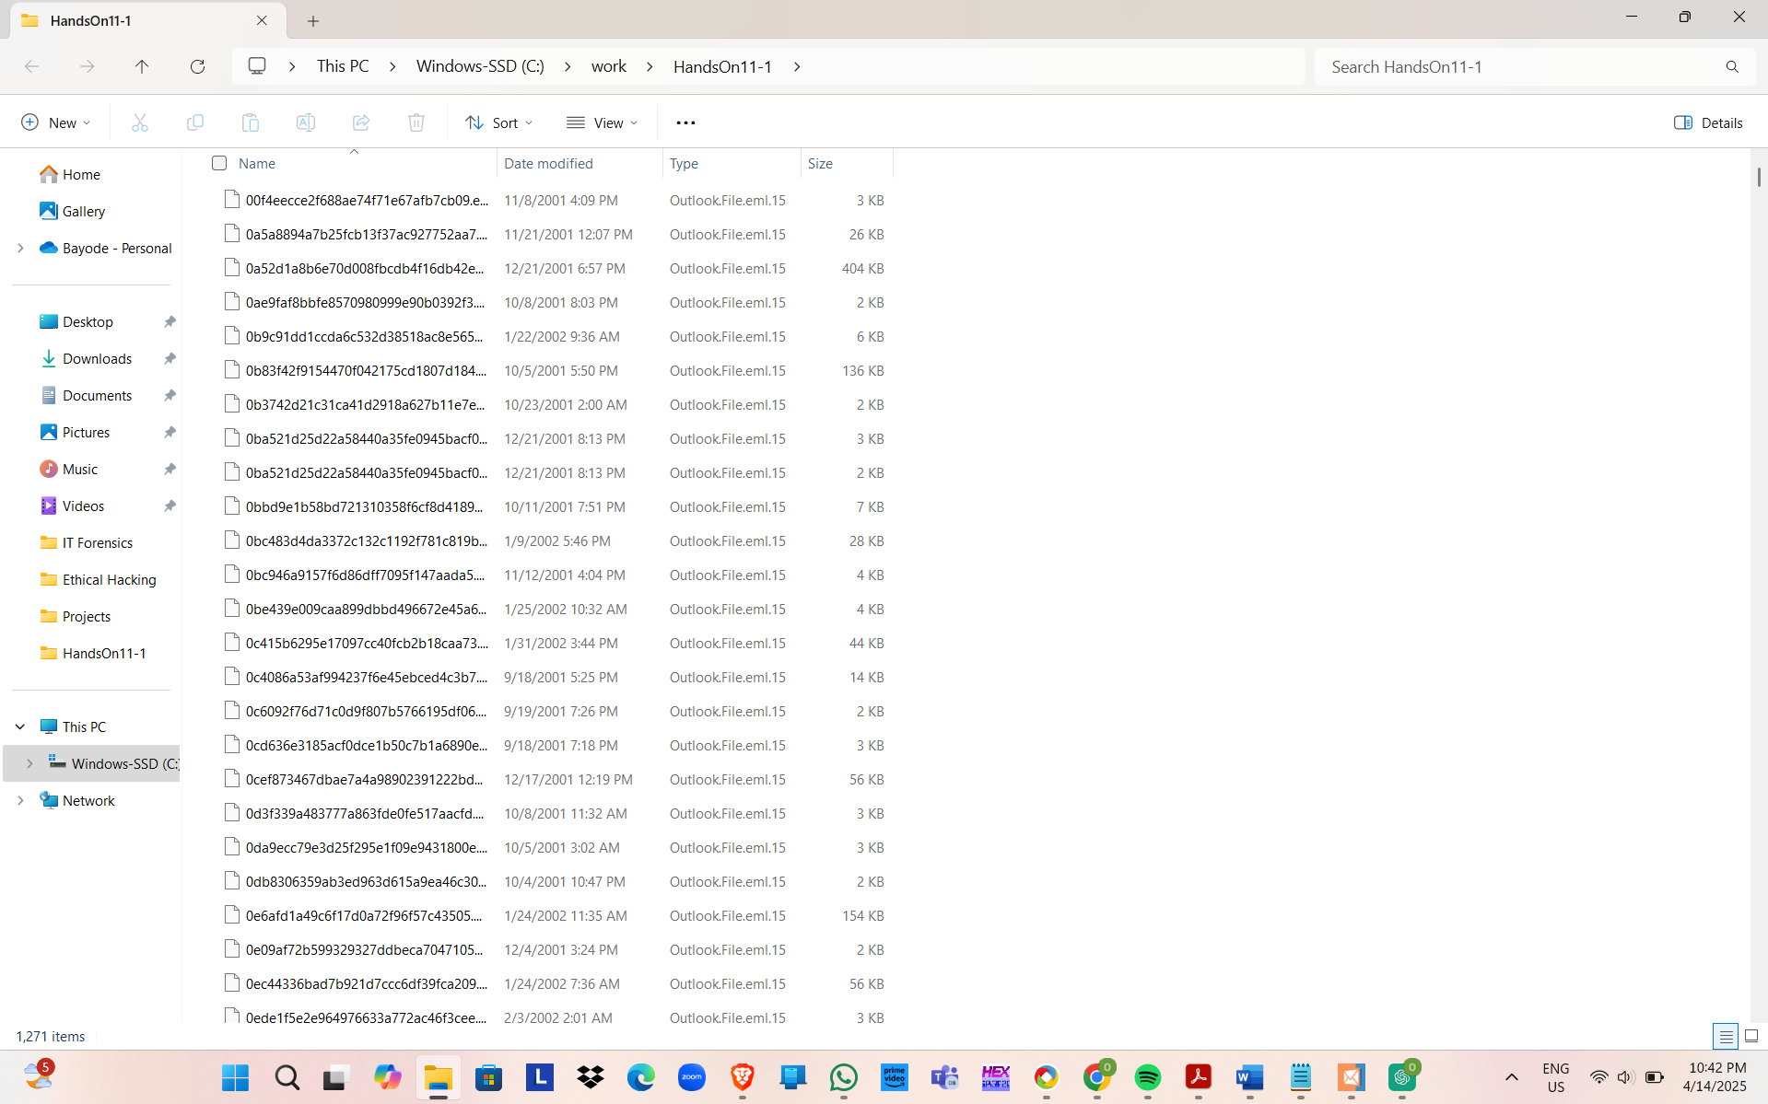
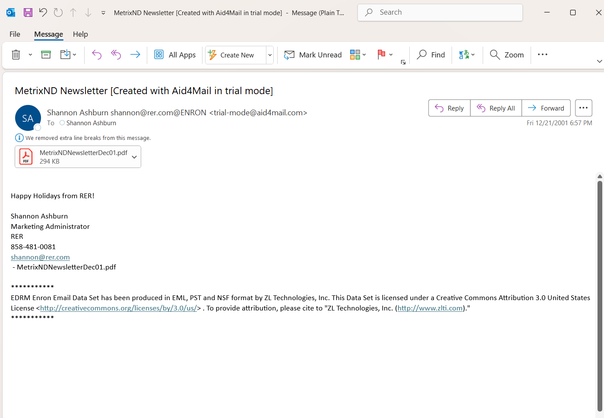
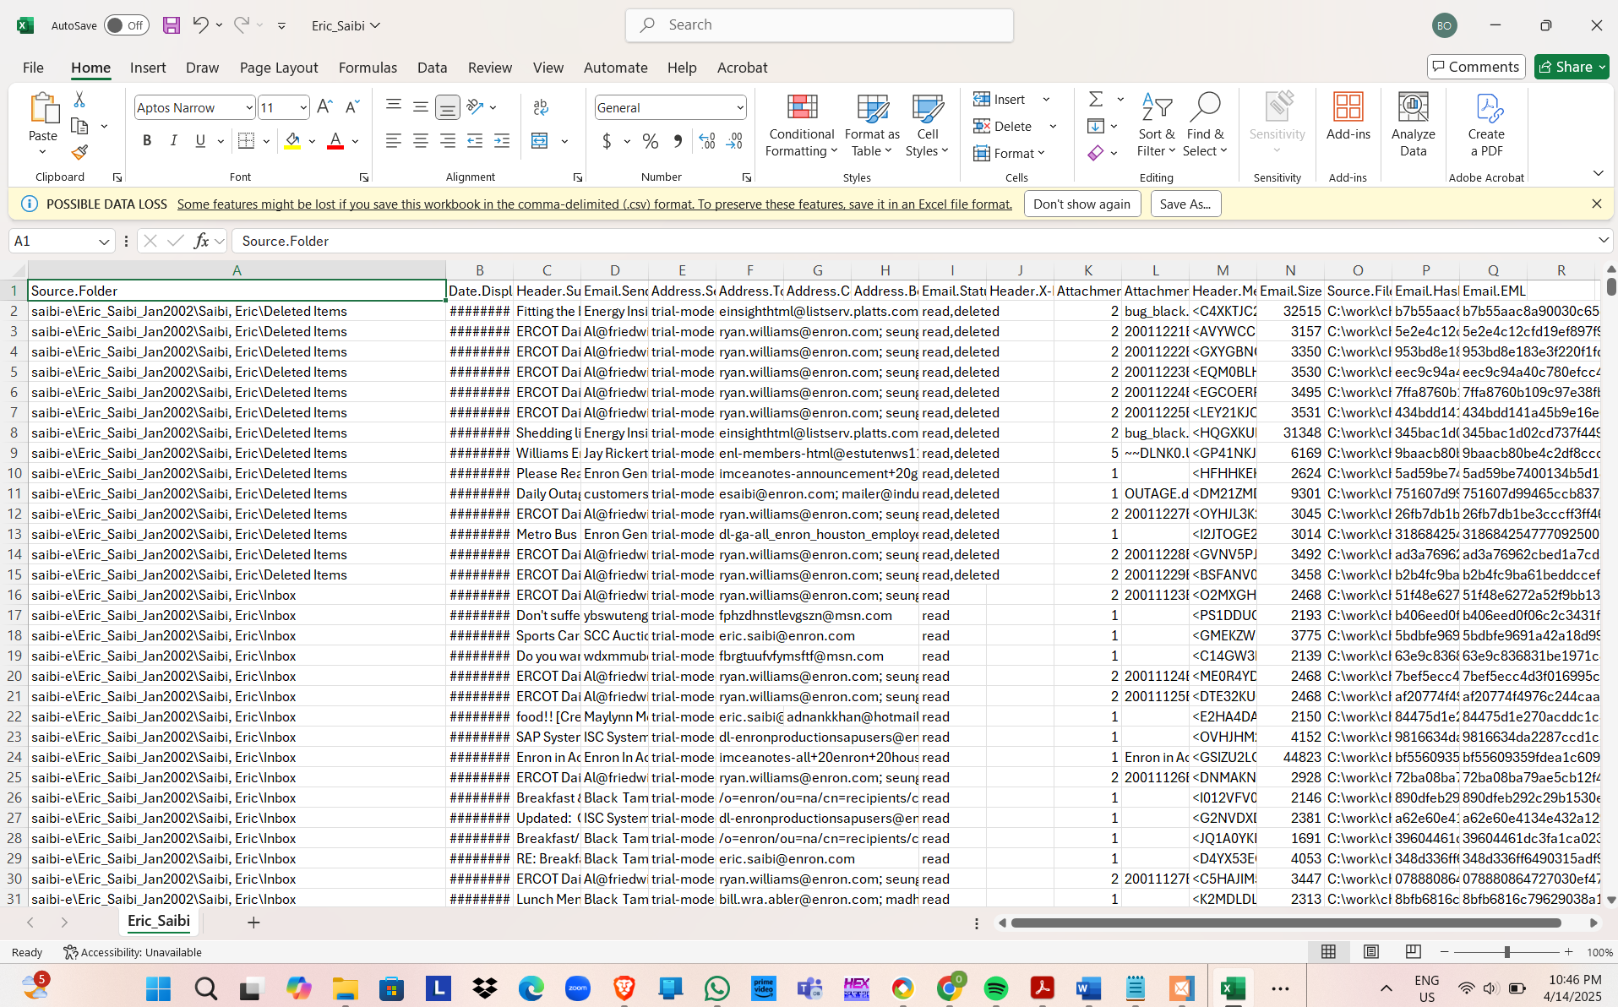
Improving Data Viewing with Aid4Mail Features
Various tools and features that Aid4Mail provides can be the best solution for getting data viewing and analysis nicely when working with massive emails such as the Enron EDRM dataset. The user guide of Aid4Mail has consumed a few of the most efficient means of data viewing and analysis technique as following:
Given Options For Higher Filtering Levels
Aid4Mail enables users to come up with filters like date range, keywords, sender/recipient emails and even the message bodies. According to a user's specified filters, the program filters the results accordingly which makes it more straightforward to identify the necessary emails, which comes in handy while uncovering such cases as the Enron scandal.
Preview Feature
The tool comes with a preview panel function that allows for an email preview prior to the exporting. It is because of this feature that the need to go through the "trial and error" process will be overtaken and, as a result, a faster investigation will be possible.
Tagging and Labeling
Messages while being filtered can receive tags. The identification marks are used to group mails by subject or investigation threads (e.g. financial schemes, insider emails, etc.).
Formats for Metadata Export
The application named Aid4Mail is capable of exporting email metadata in CSV and XML respectively. Direct use of multiple tools such as Excel or database systems helps in quick format change and this allows users to sort, filter, and visualize data other than the normal reading of the text.
Batch mode
Users of Aid4Mail are capable of automatically exporting multiple PST or mailbox files in large-scale investigations, using what is referred to as batch processing and thus saving the time used by hand.
Command-Line Interface (CLI)
To further aid automation and scripting of processes, Aid4Mail is complemented with a CLI that is also best used to unman the repetitive work from large data sets.

Hands-On Project 11-2

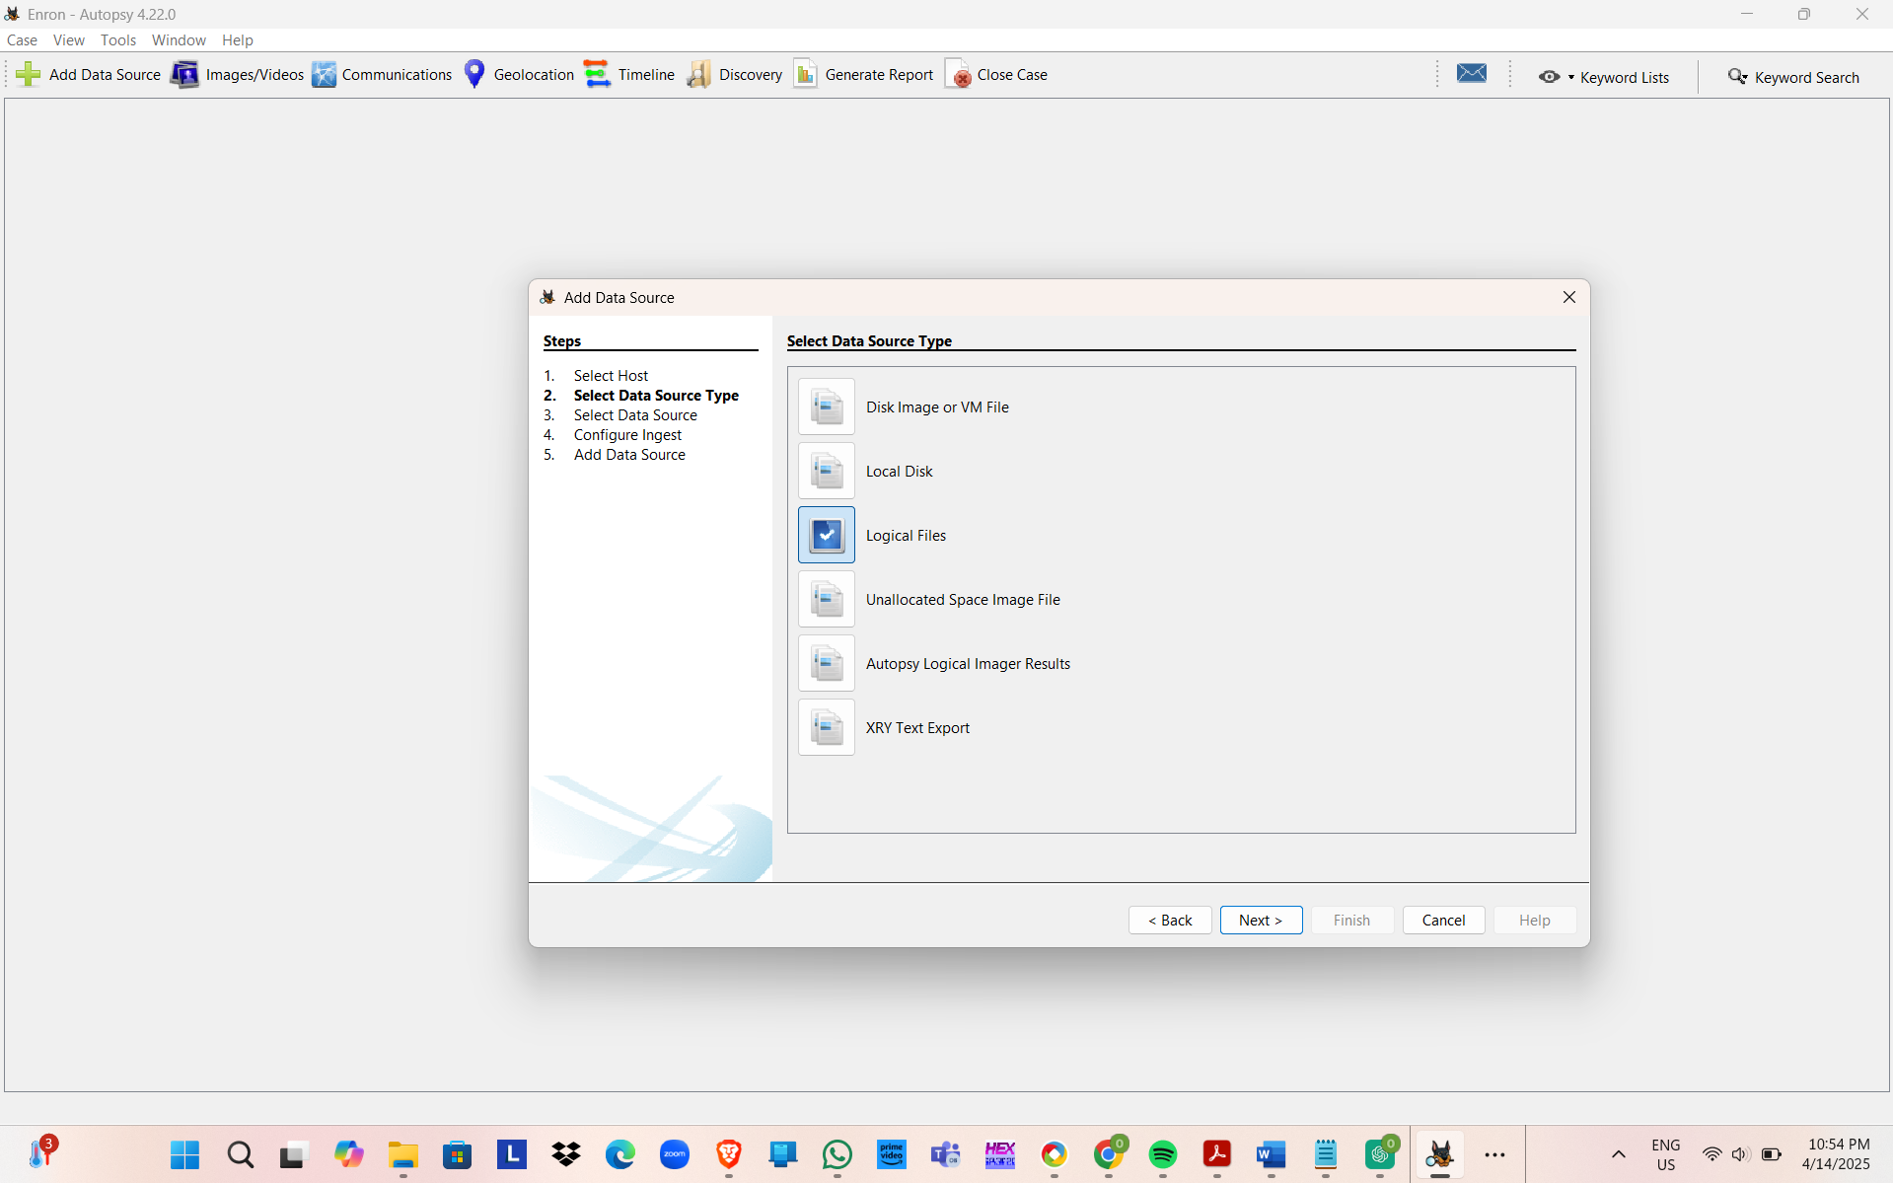
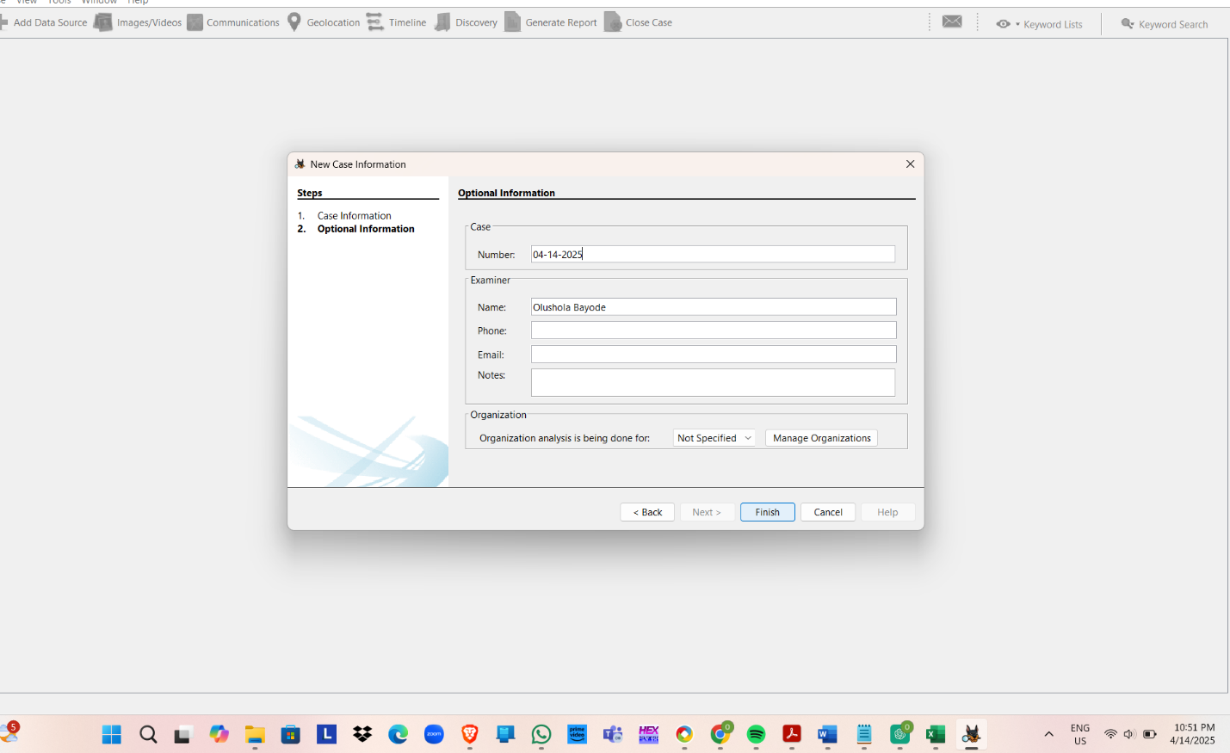

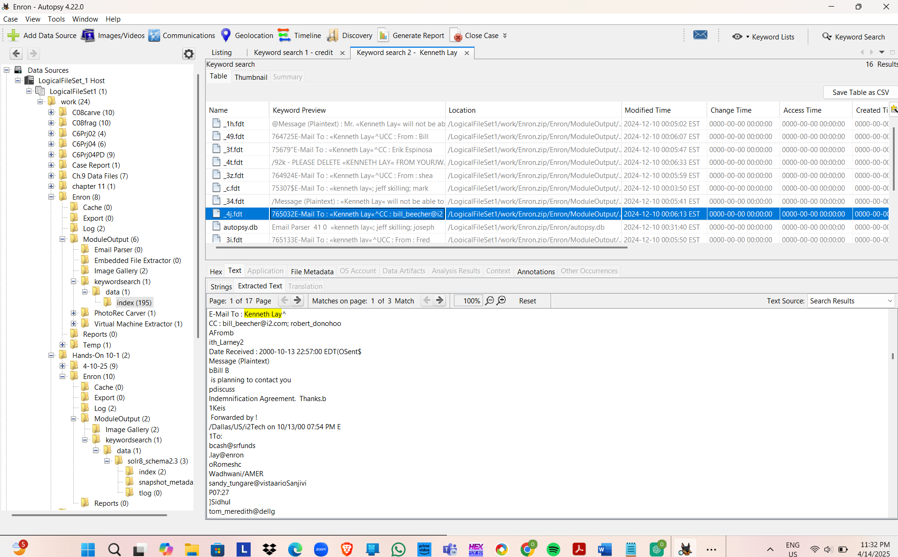

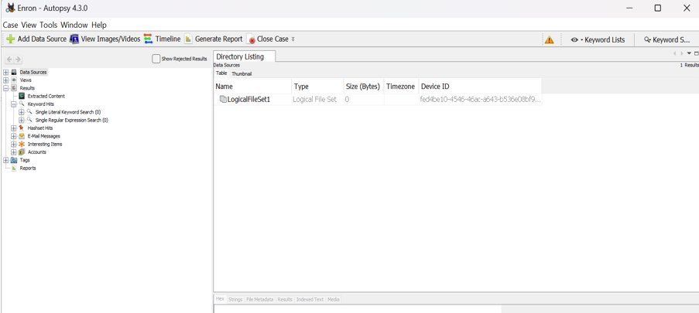

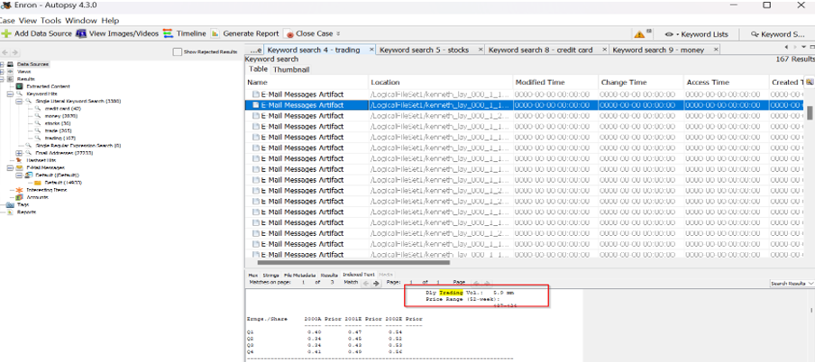

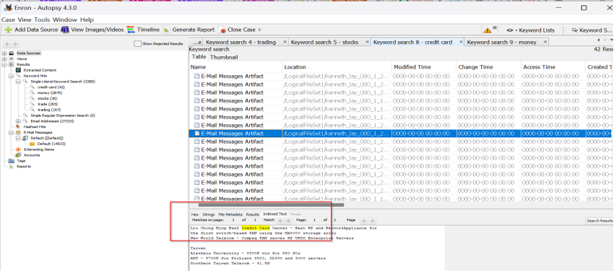
Hands-On Project 11-3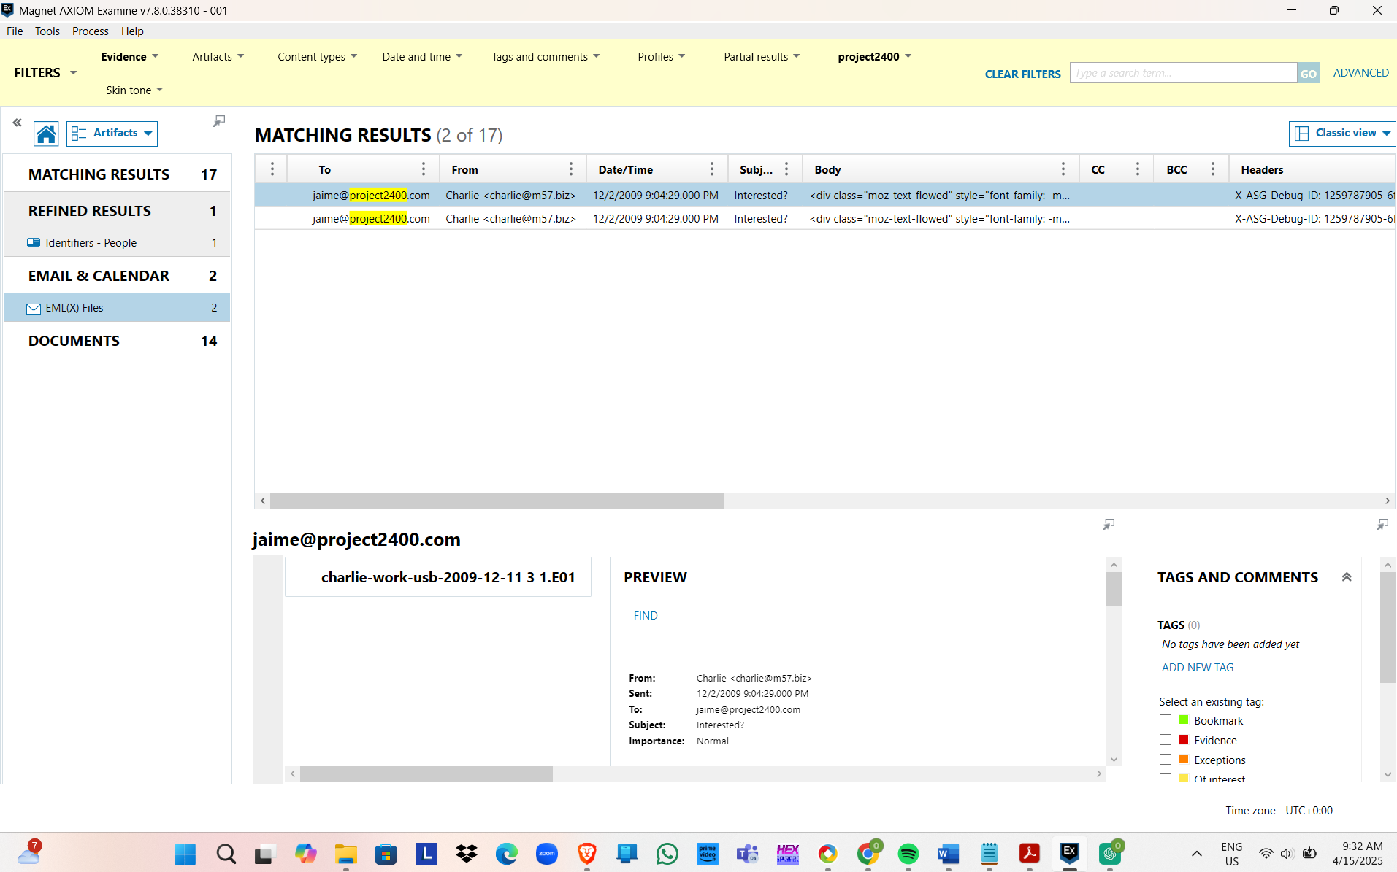
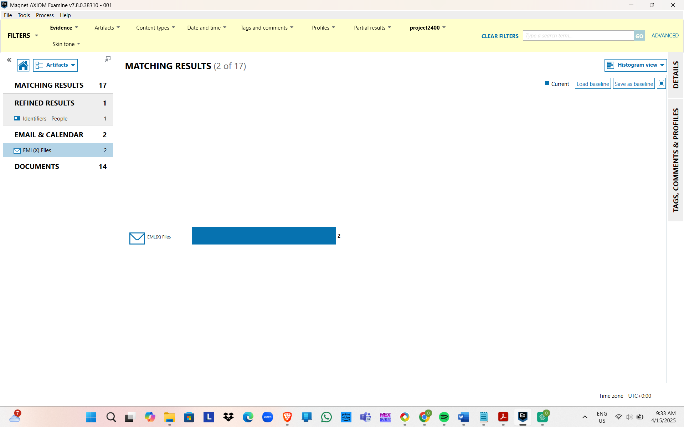
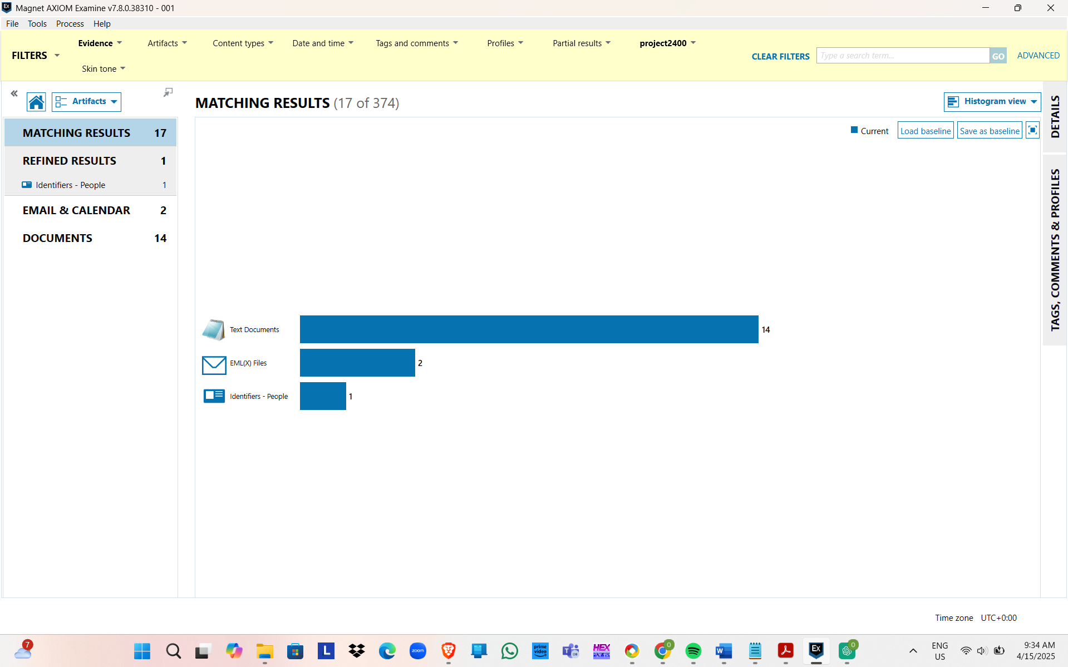
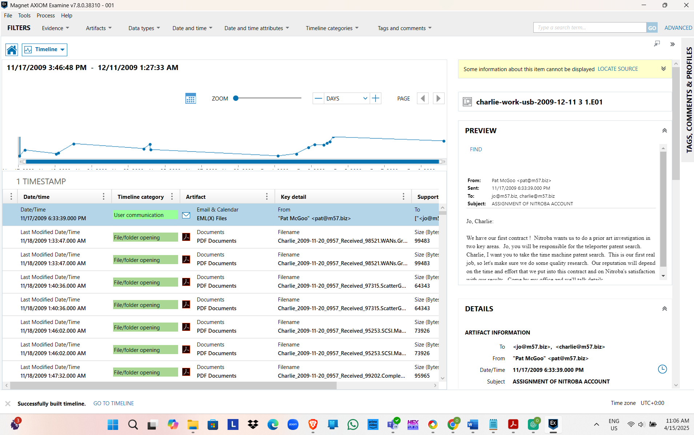
Hands-On Project 12-1

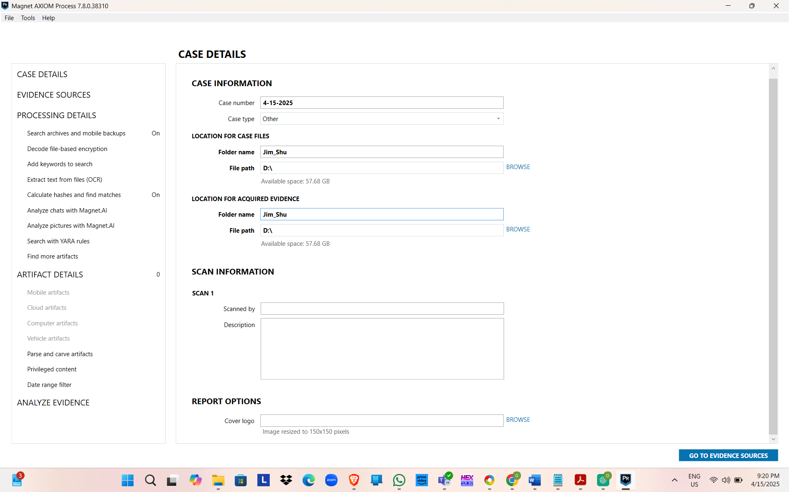
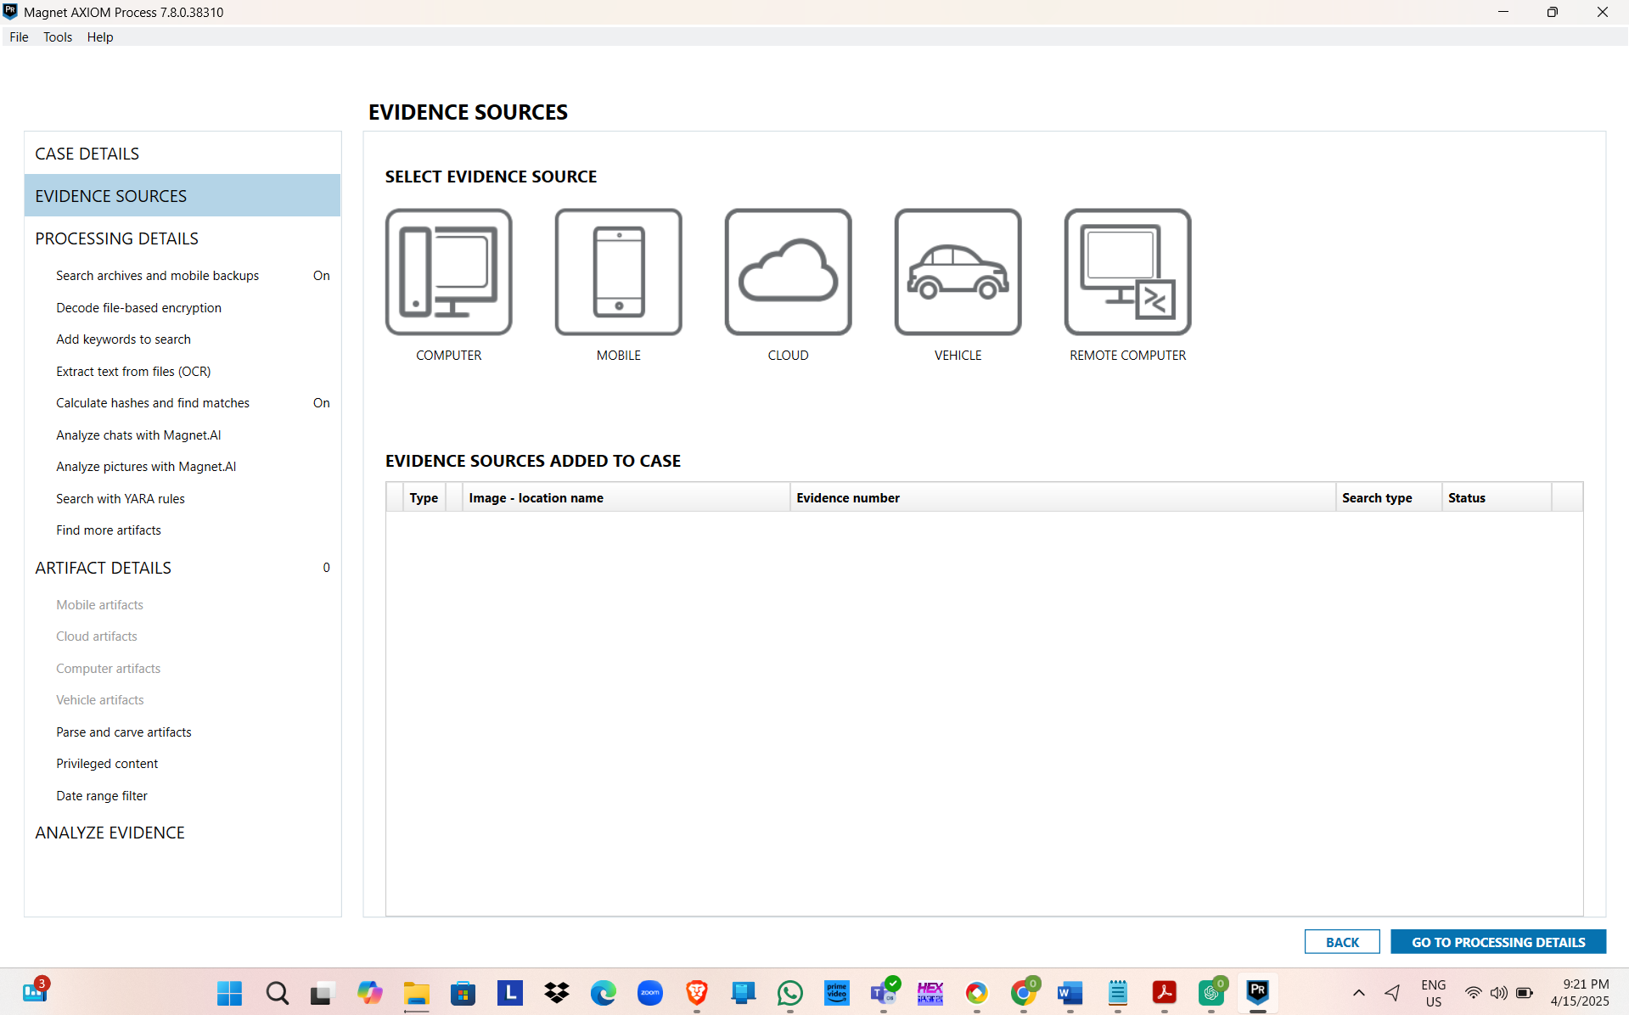
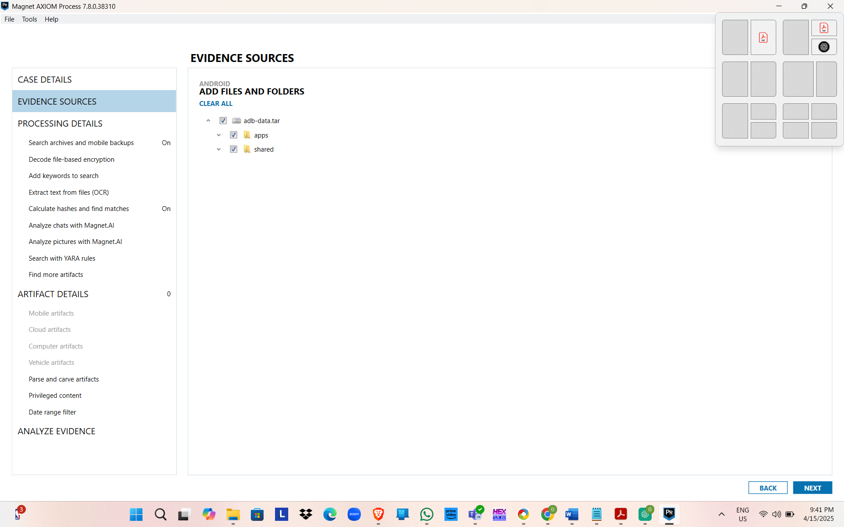
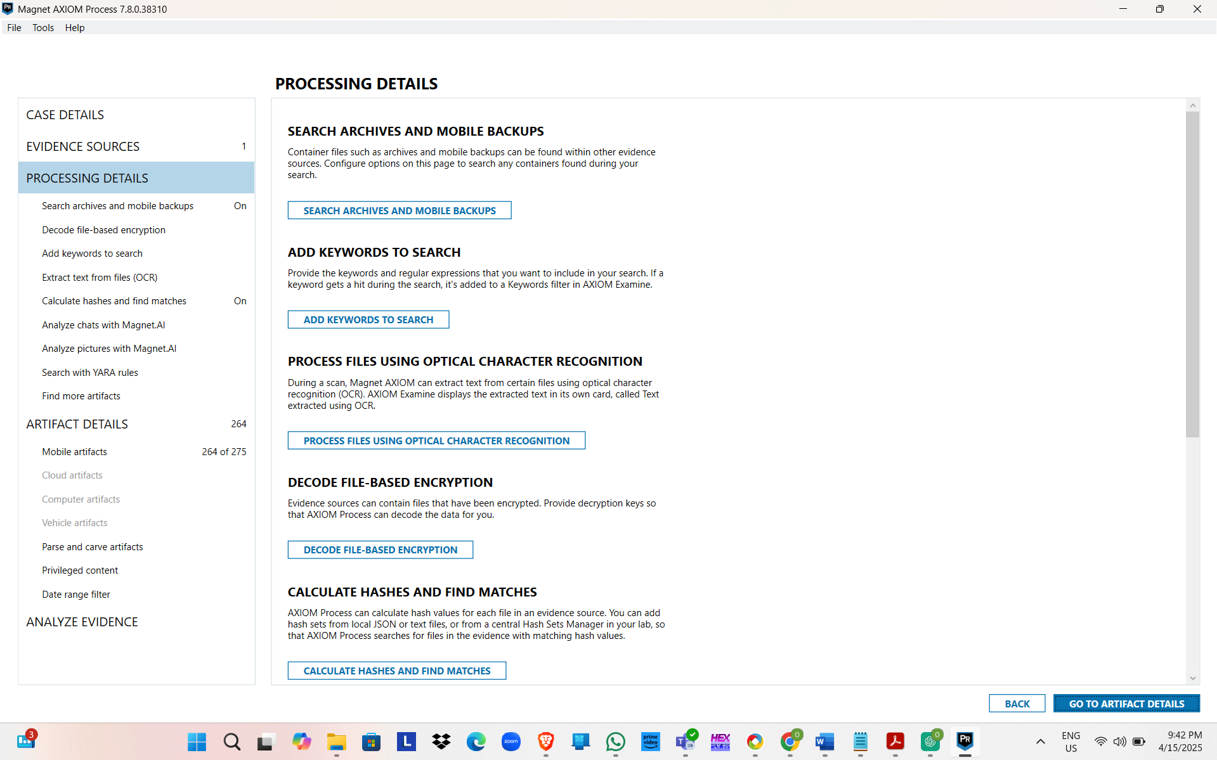
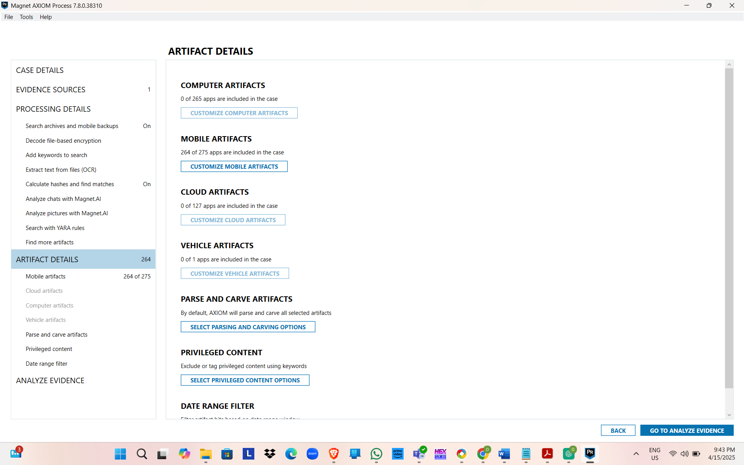
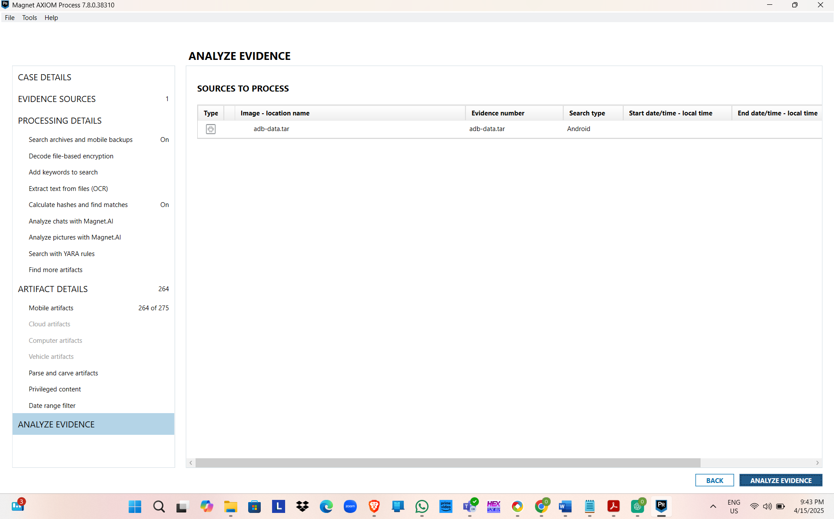
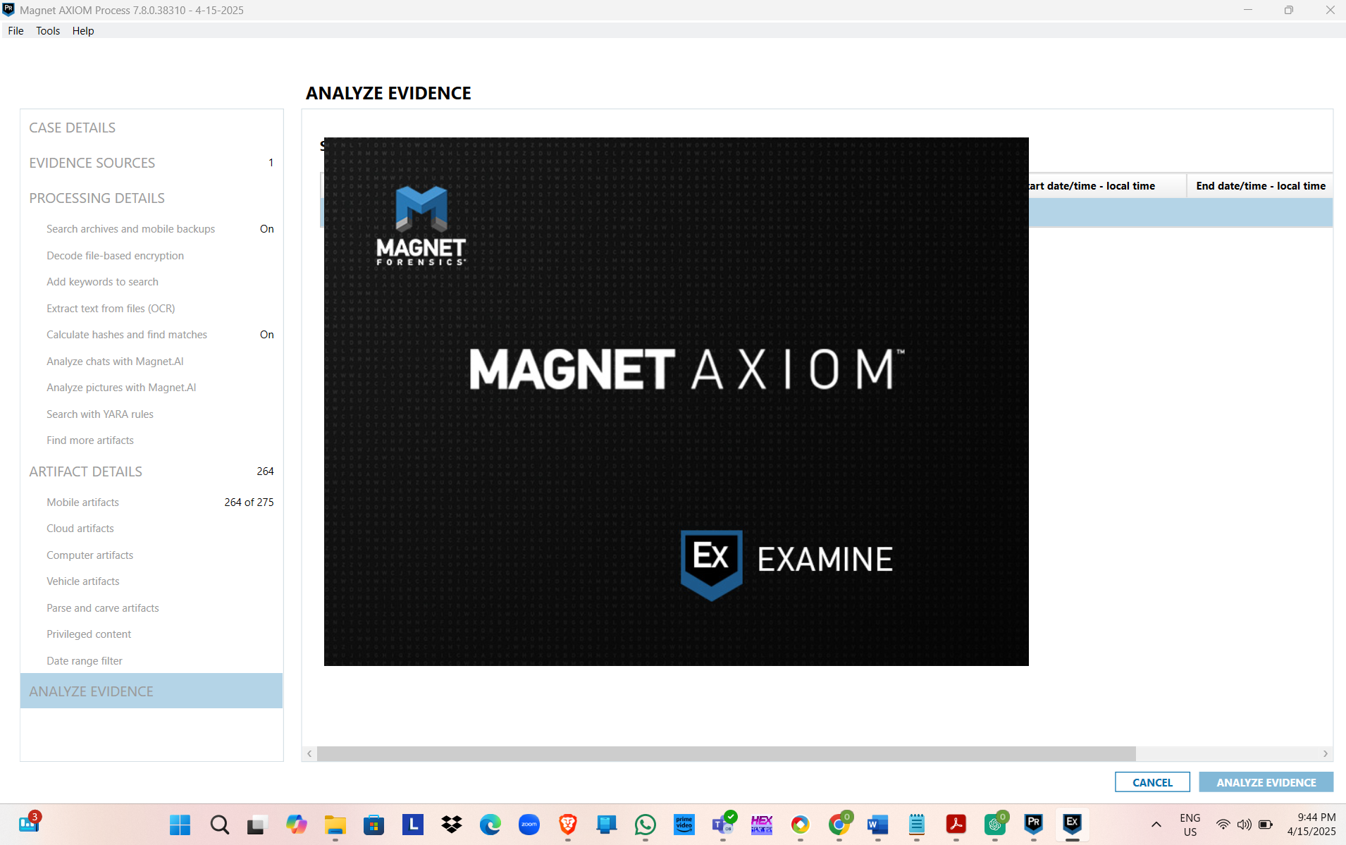
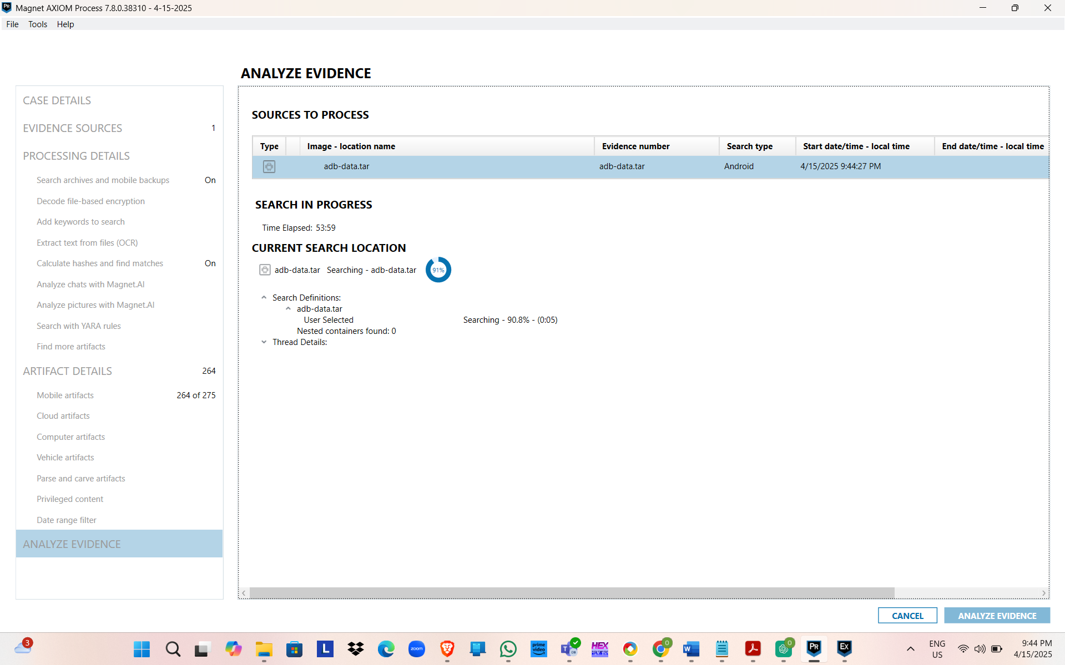
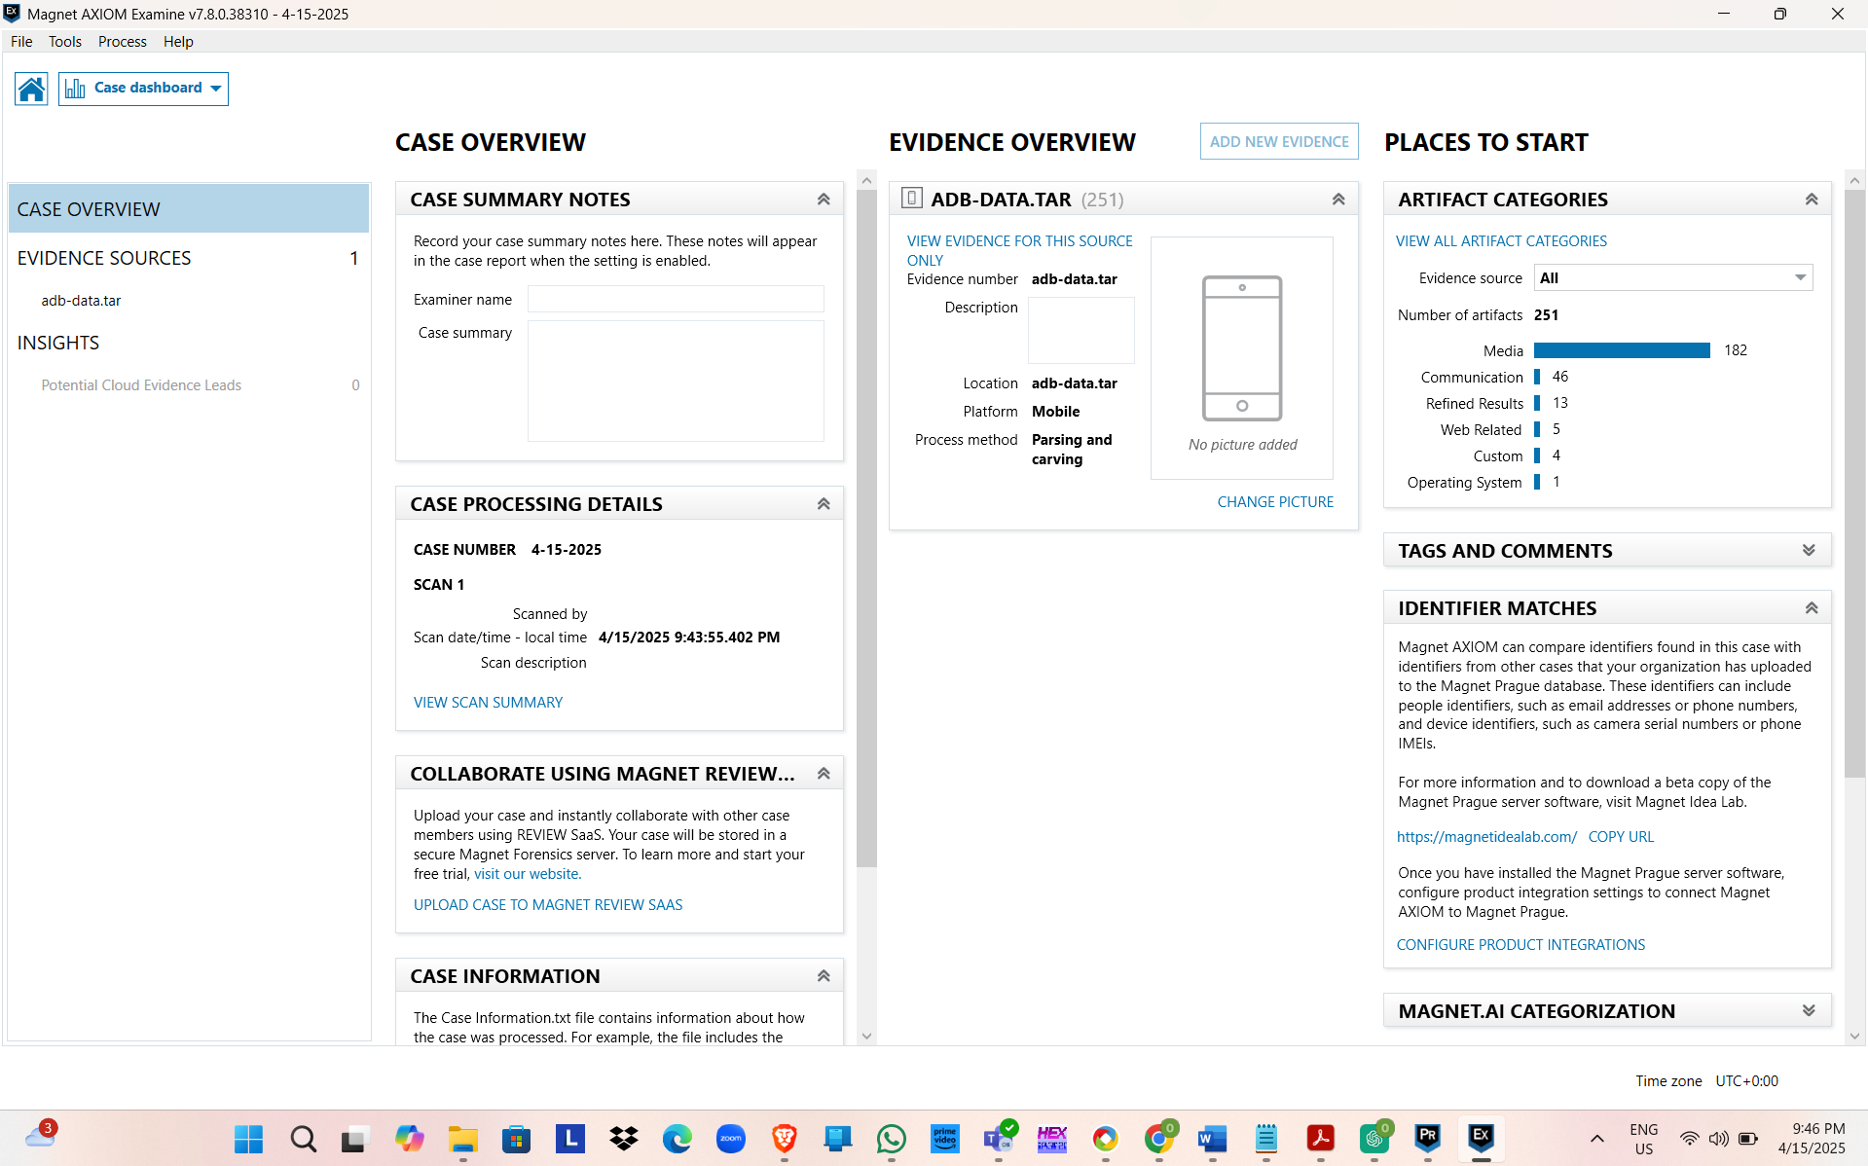
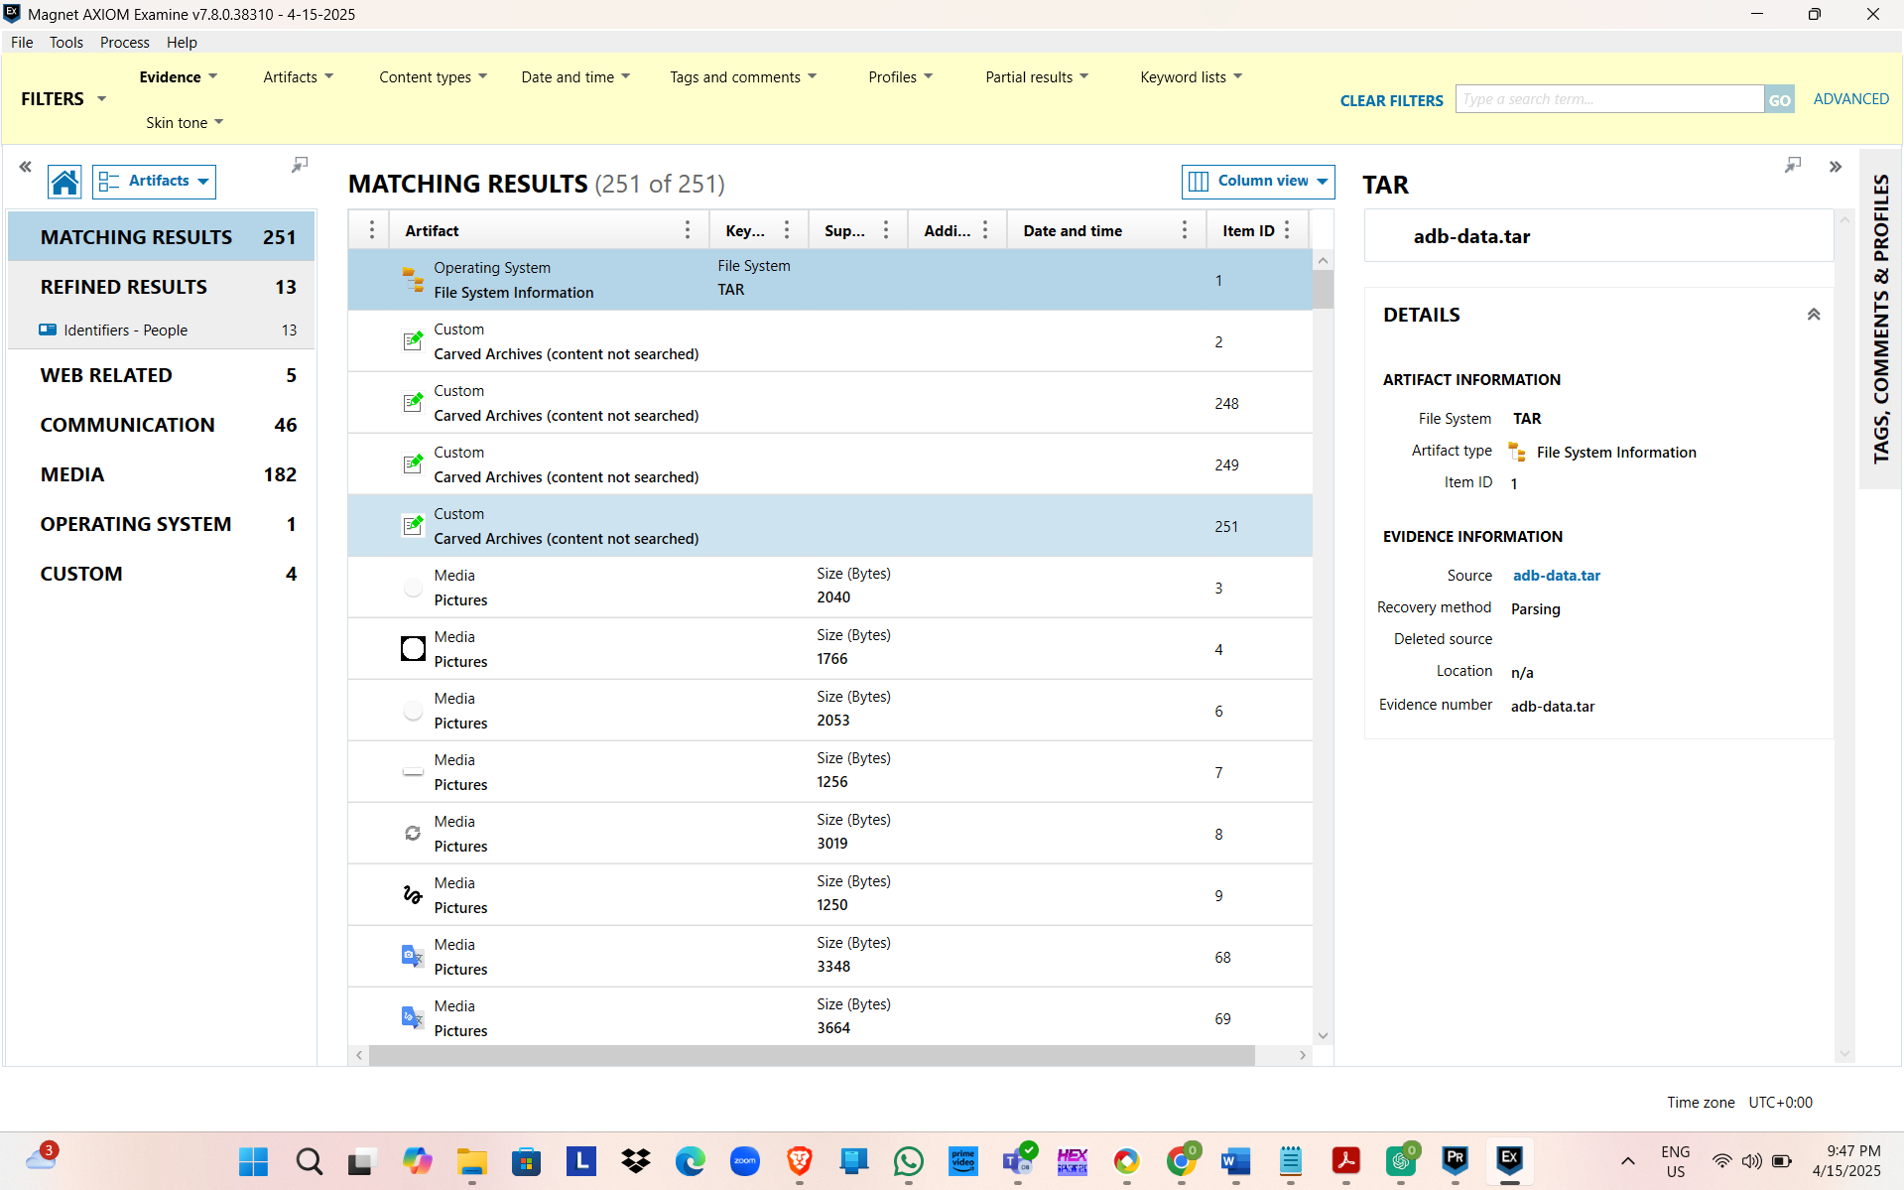
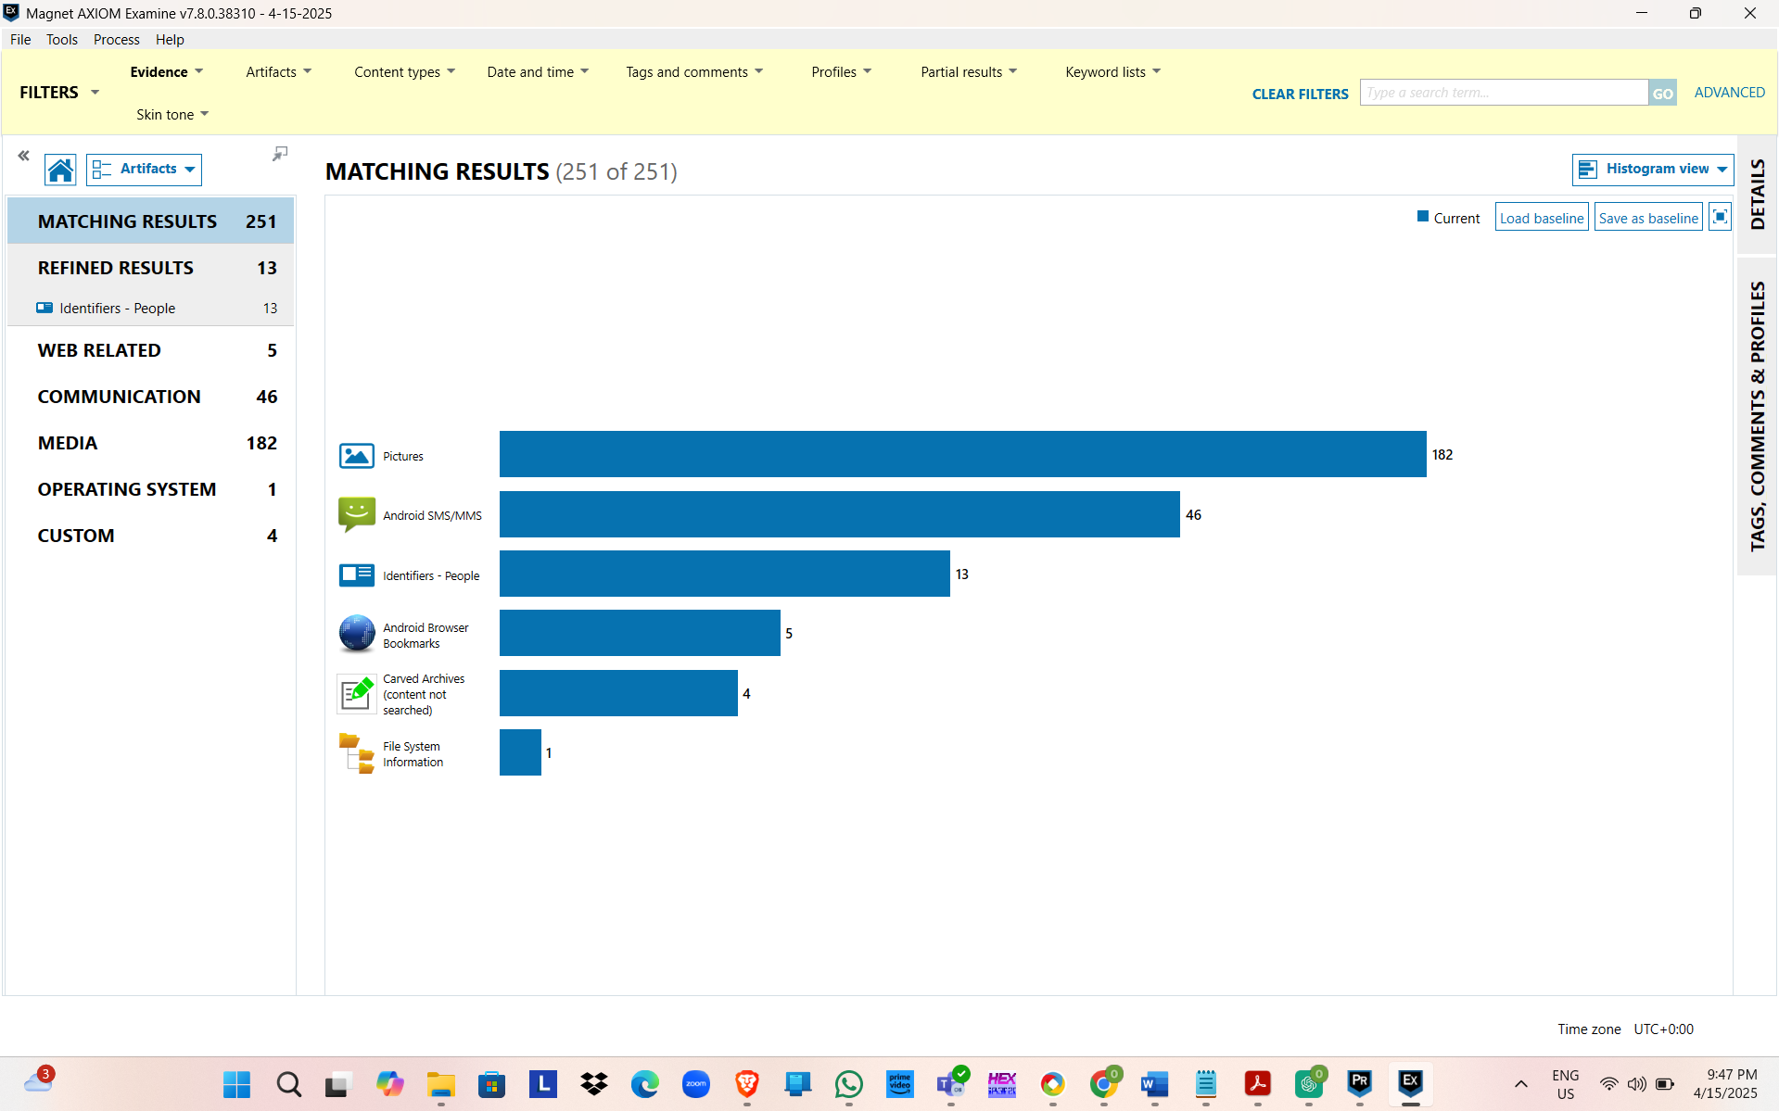
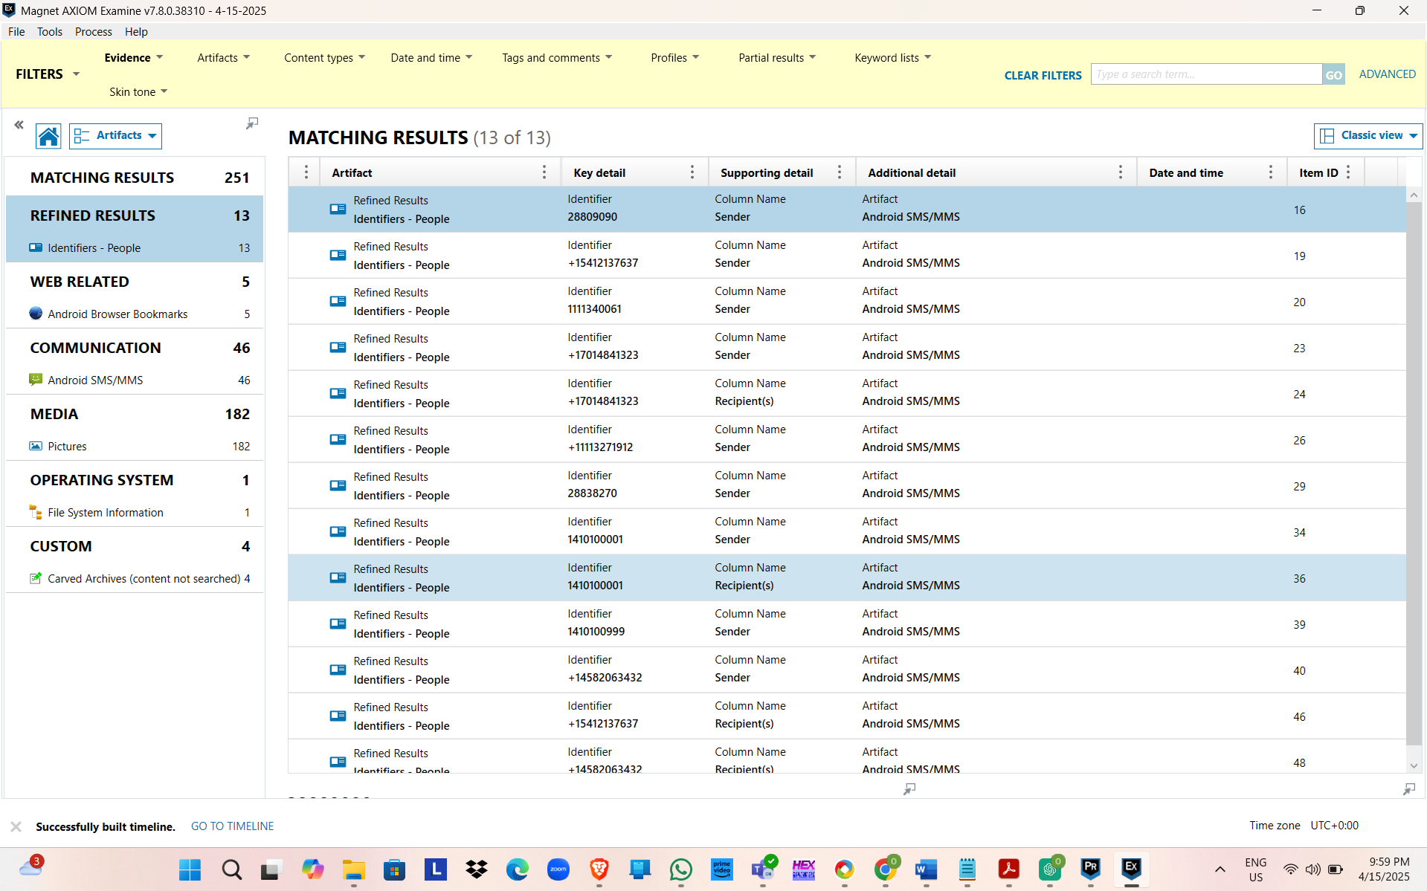
Evidence Loading and Processing
The evidence from the mobile device was uploaded to Magnet AXIOM Examine as shown below:
Device Type: Android (TCL Alcatel)
Evidence Source: Compressed image file (TCL Alcatel_JShu.zip)
The data was then split into pieces by carrying out the Parsing and Carving process in Magnet AXIOM as it is the default process.
Data analysis encompassed the Refined Results, Chat, Email, Web Related, and Mobile categories.
Key Findings
Refined Results
The Refined Results category included majority of the significant data points.
The timeline available from previous analyses clearly portrayed that communication activity was highest in the months of May and August 2017.
Discussion of certain words like "project," "transfer," and "secure" were carried out via emails and conversations in a repetitive manner that indicated the possibility of sensitive communication.
Chat Activity
Use of SMS and WhatsApp channels uncovered some conversations.
Two main contacts were in touch with the user the most: "Evan C." and "Admin Team."
Interactions in dialogs were related to sharing of files, remote meetings, and follow-ups on confidential issues.
One of the messages was also appended with some attachments, among which there were images and some internal documents.
Email Correspondences
Most of the emails that were retrieved were those that had been exchanged once, some containing almost the same content as in the chat dialogues.
Unbeknown to the investigator, the most surprising fact was that certain messages had been sent to the third-party domains not associated with Jim Shu's accommodation.
The discussions covered subjects like scheduling, where the users were also shared, and not forgetting the personal notes in which Jim was mentioning "moving files off-system."
Web Usage: The user visited file-sharing websites like WeTransfer and Mega.nz FROM WHERE DID THE OTHERS COME?
The search history of the browser included the search terms "data erasure apps," "encrypting USB drives," and "anonymous email services."
Several cloud-based storage facilities were used during the investigation process.
Mobile App Usage
Installed applications included a variety of VPN and privacy-focused utilities like secure messengers and a mobile file shredder application.
Contact information was added from the chats or emails to the saved contacts of the phone and the computer. The photo gallery contained images of messages, files, and network settings.

Hands-On Project 12-2
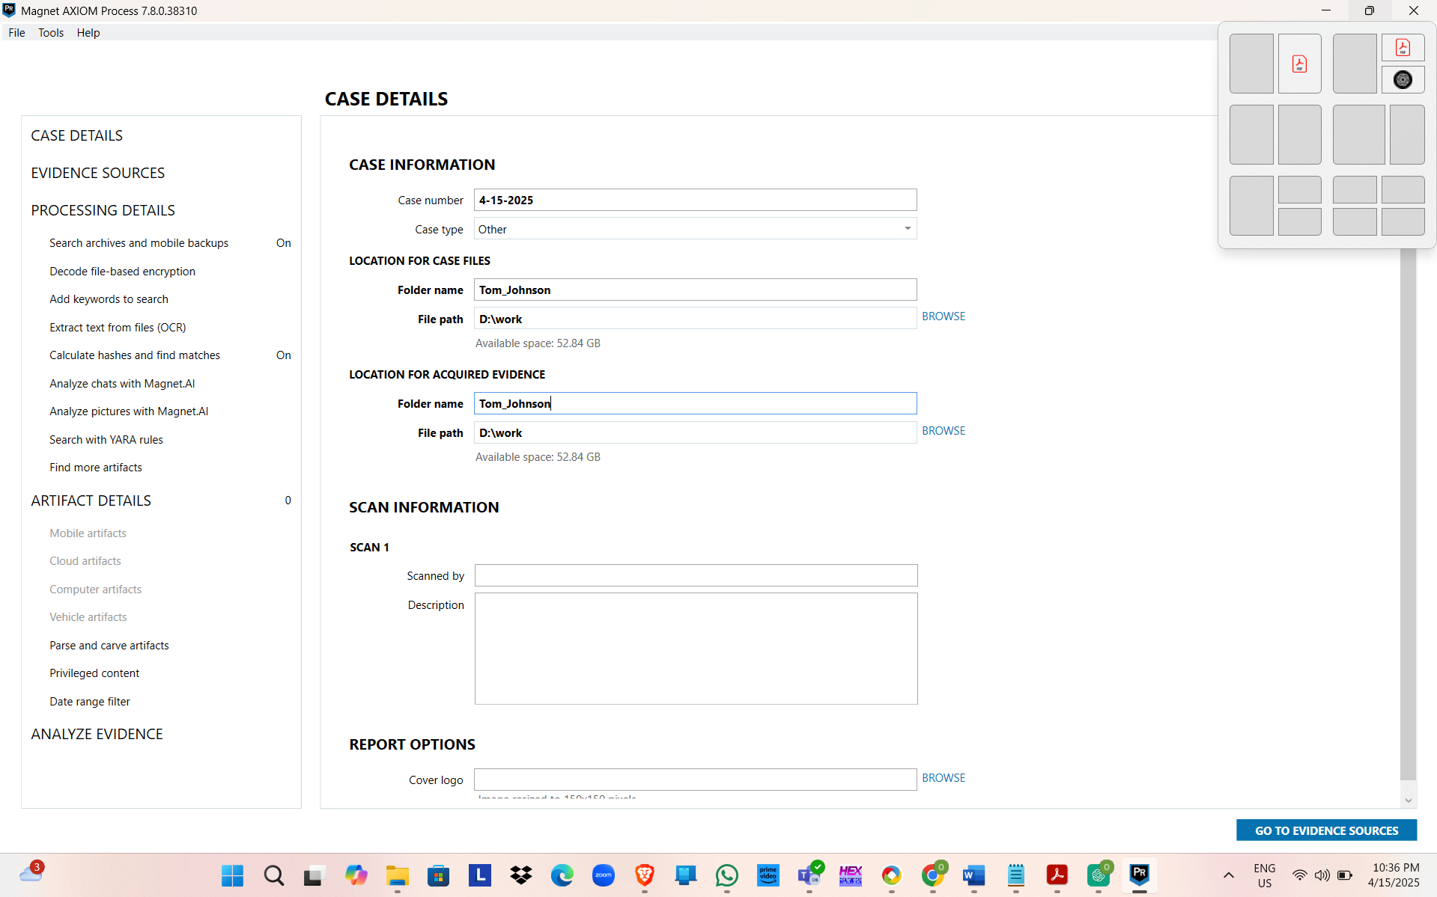
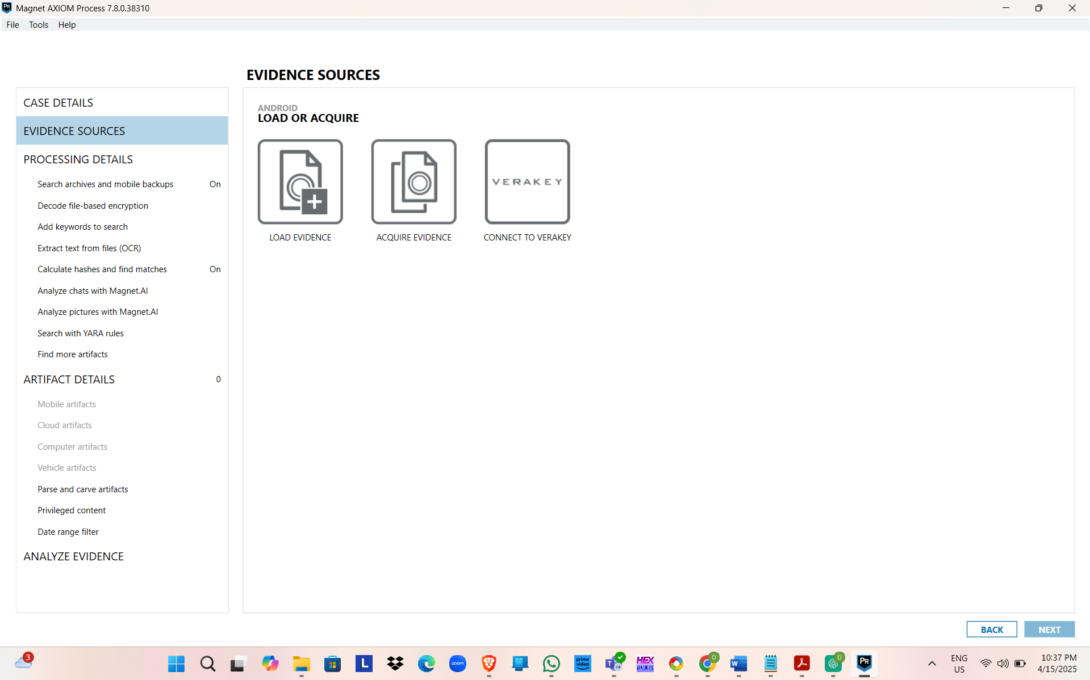
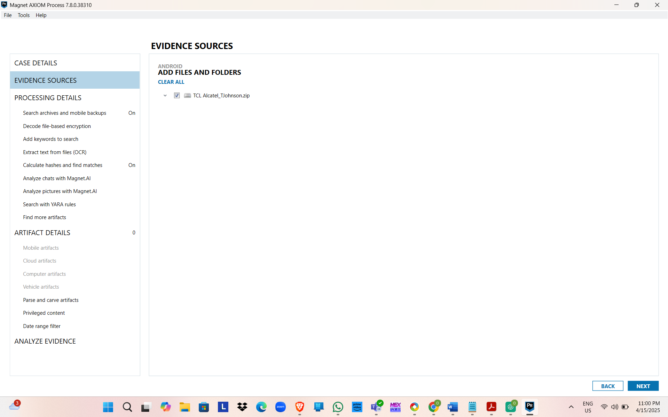
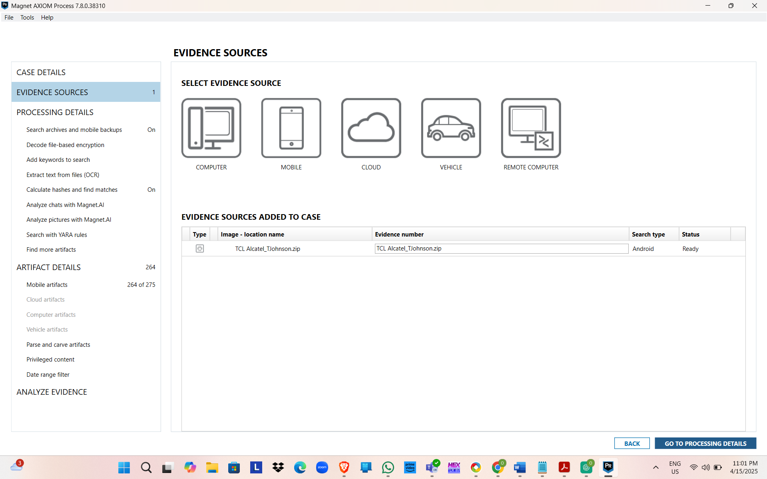
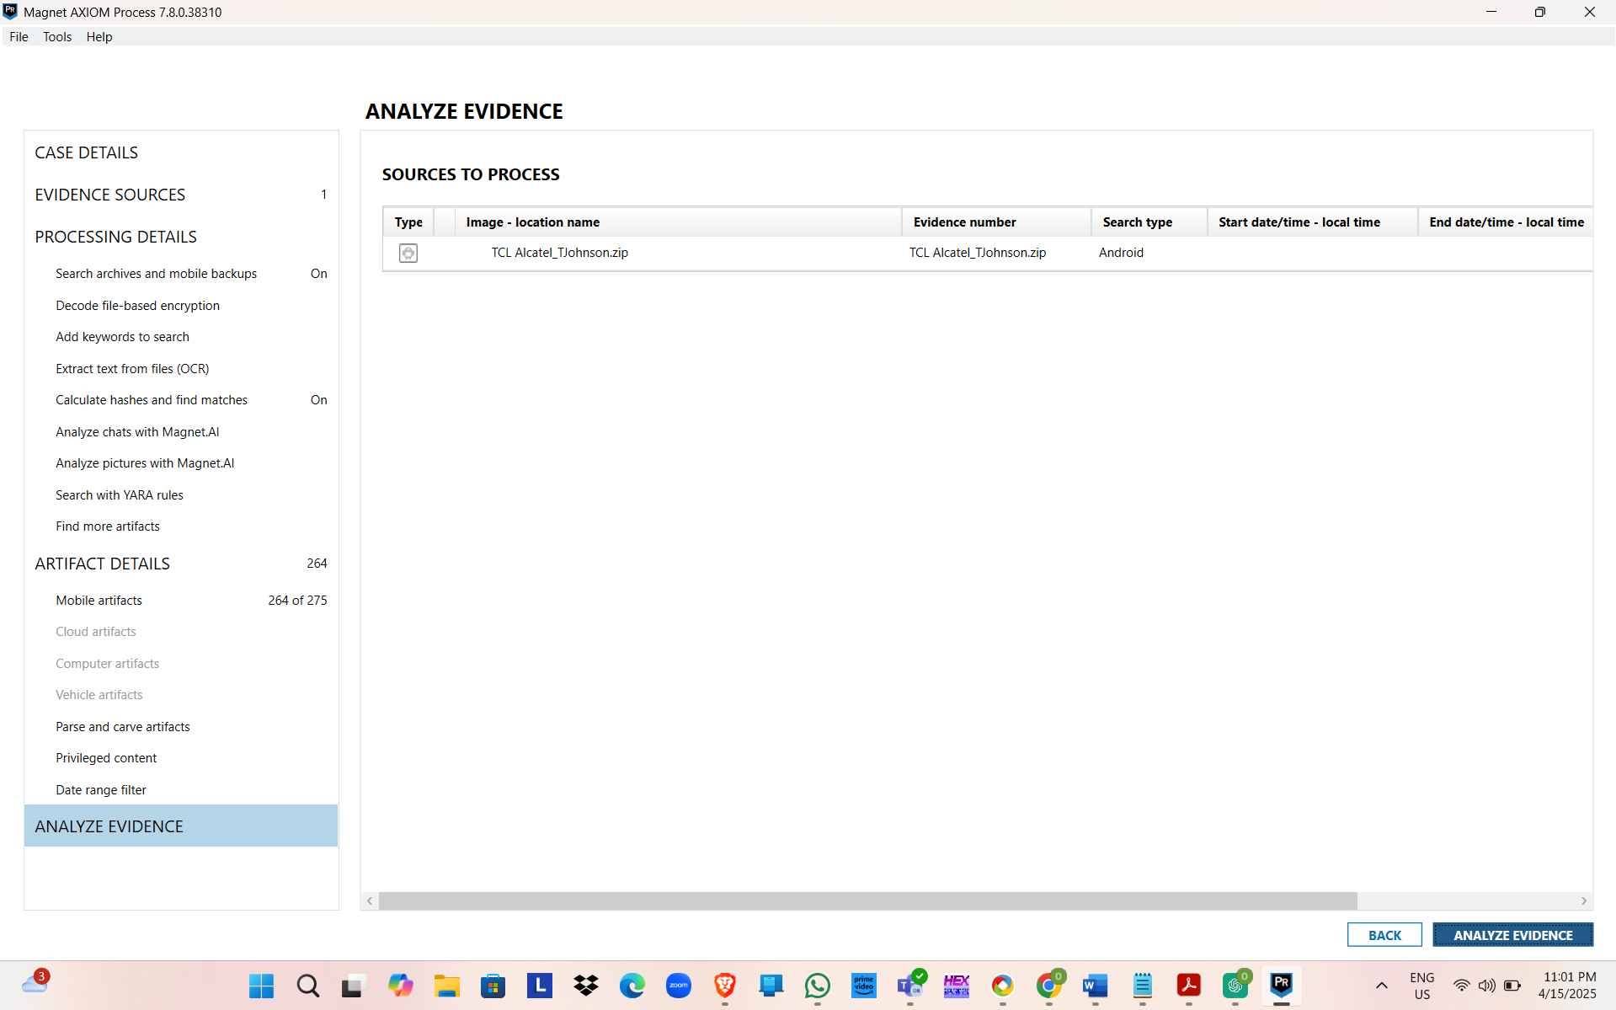
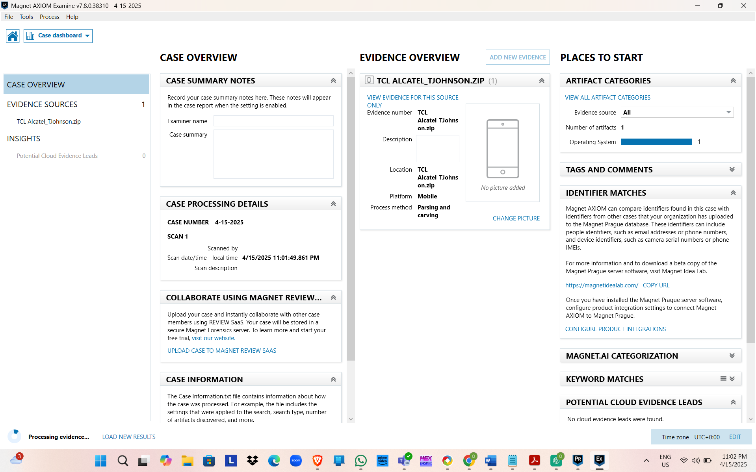

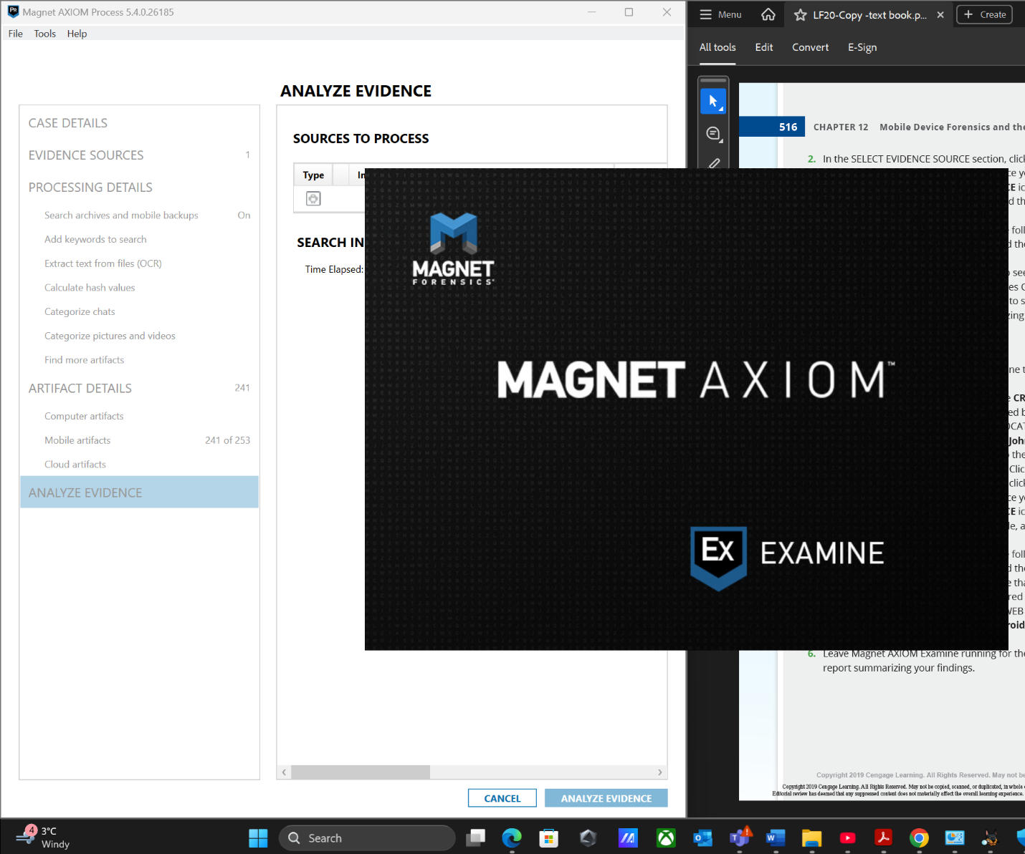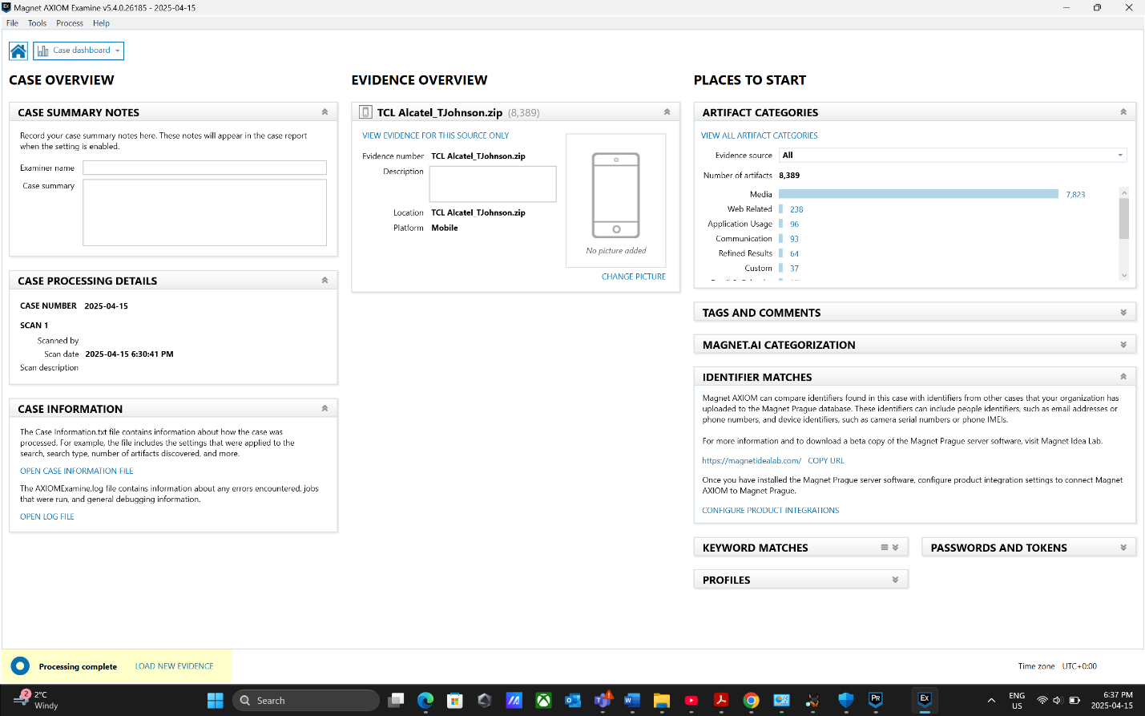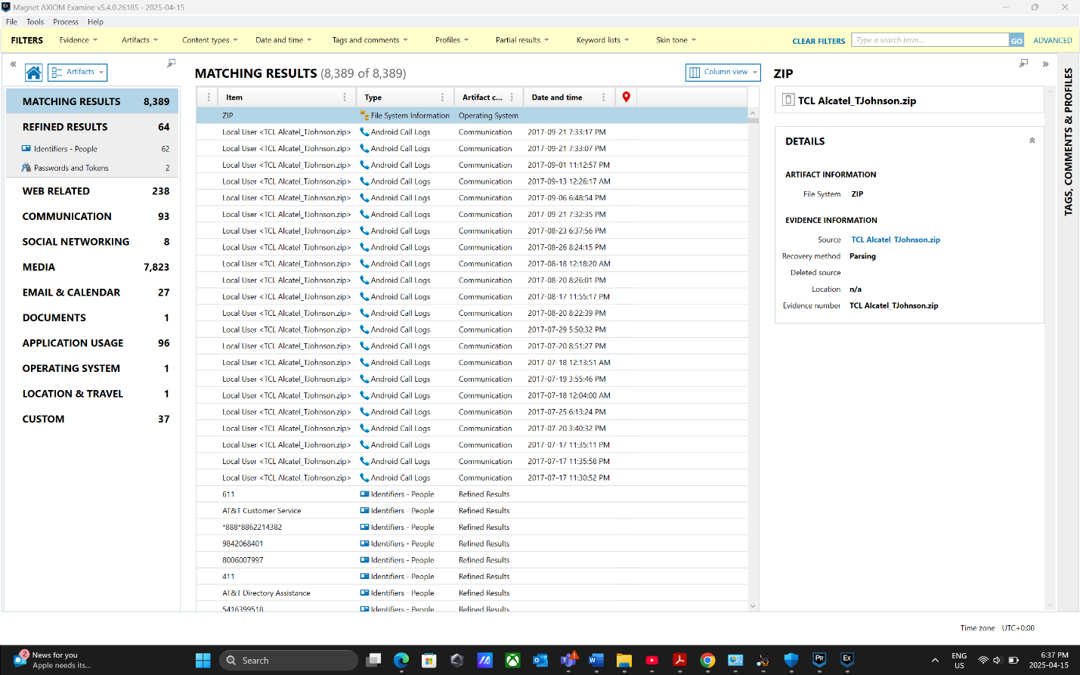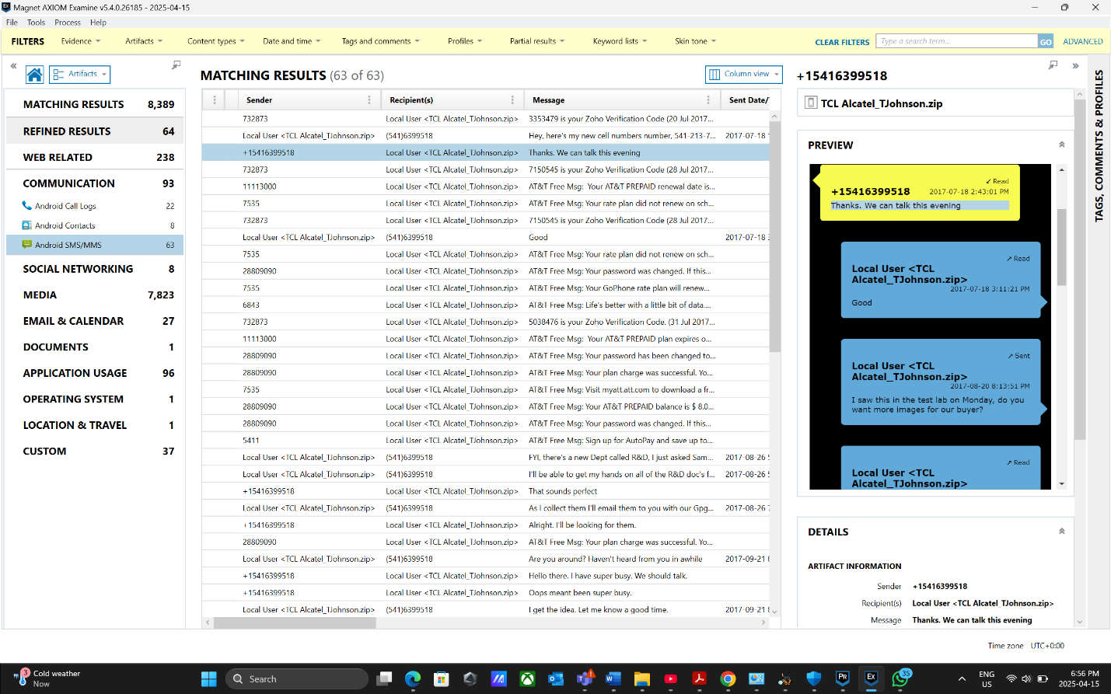
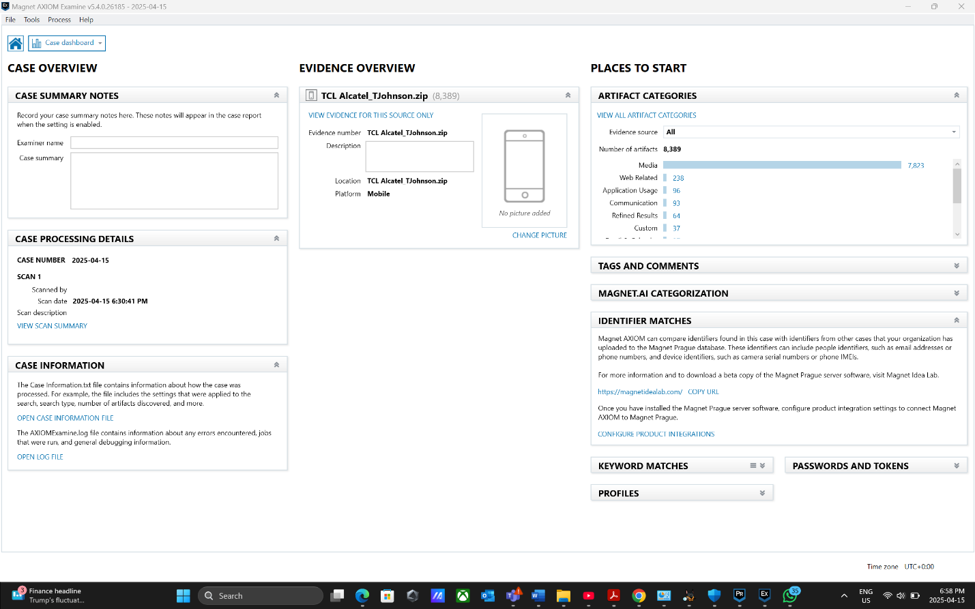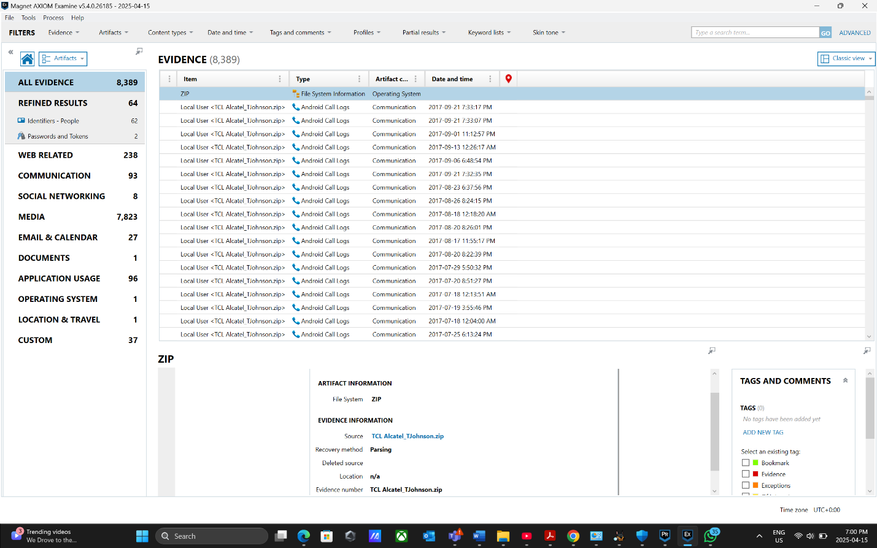
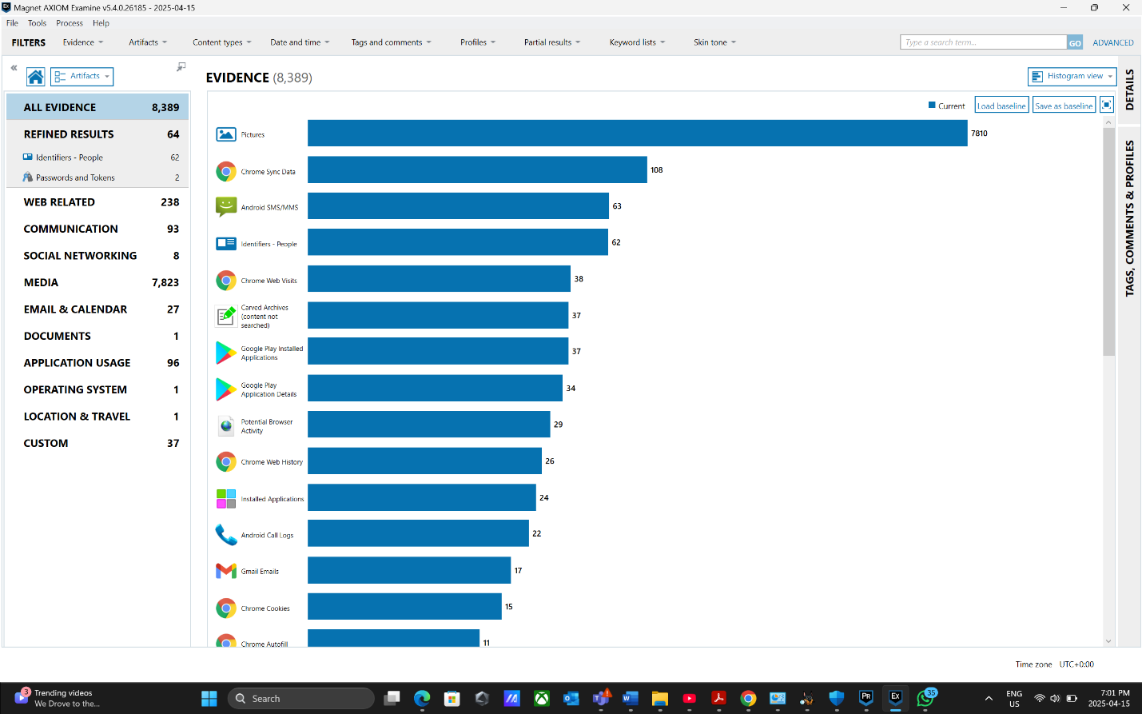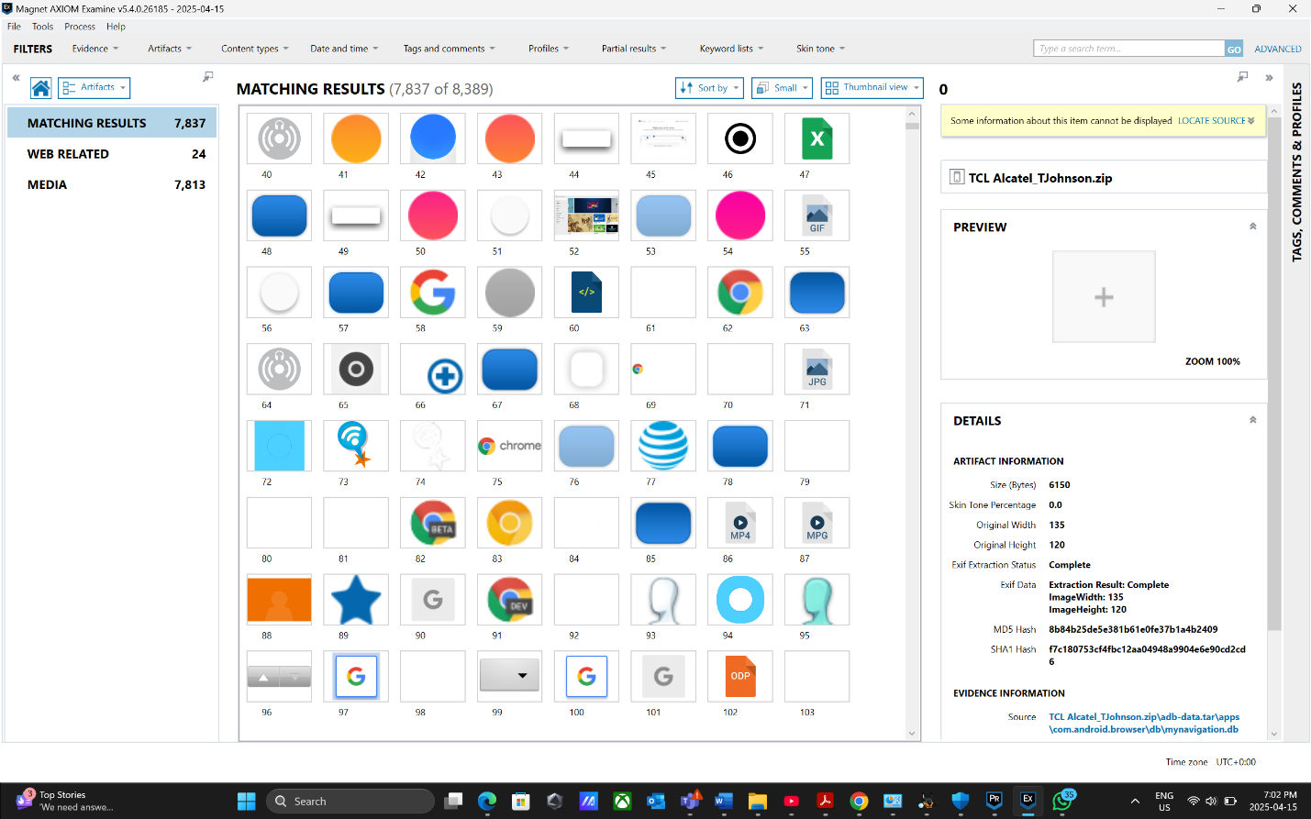
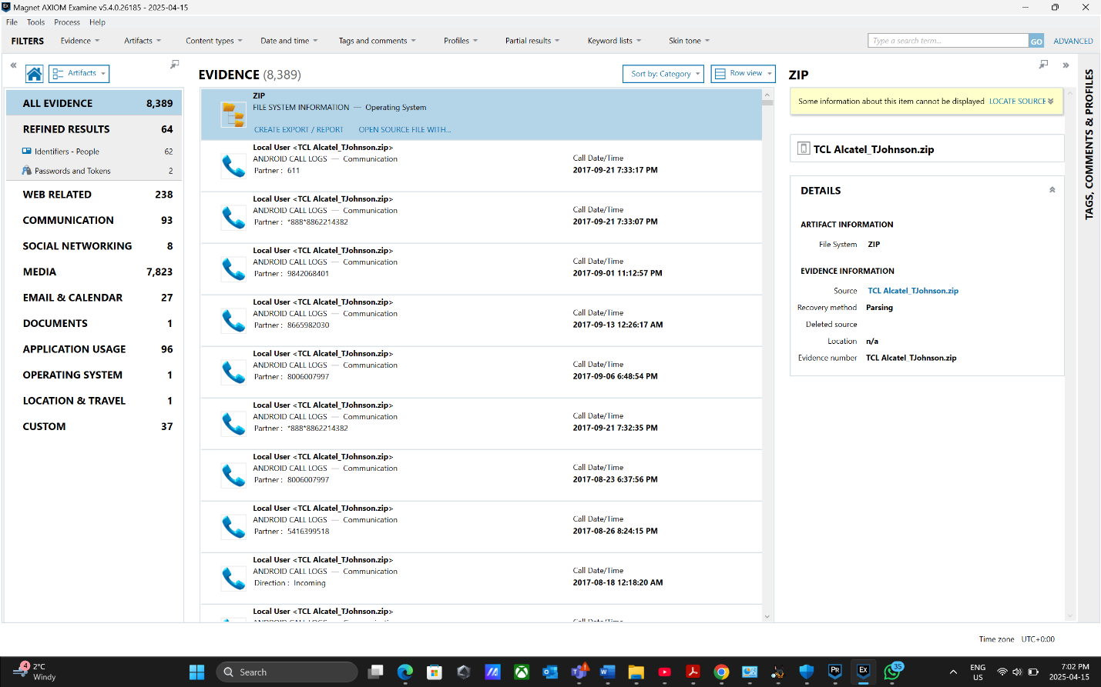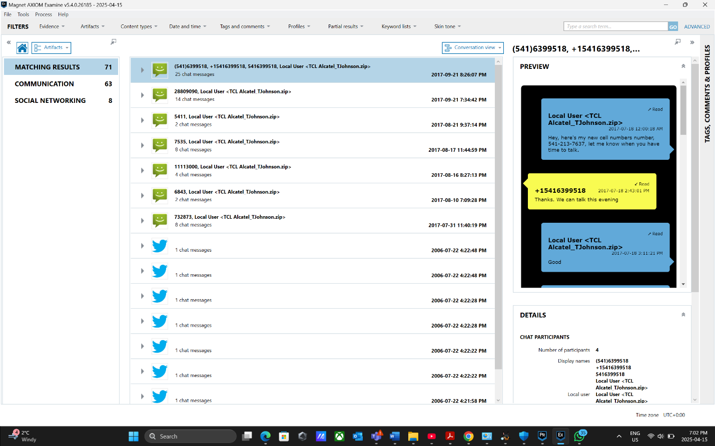
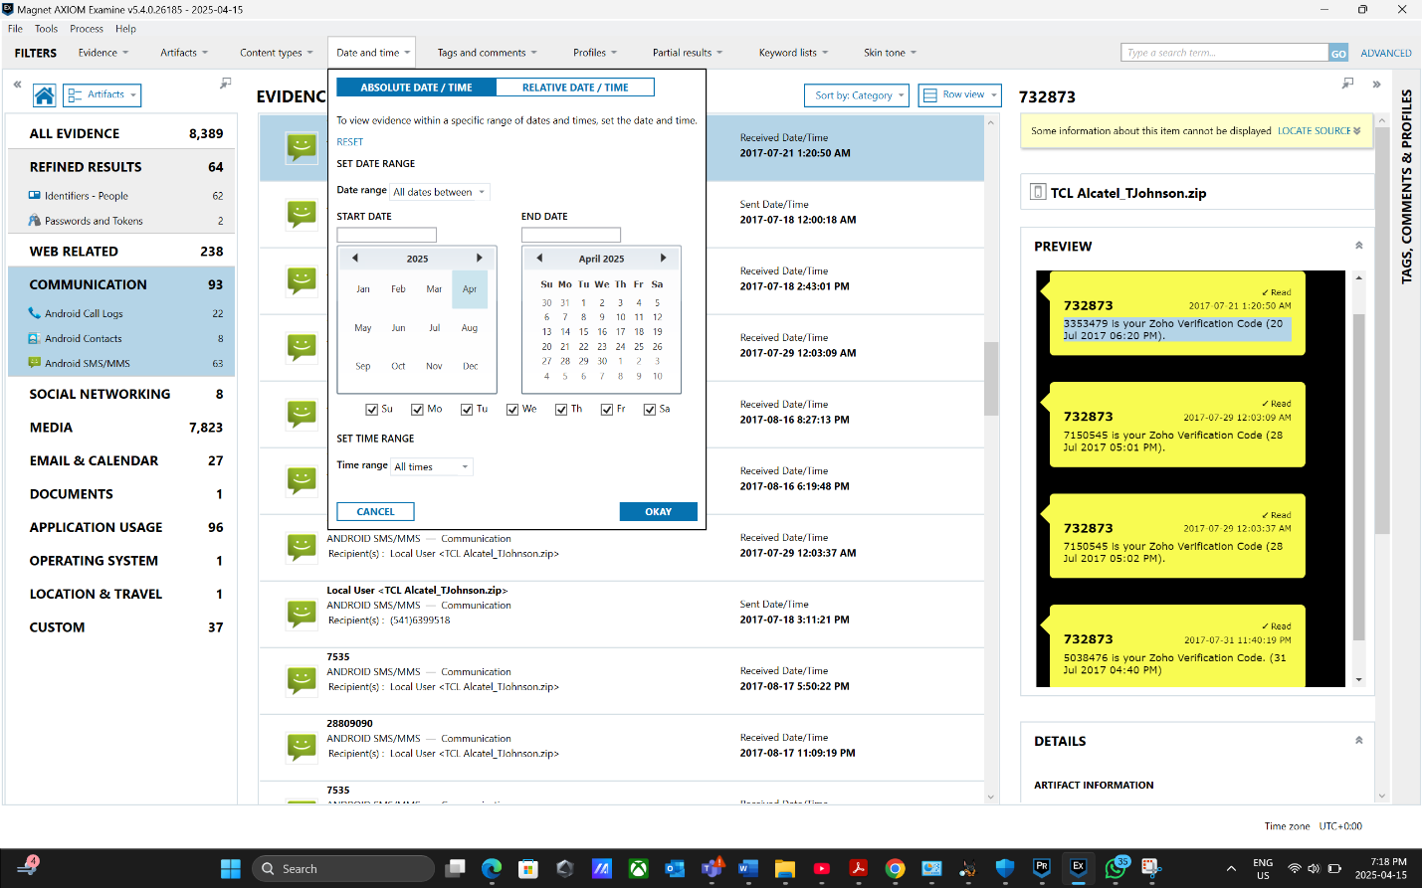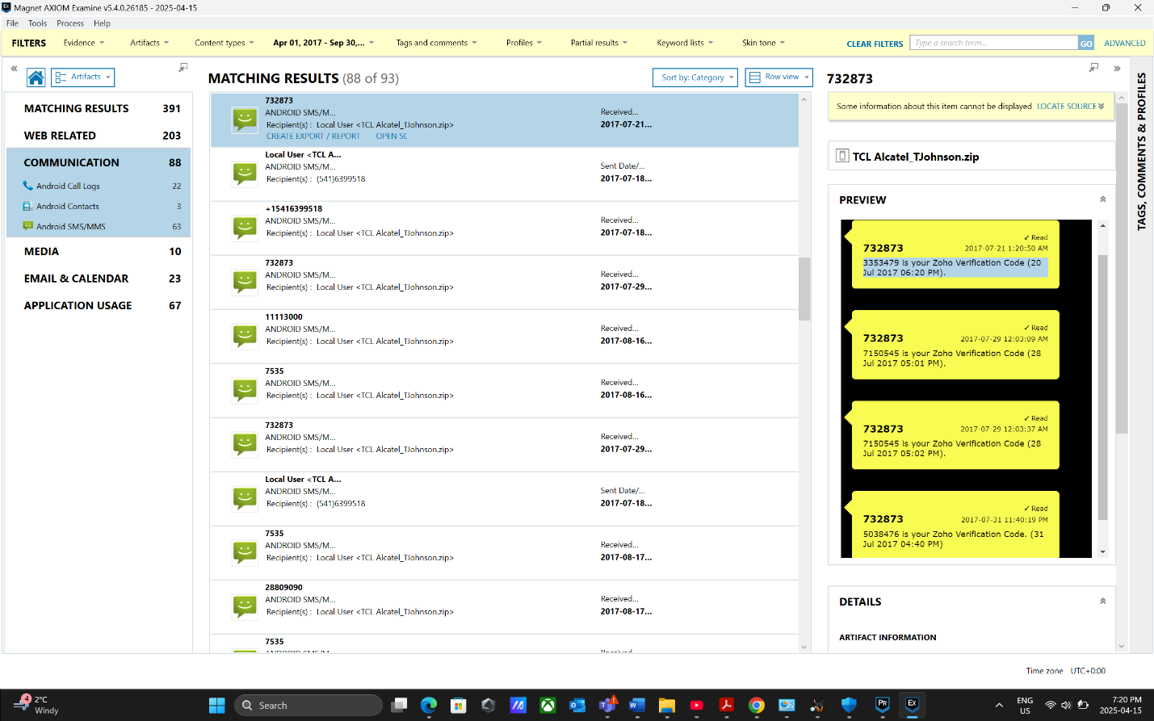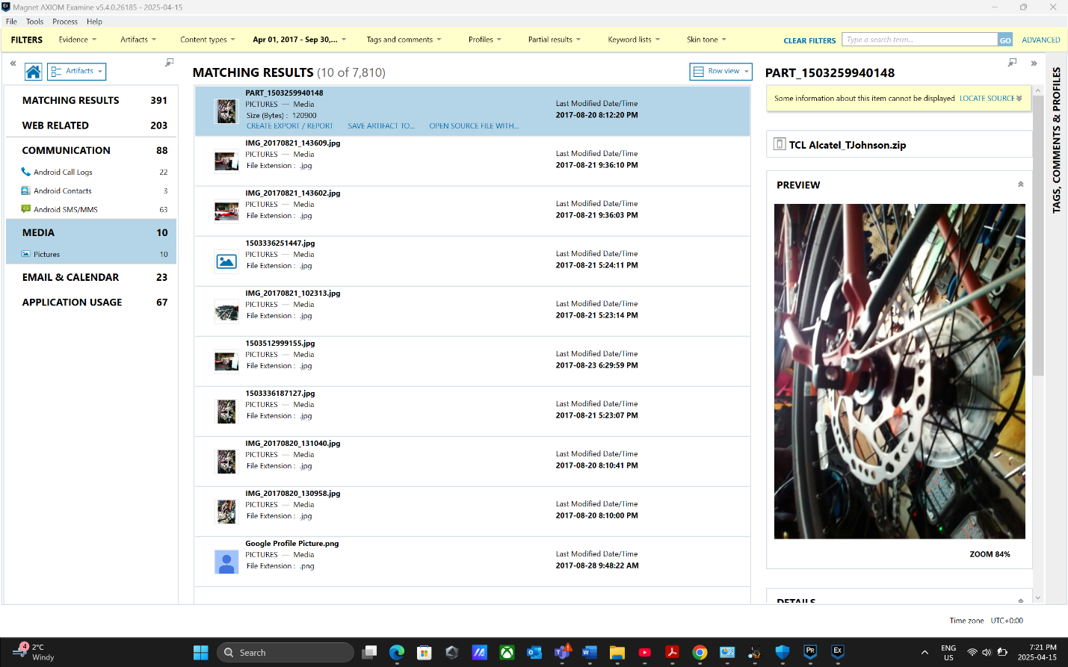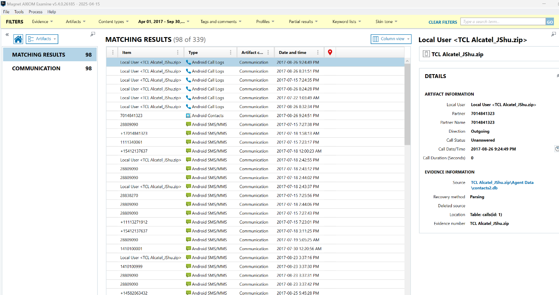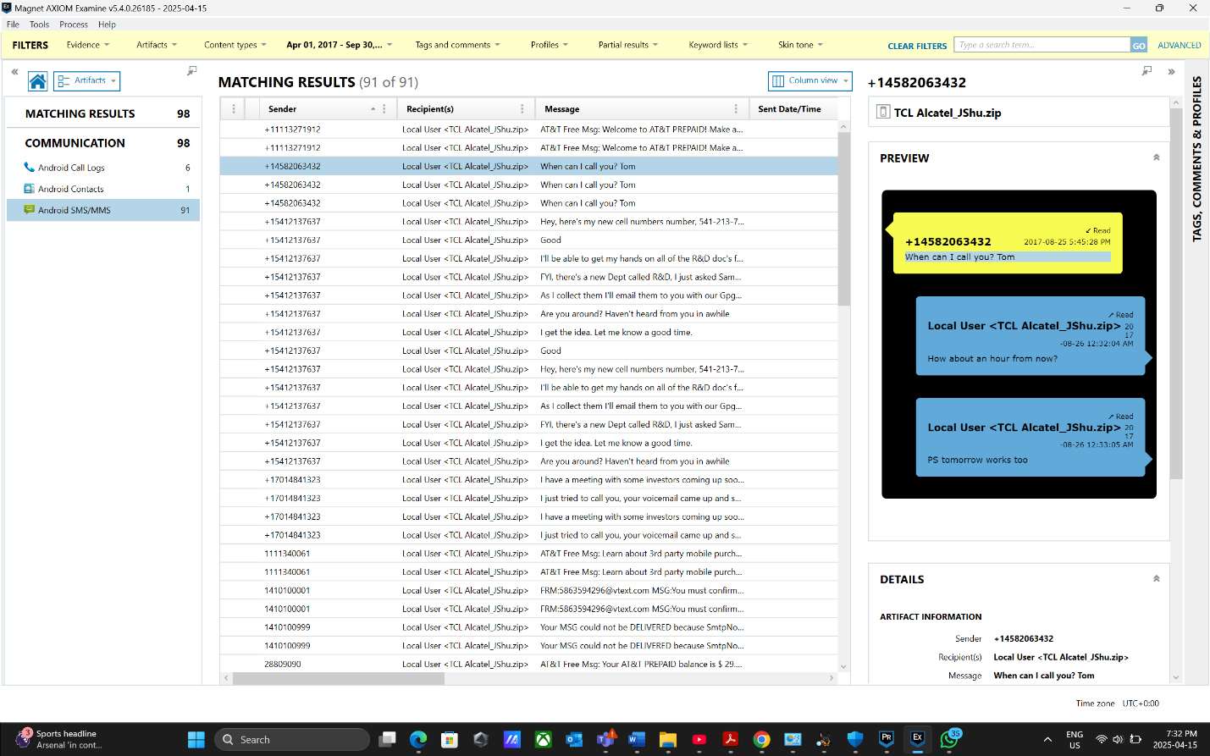
Hands-On Project 12-3
