

Course: CYB304
IT Security Forensics
(Canadian Context)
Lab 7: Data Acquisition
Instructor:
Muhamma Saleem

Student Name: Olushola Enoch Bayode
Student ID: 23077087
Section: 3rd Semester

Hands-On Project 7-1
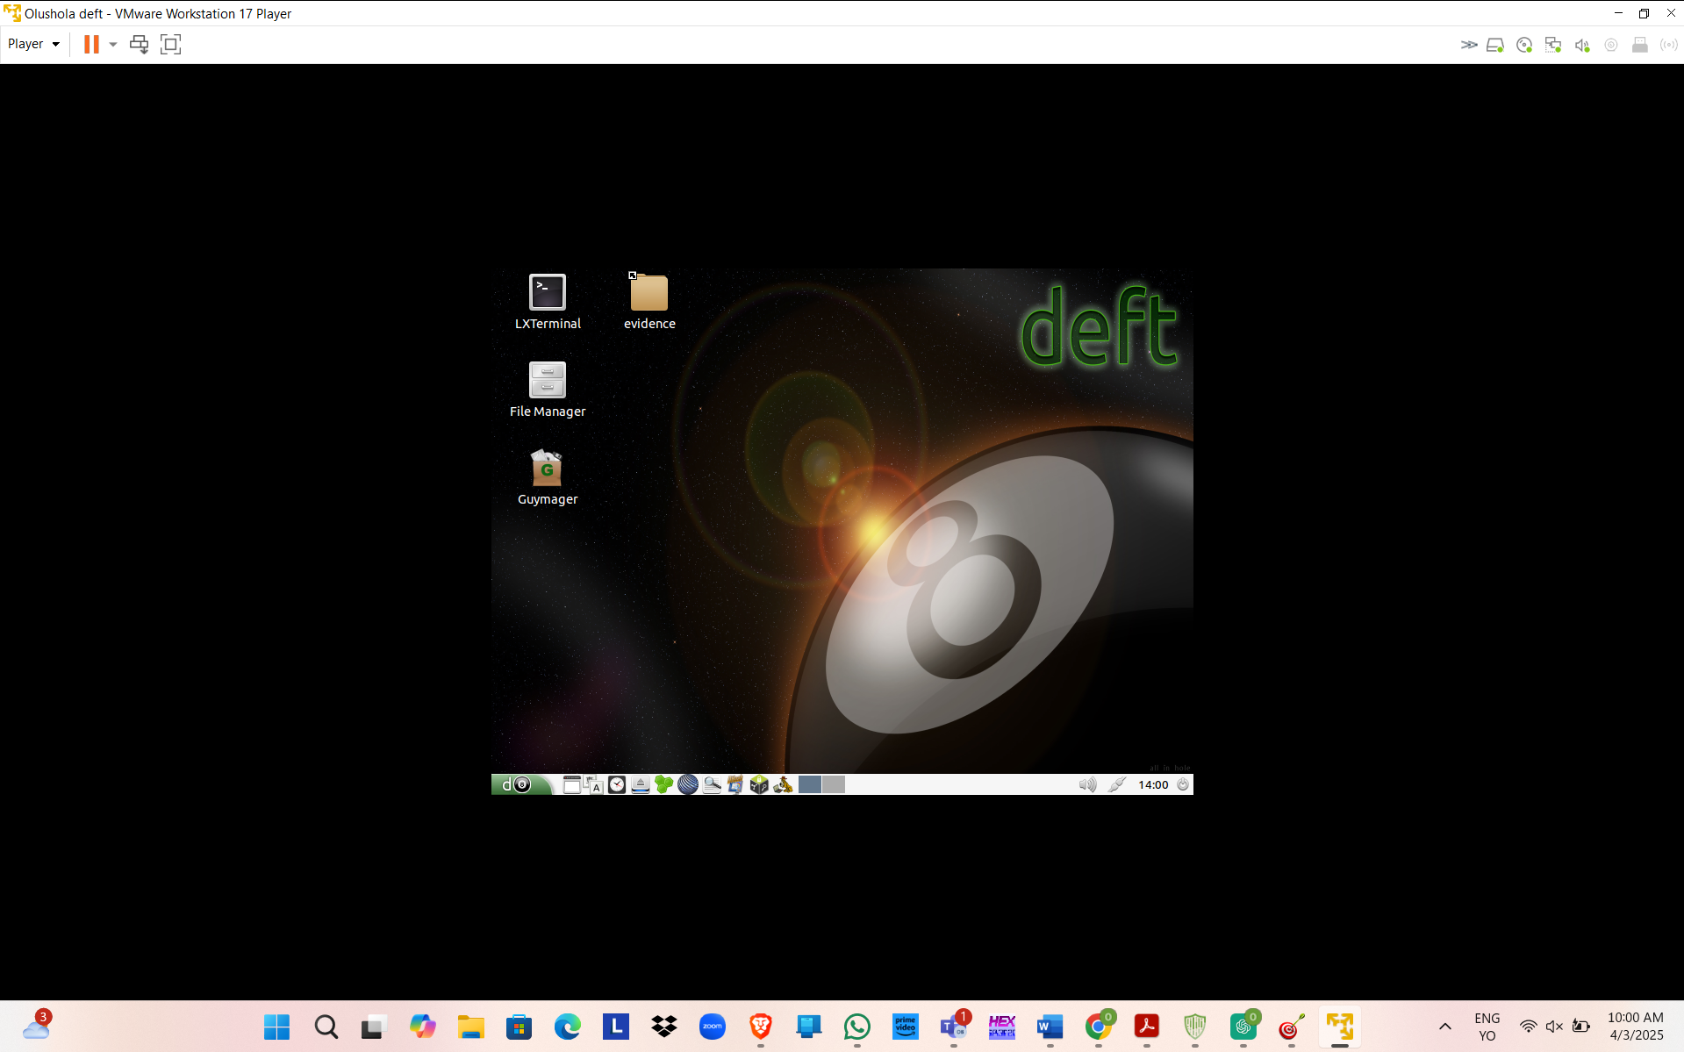
DEFT
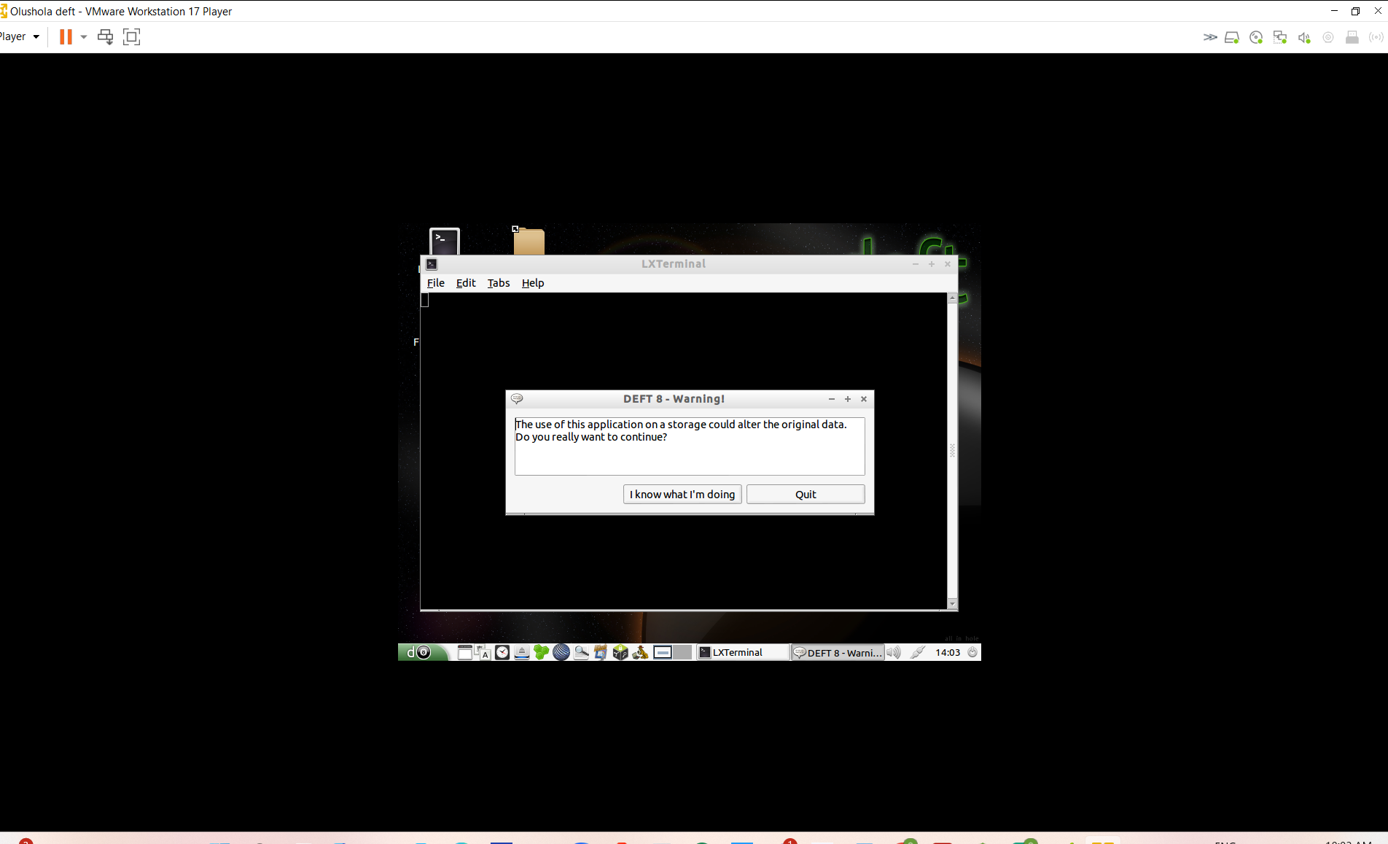
Mount Manager
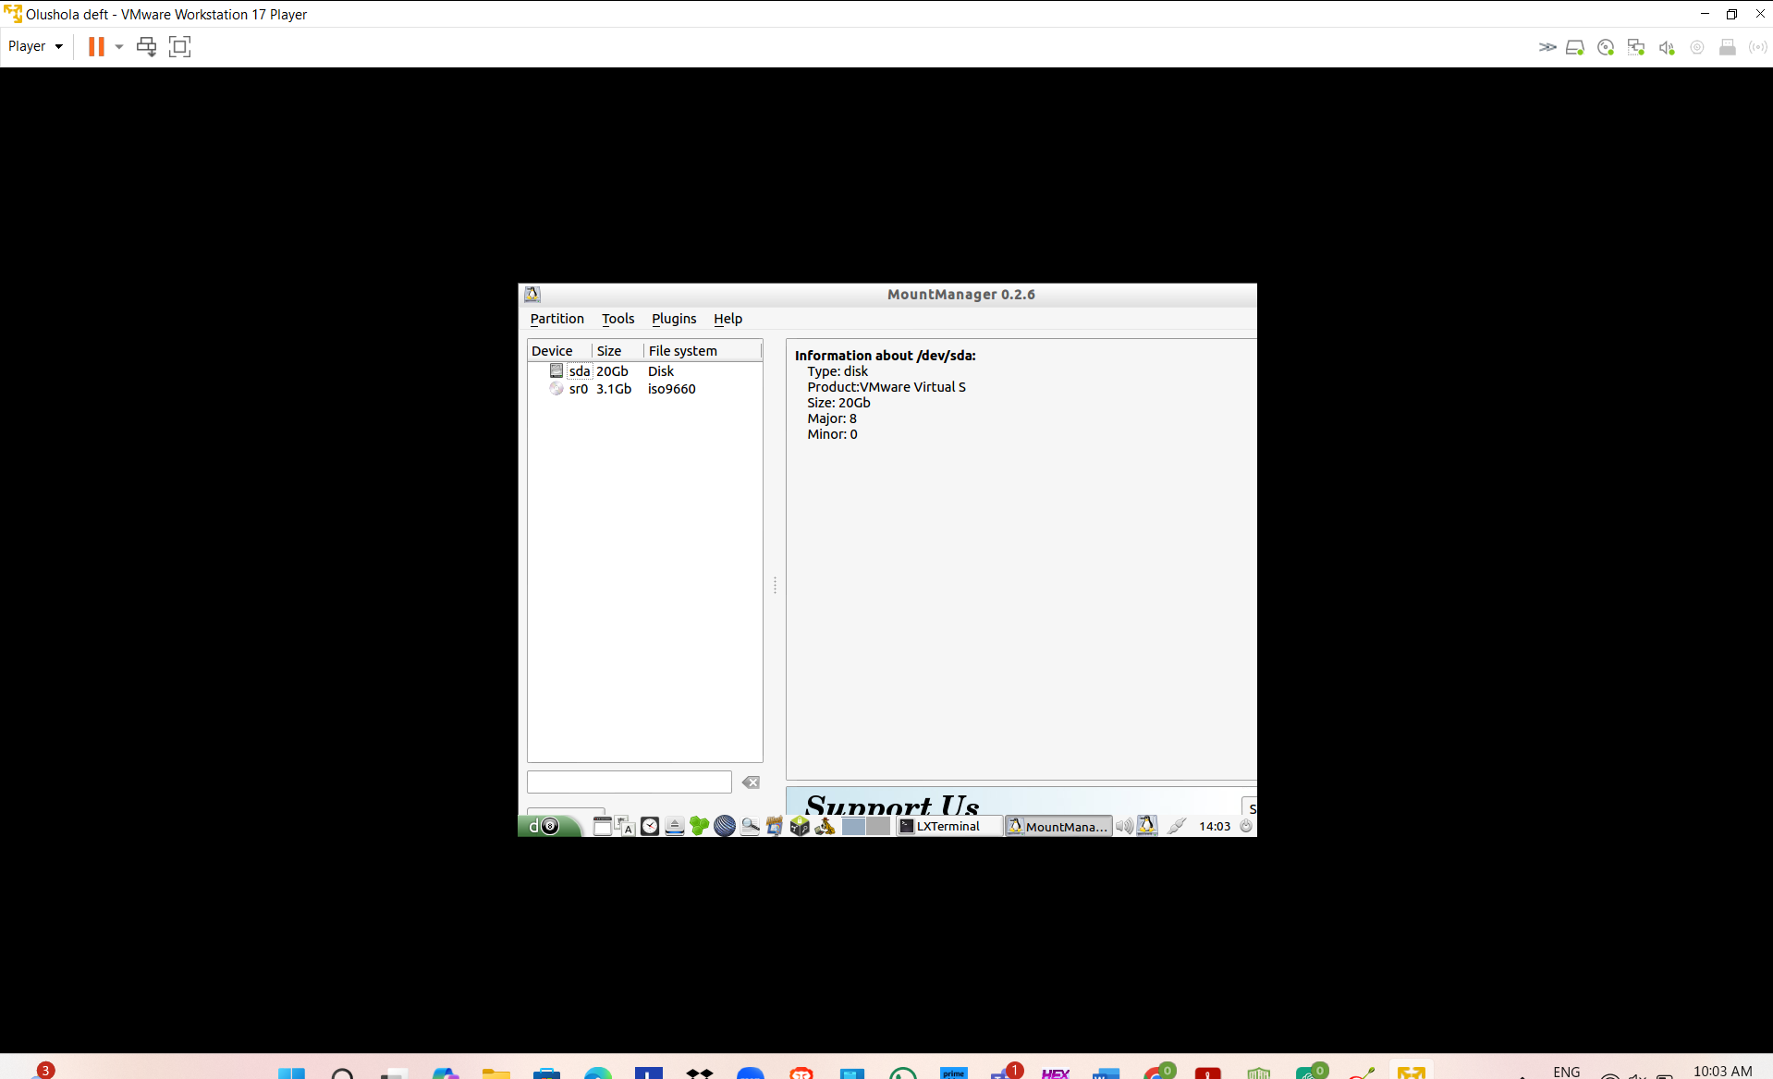
DHash
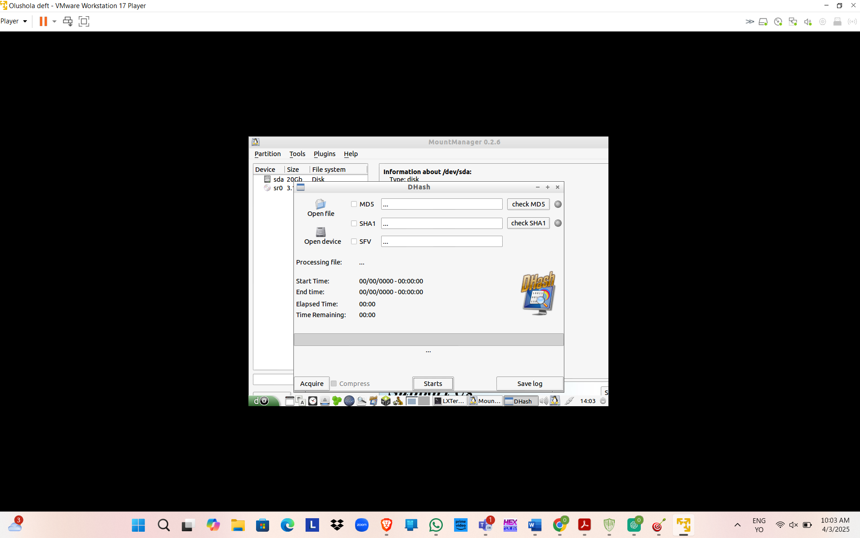
Autopsy
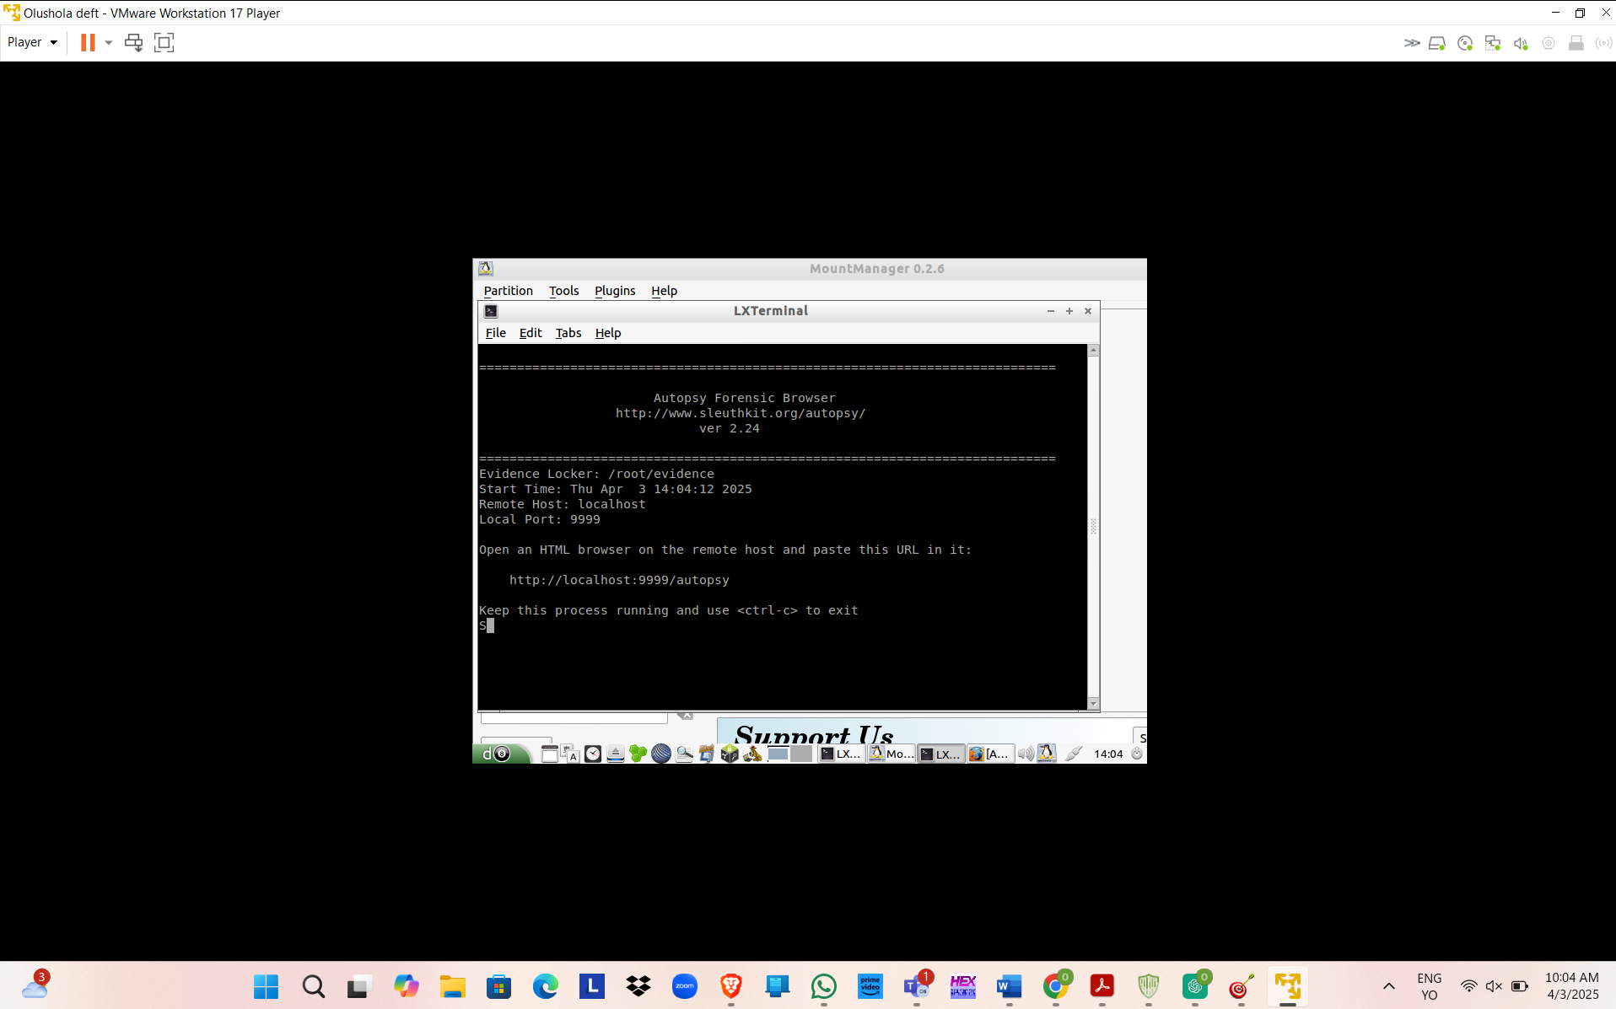
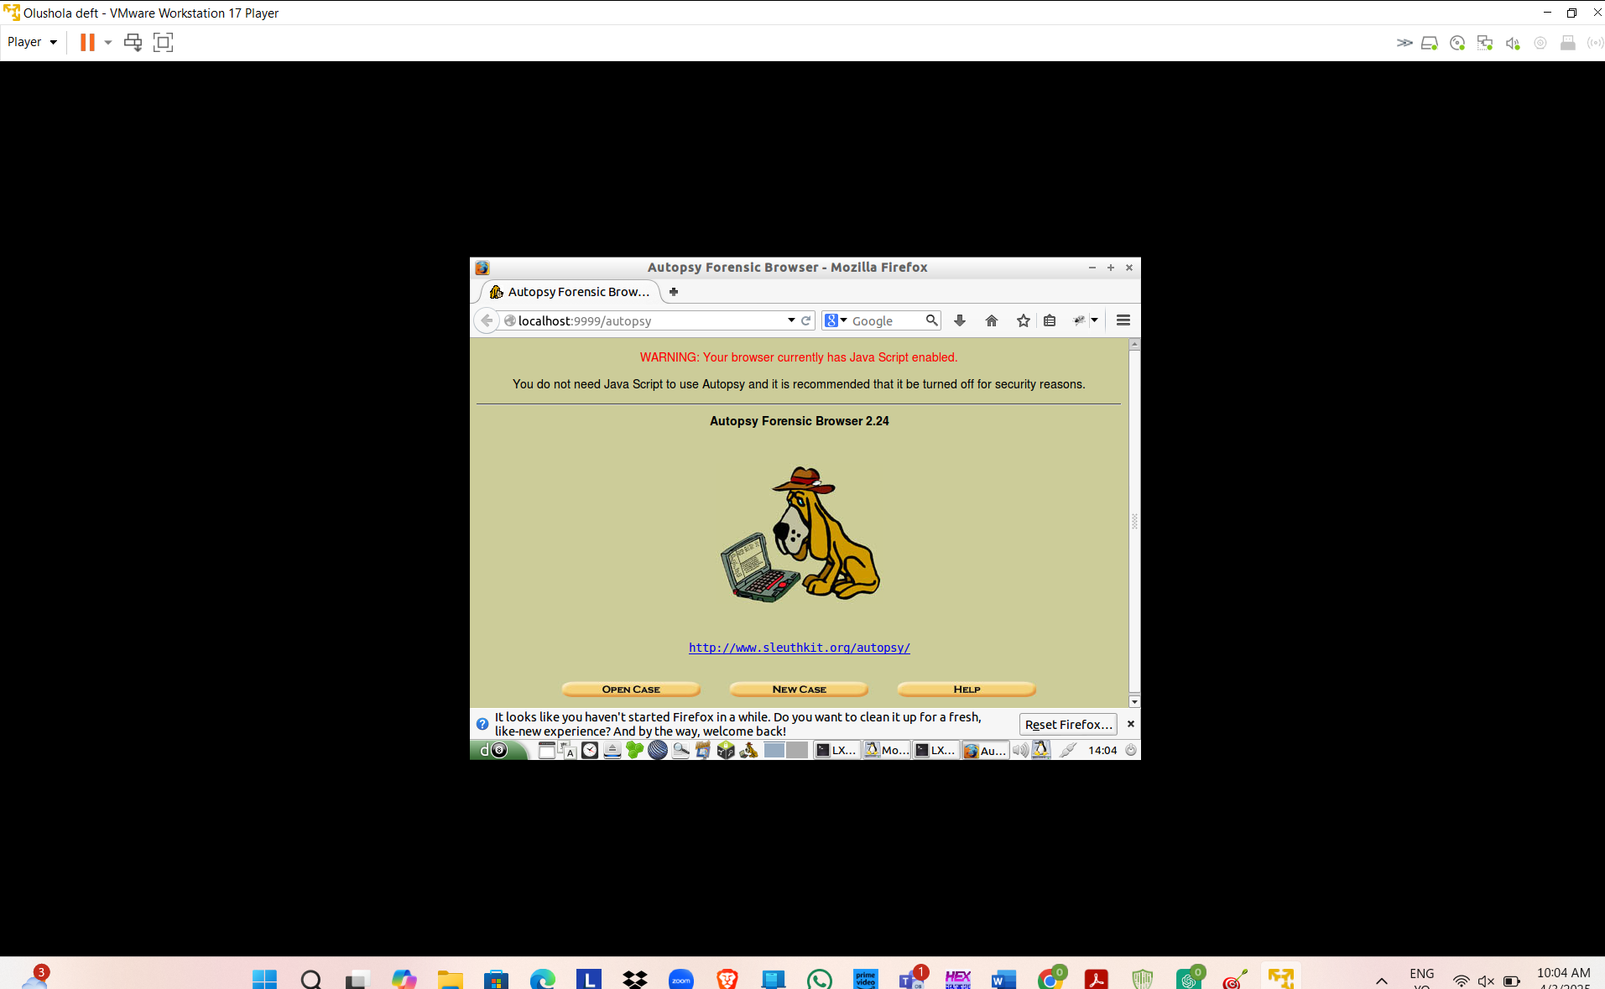
DFF
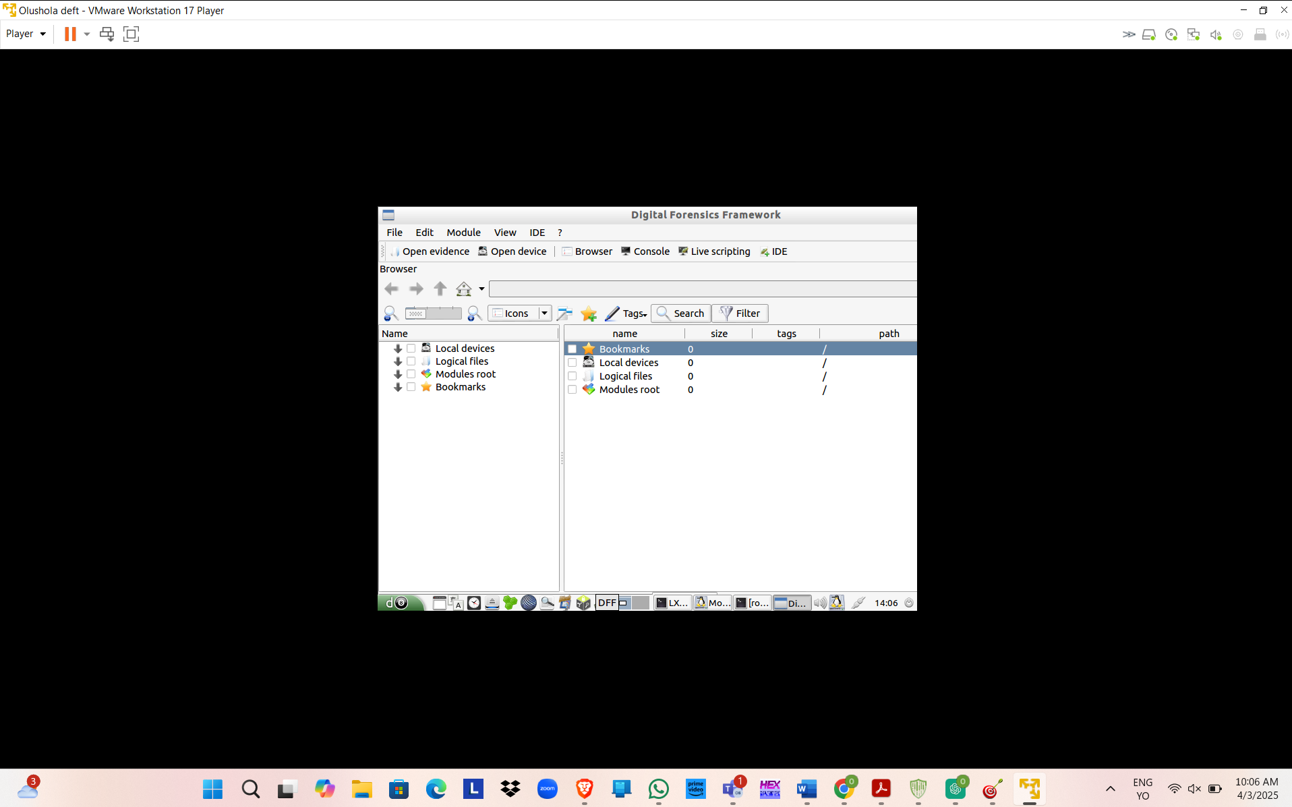
GHEX
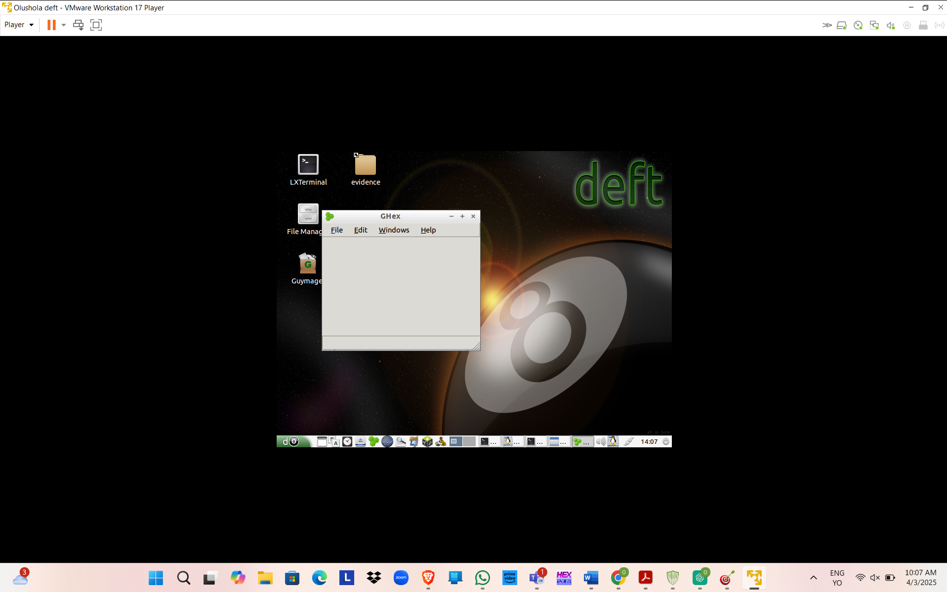
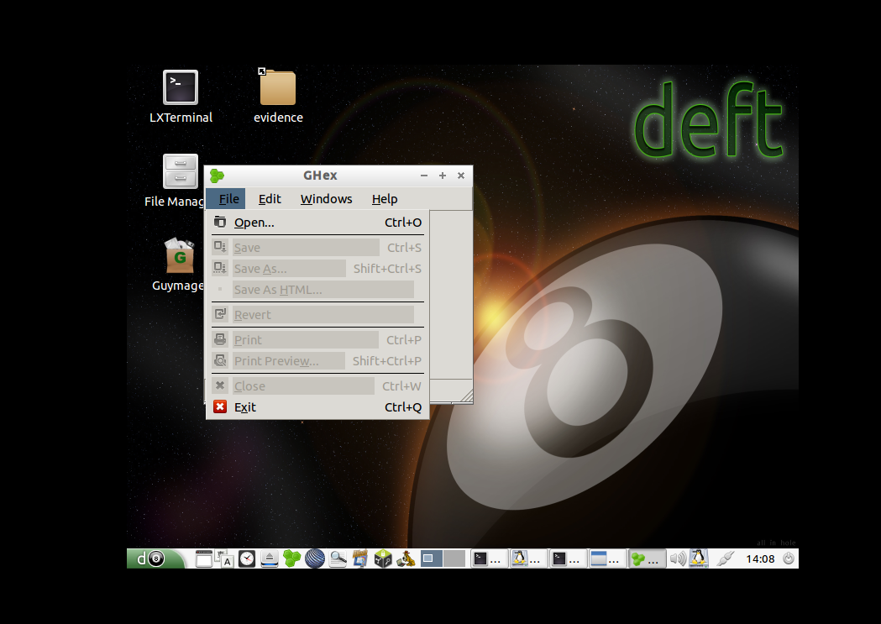
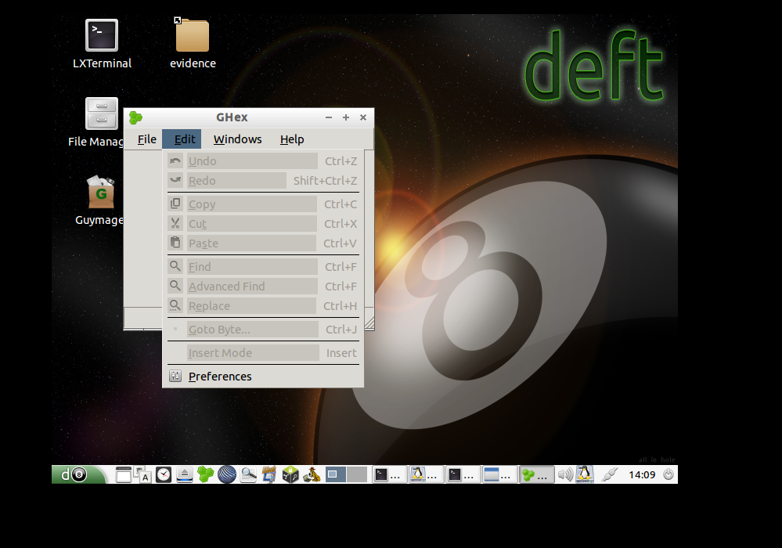
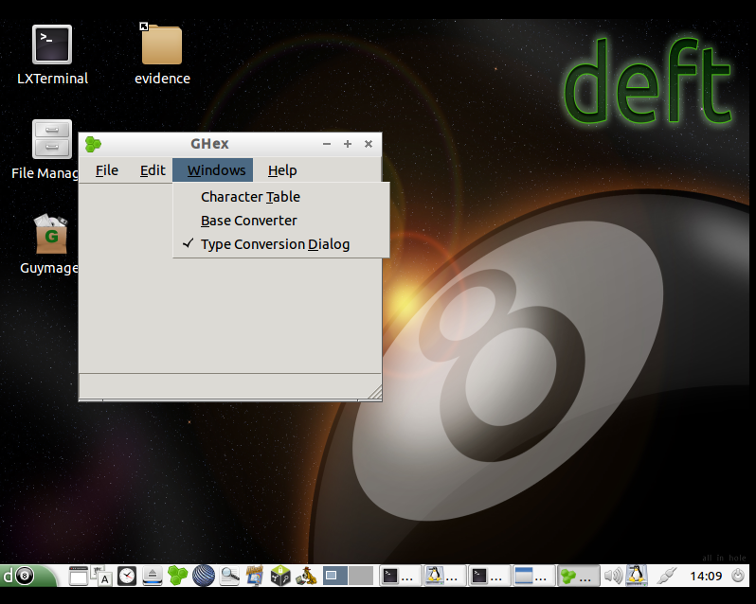
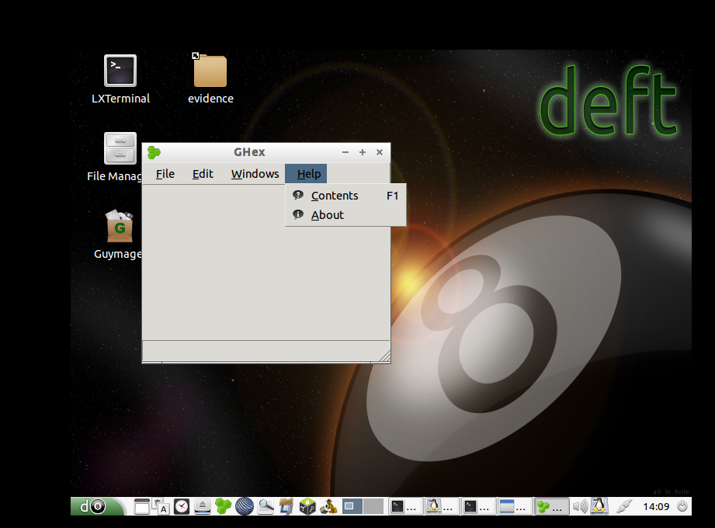

Step 1:
Exploring Autopsy Forensic Browser
Autopsy is a
dynamic free tool that forensic experts use to investigate digital
evidence. It is really a responsive piece of software that is highly rated and
is thus efficient while examining disk images, recovering deleted files, and
extracting metadata.
What to Do:
- Click the Autopsy icon to start the application.
- Spend some time on its interface and main features:
- Case management
- File system analysis
- Keyword searches
- Hashset filtering
- At the same time, capture a screenshot of the Autopsy Forensic Browser window and text interface.
- Close the application after you have finished.

Step 2:
Understanding Digital Forensics Framework (DFF)
Digital
Forensics Framework (DFF) is mostly another useful forensic tool. Its main
purpose is helping the investigators in the examination of different file systems,
memory dumps, and storage devices. It promises to be an easy-to-use tool with a
fast and quite clean user interface to collect and analyze digital evidence.
What to Do:
- Double-click the DFF icon to start your program.
- Discover its functions like:
- File system analysis
- Memory dump analysis
- Evidence collection and reporting
If you still have some spare time, visit the vendor's website to read the full list of features and learn about the product in greater detail.

Step 3:
Using GHex (Hex Editor)
The extremely simple, yet functional, hex and binary editor GHex aids
a forensic analyst in the viewing, and the modification of, raw file data very
easily and with power. This software is totally free and a part of open-source
software that supports Linux and is used by many security experts for the
reconstruction of the original content from the encrypted information of an
image file, source code debugging, reverse engineering, byte patching,
authorizations, data recovery, and other activities. The much easier usage of
GHex editors can be seen in the example of ransomware analysis, for those who
may not be familiar with concepts of security and cannot separate security
features from malicious activity in the presence of new encryption
schemes.
What to Do:
- Click the GHex icon to start the program.
- See the way it displays the file content in both the hex and ASCII formats.
- Think about the way this tool can help with digital forensics:
- Converting data from malware
- Finding again or recovering the lost or damaged data
Hands-On Project 7-2
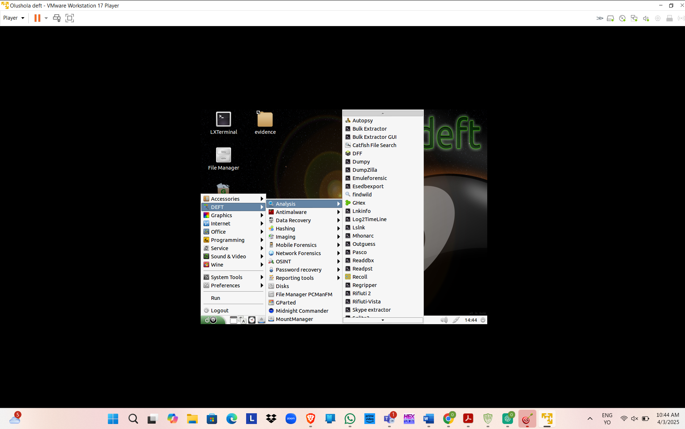
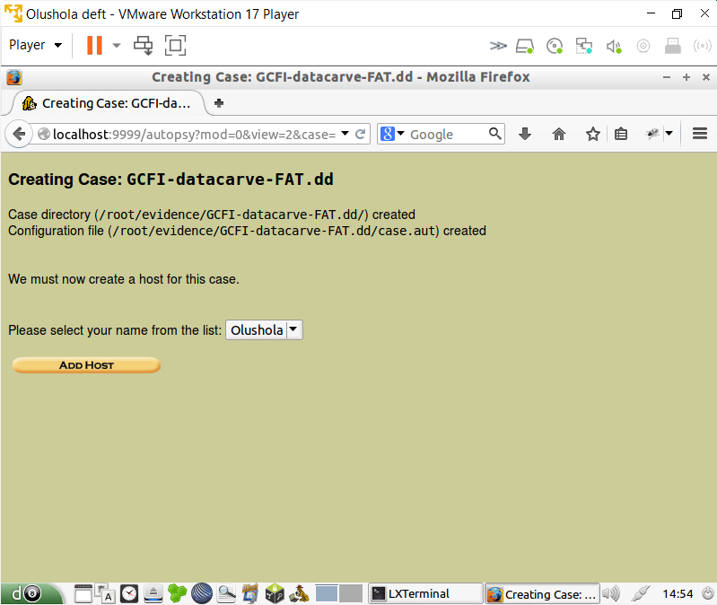
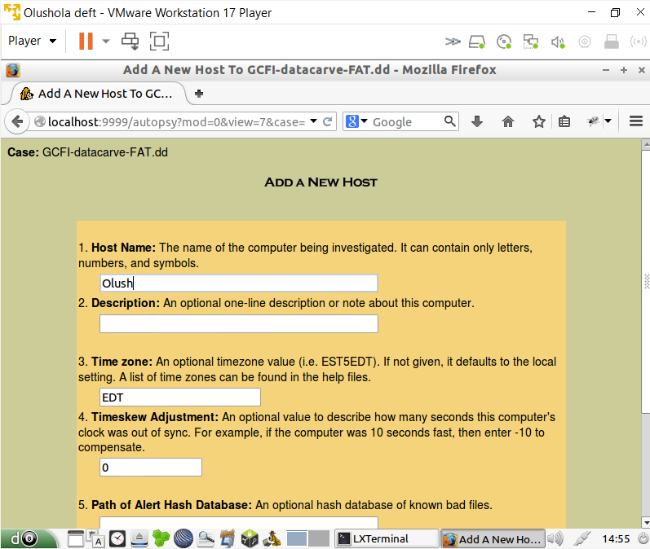
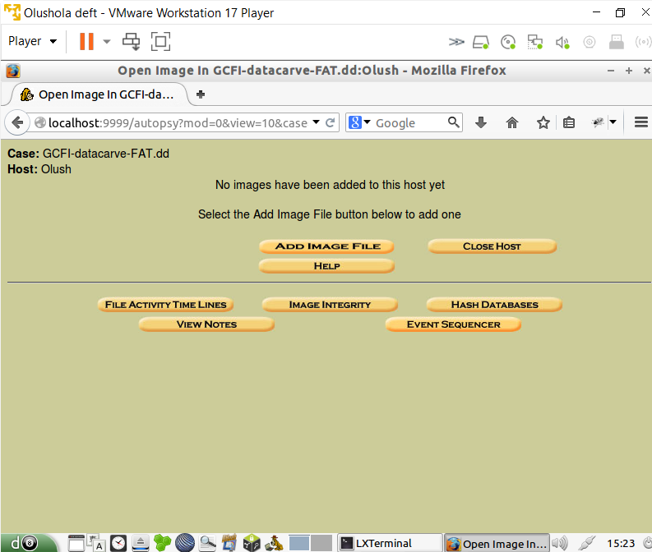
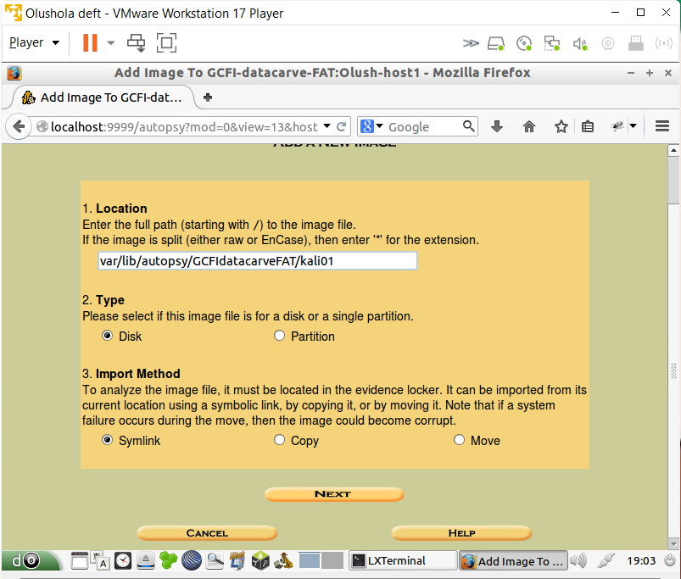
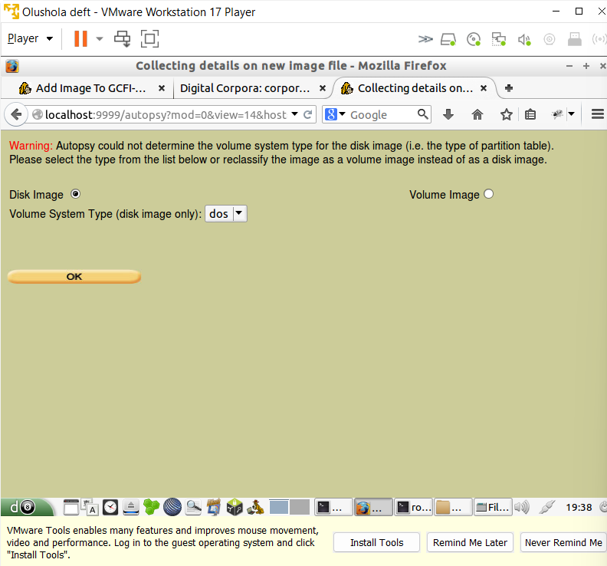
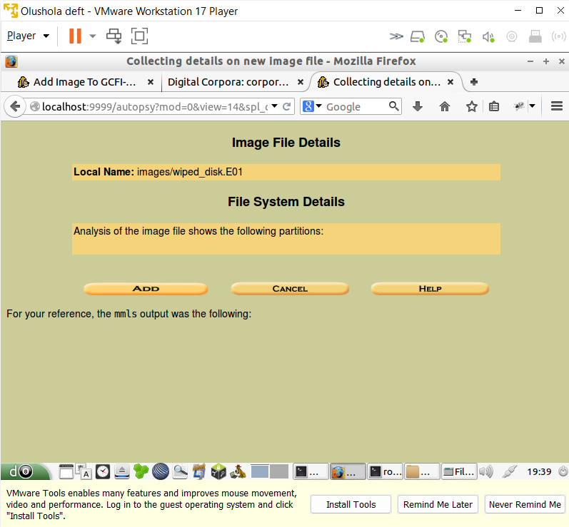
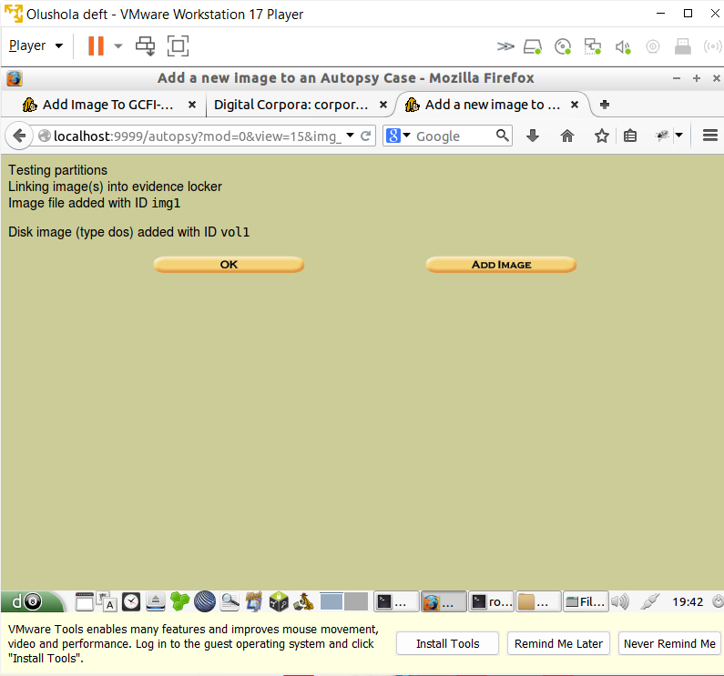
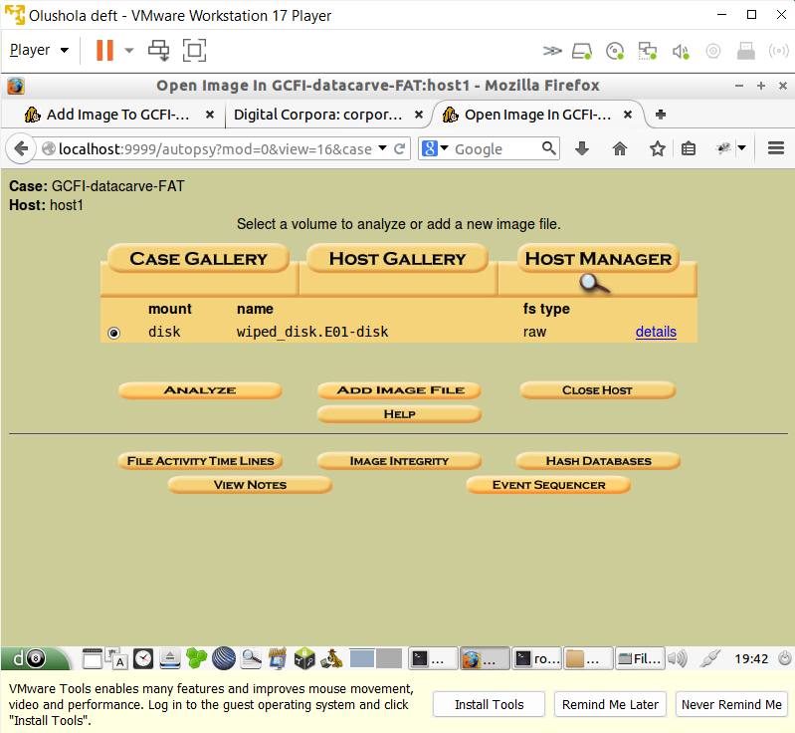
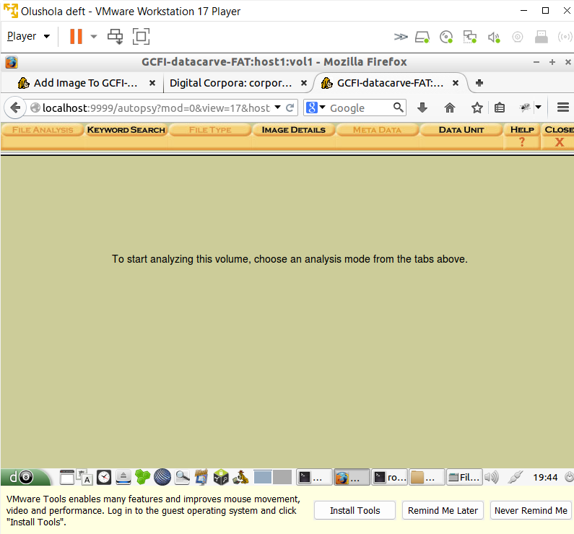
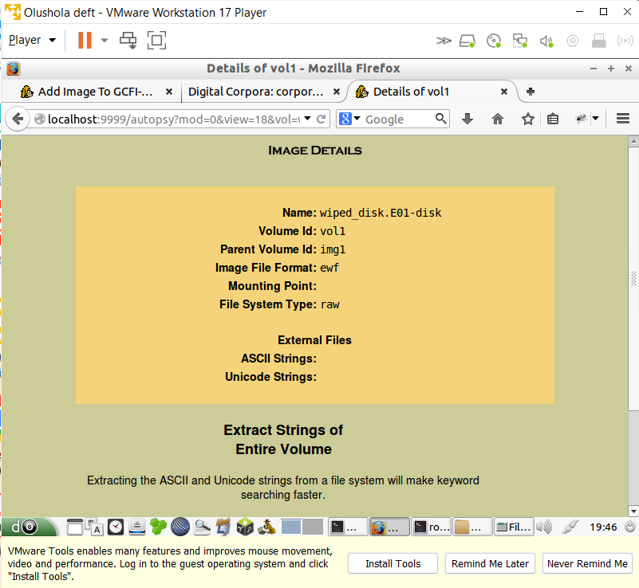
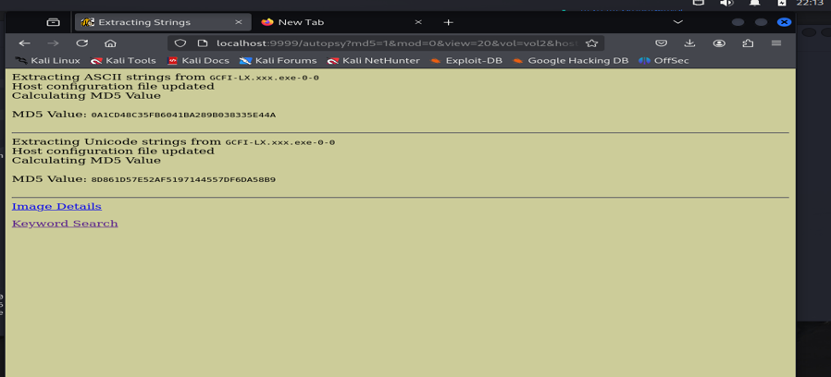

Hands-On Project 8-1
Creating a case C08Frag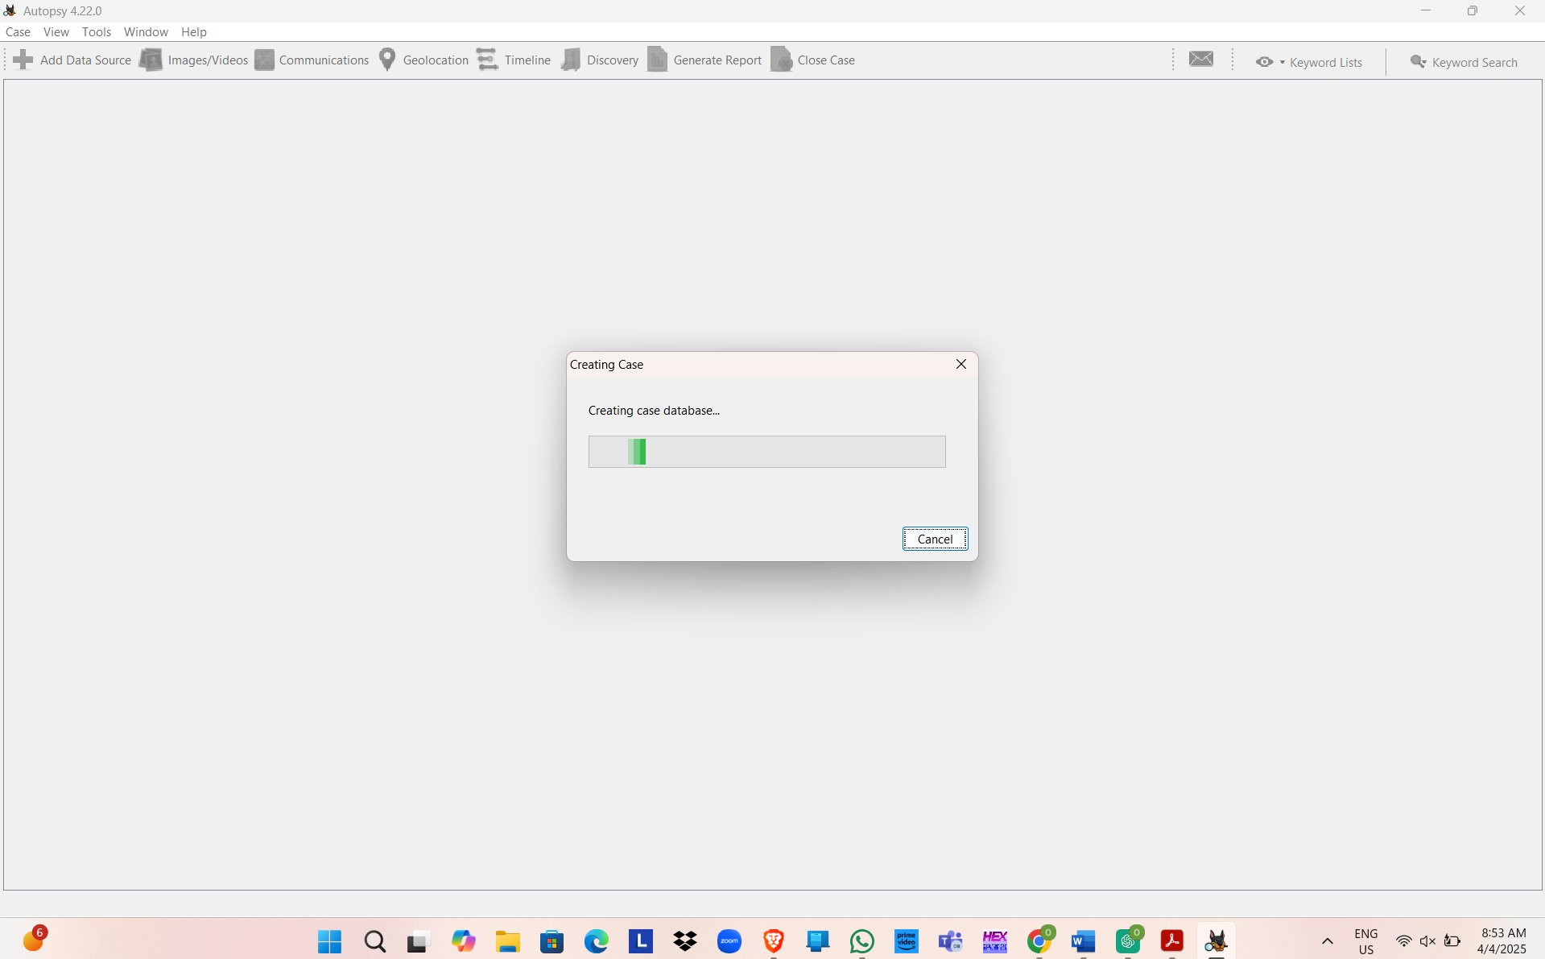
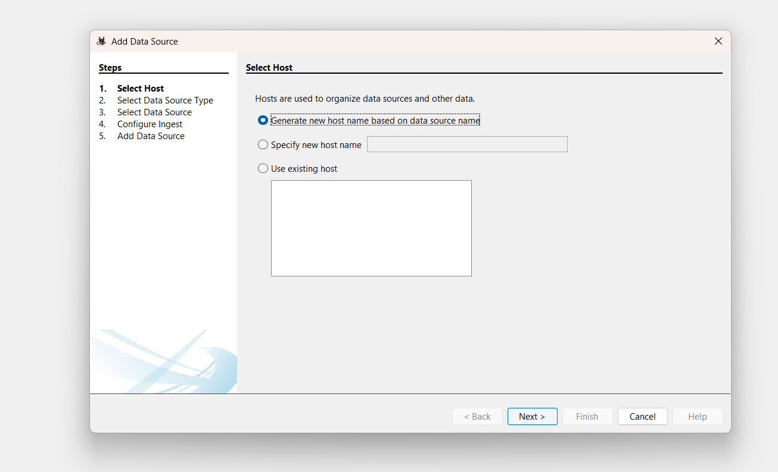
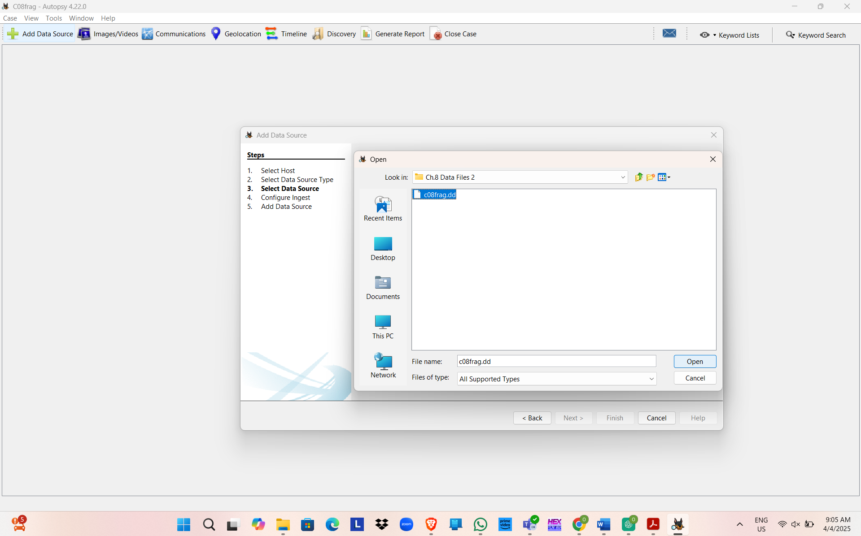
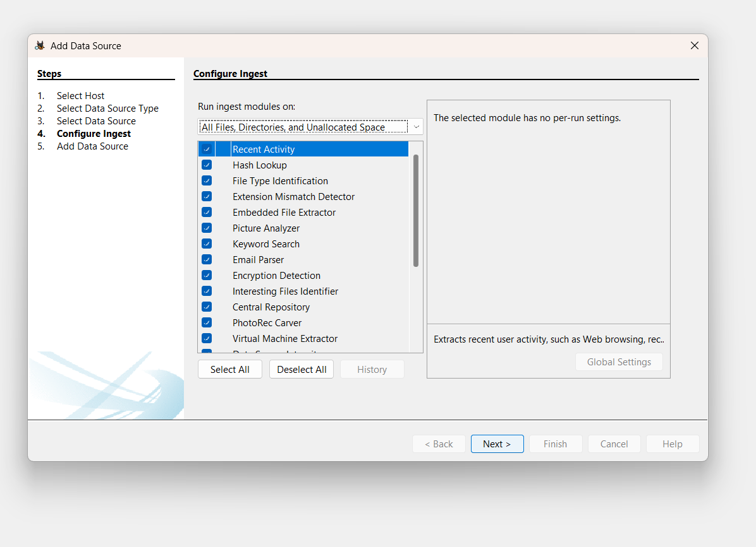
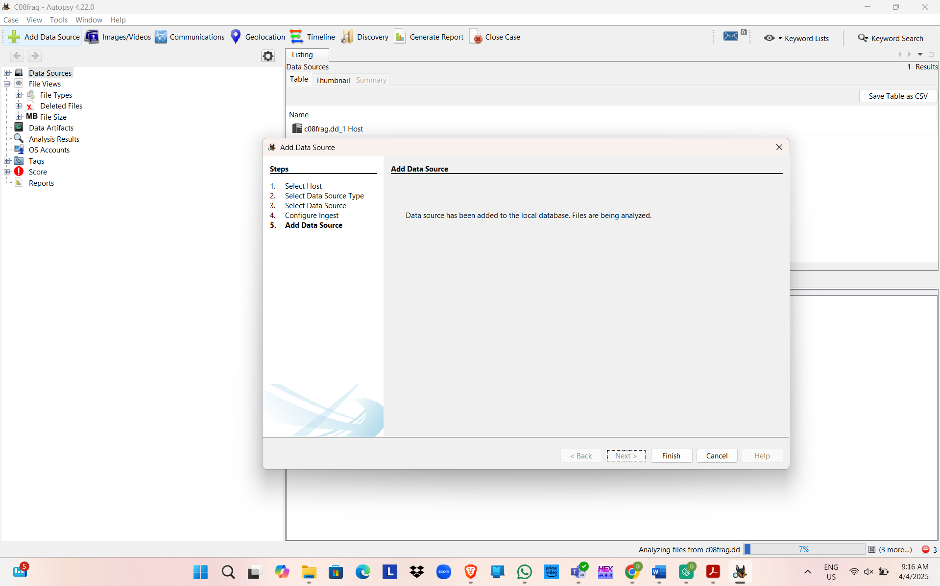
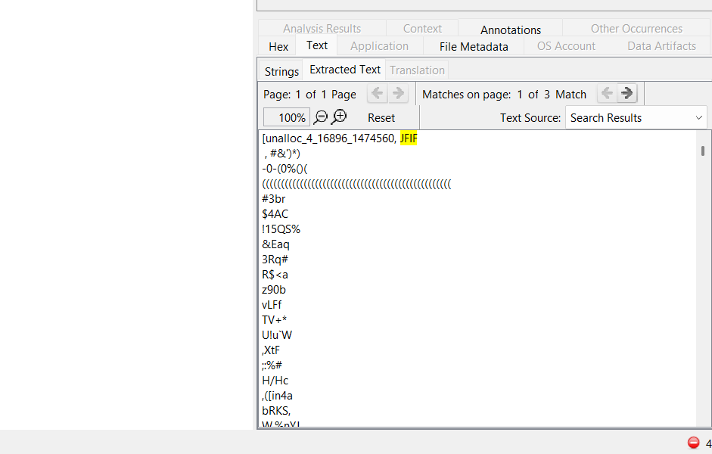
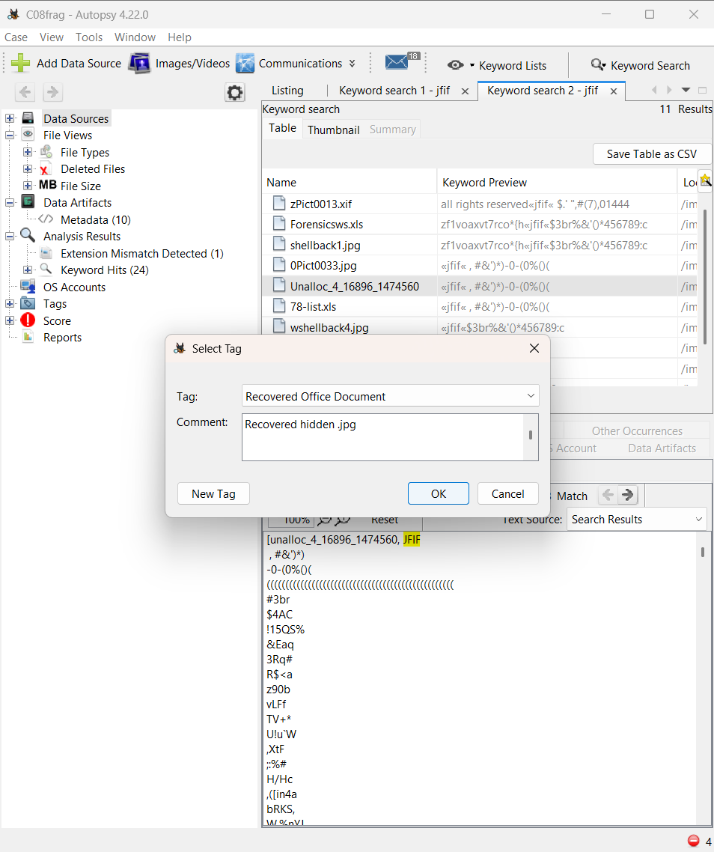

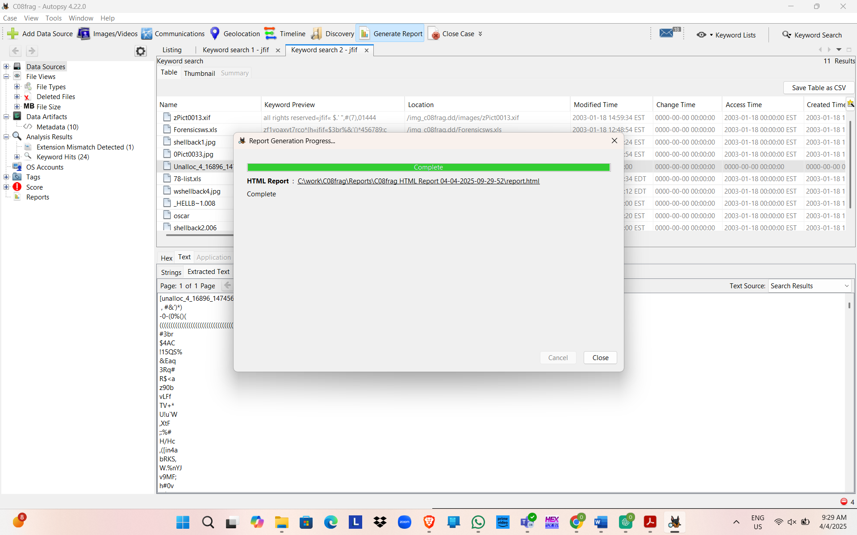
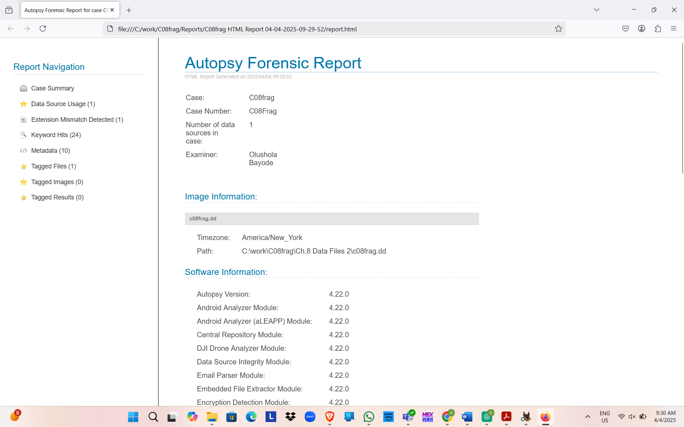

Hands-On Project 8-2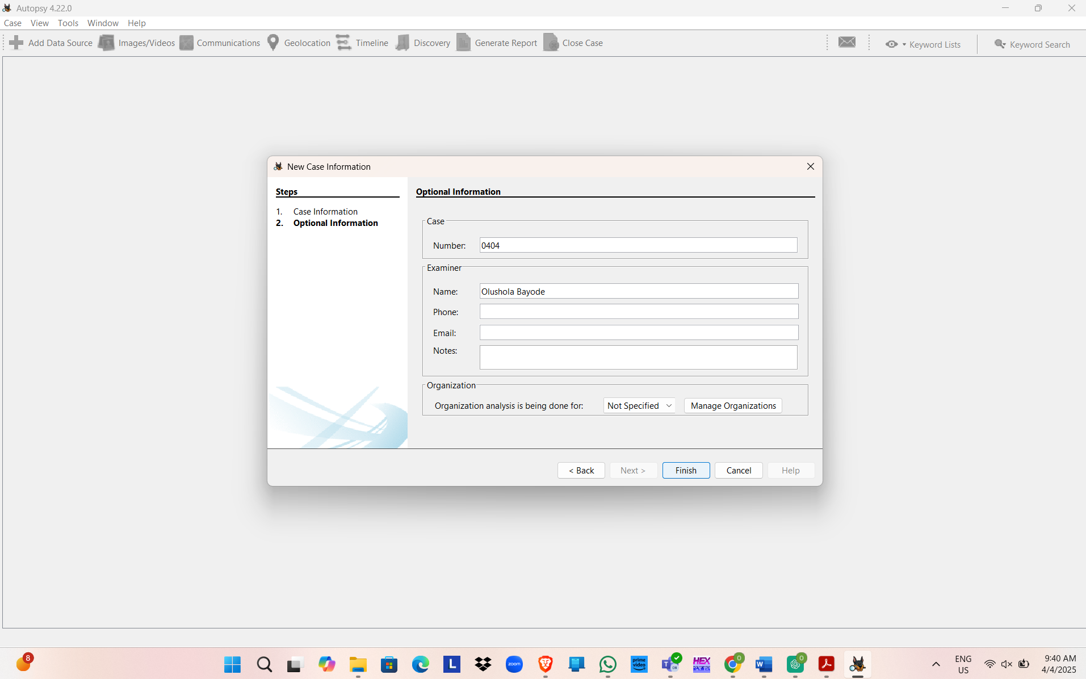
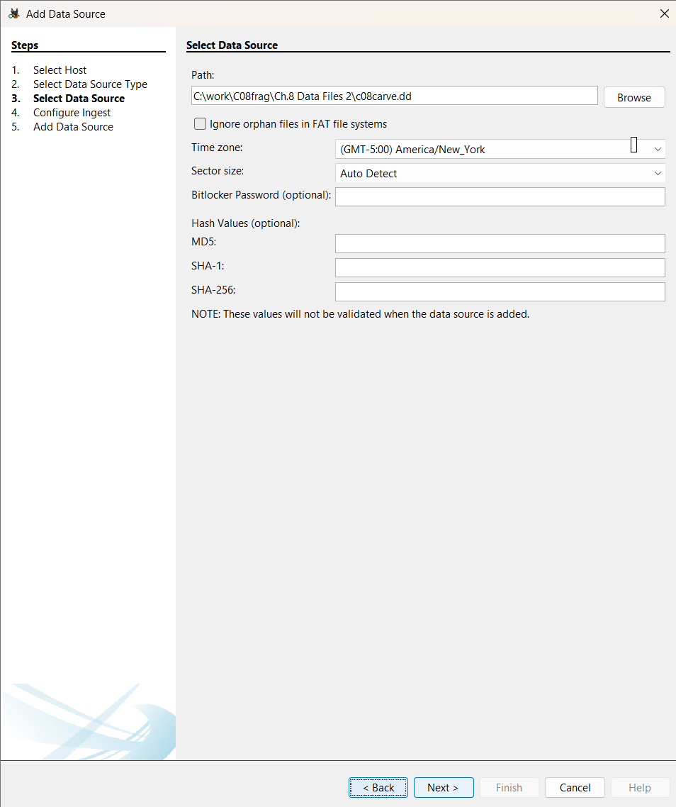
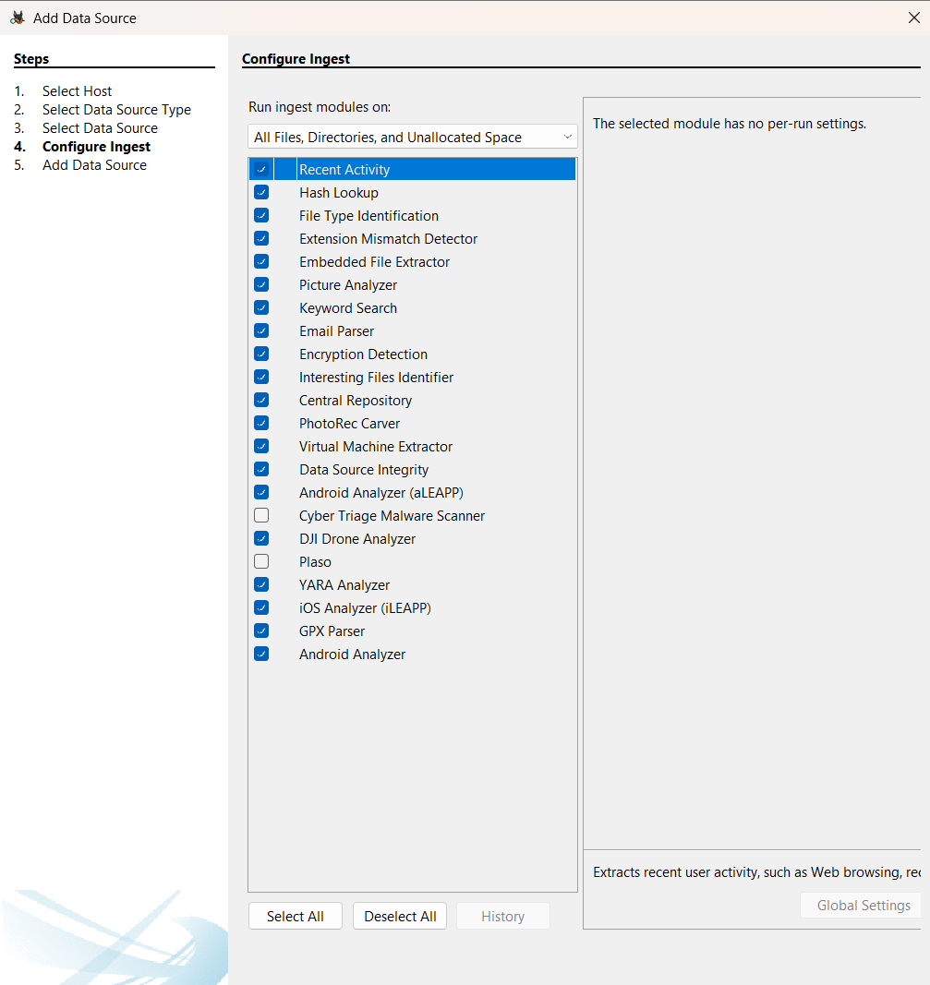
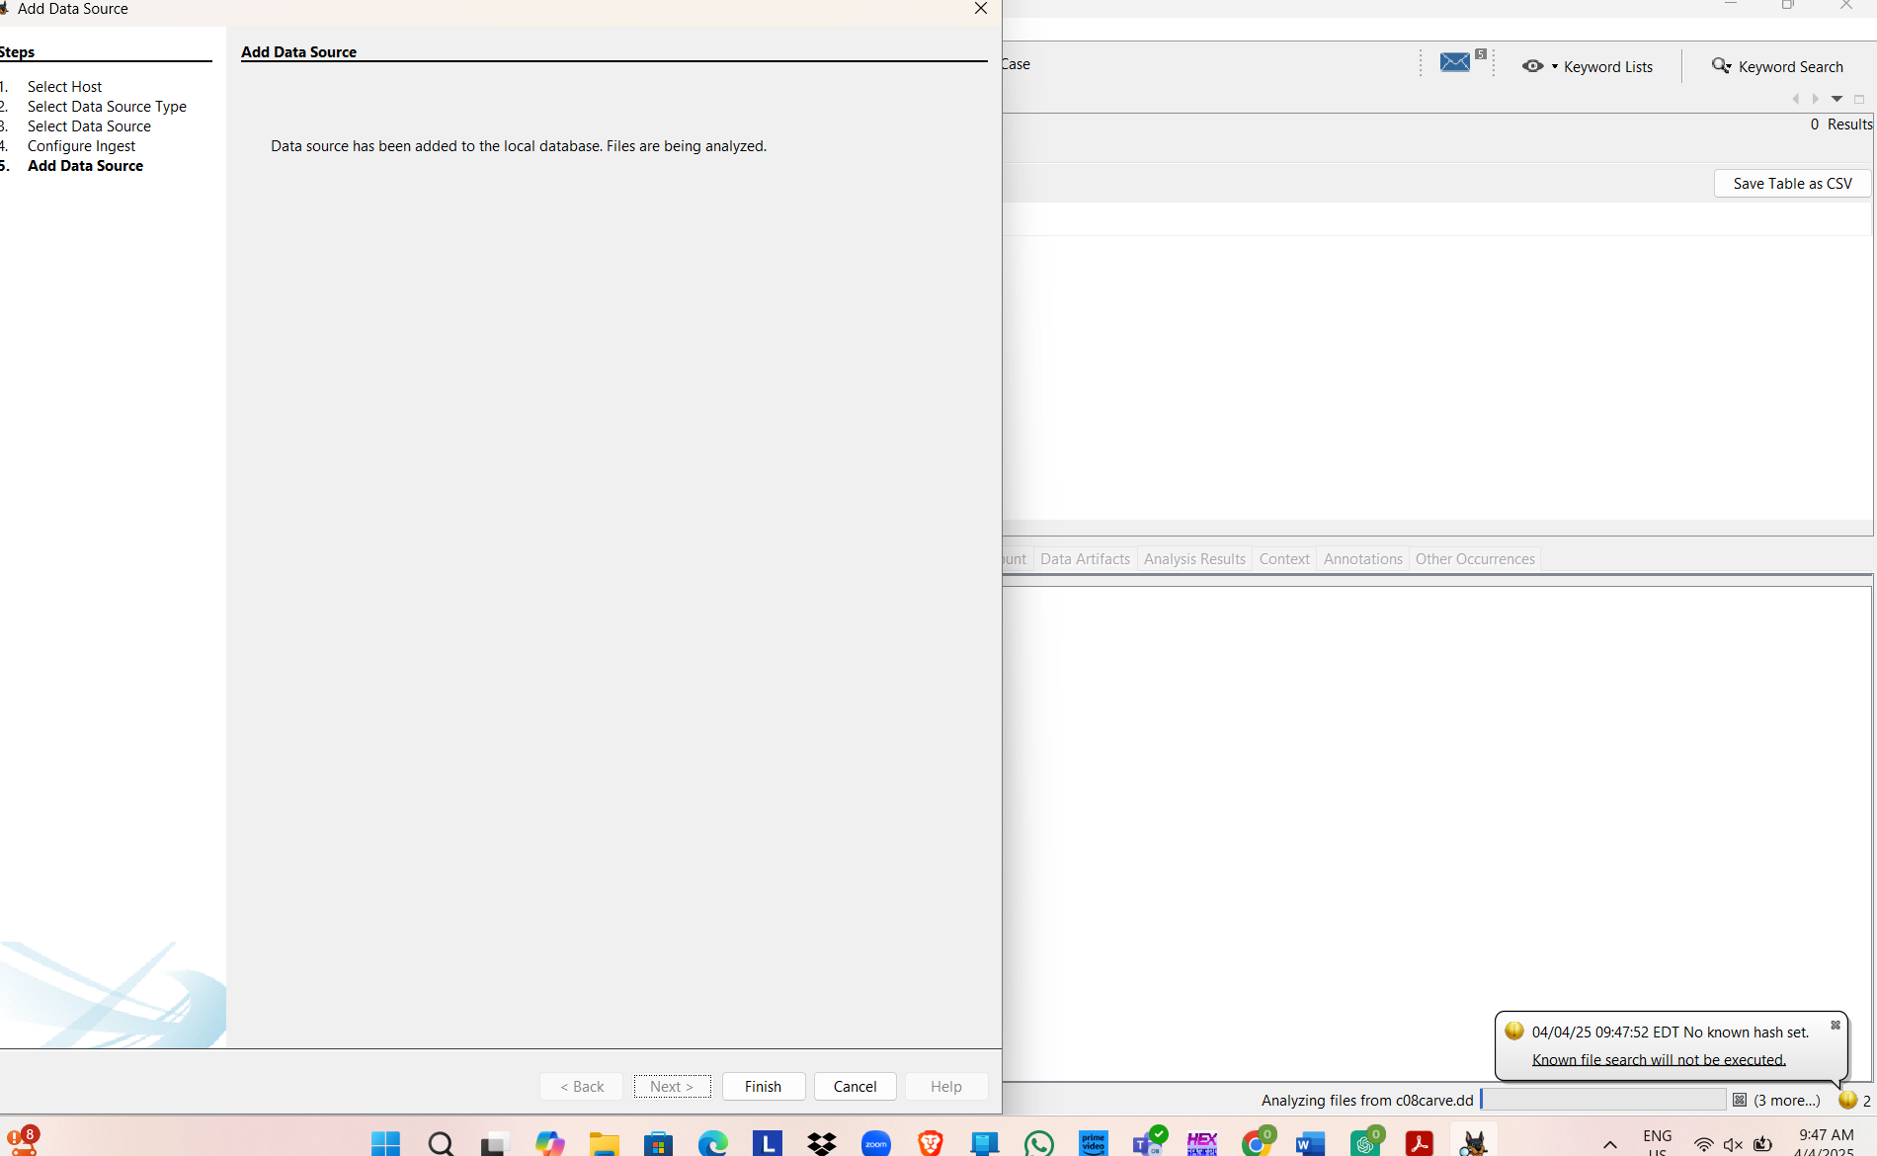
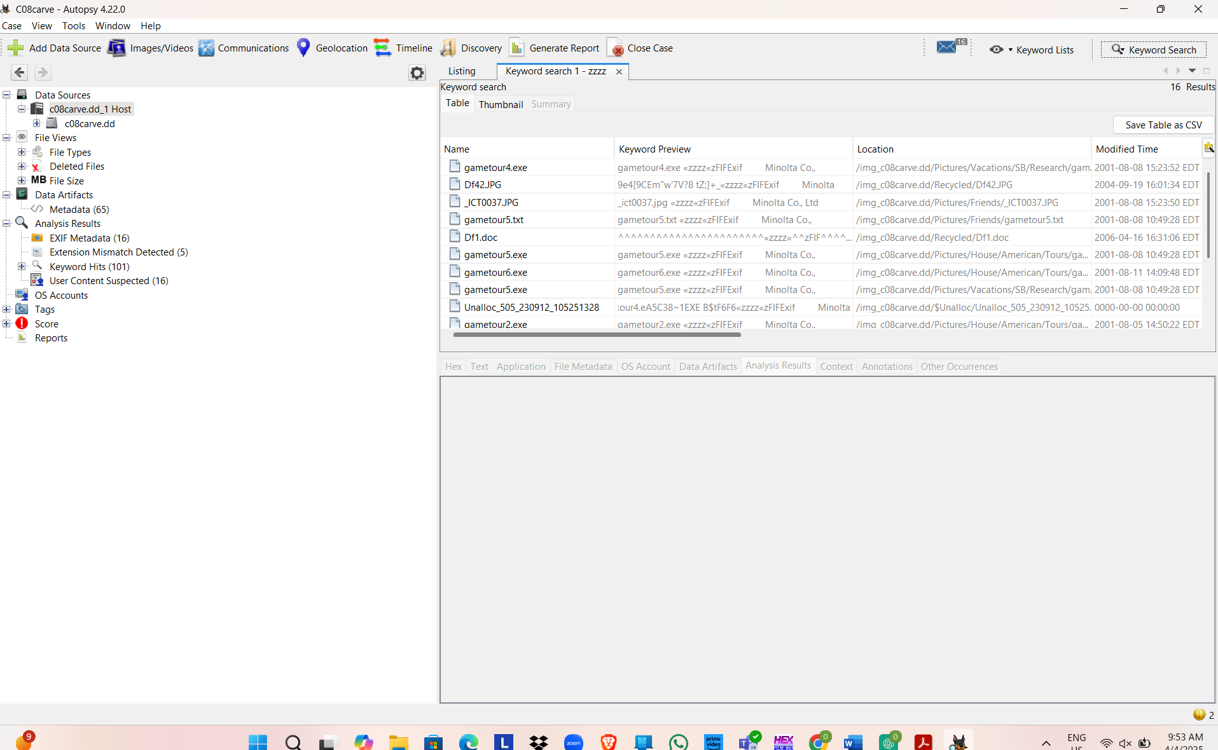

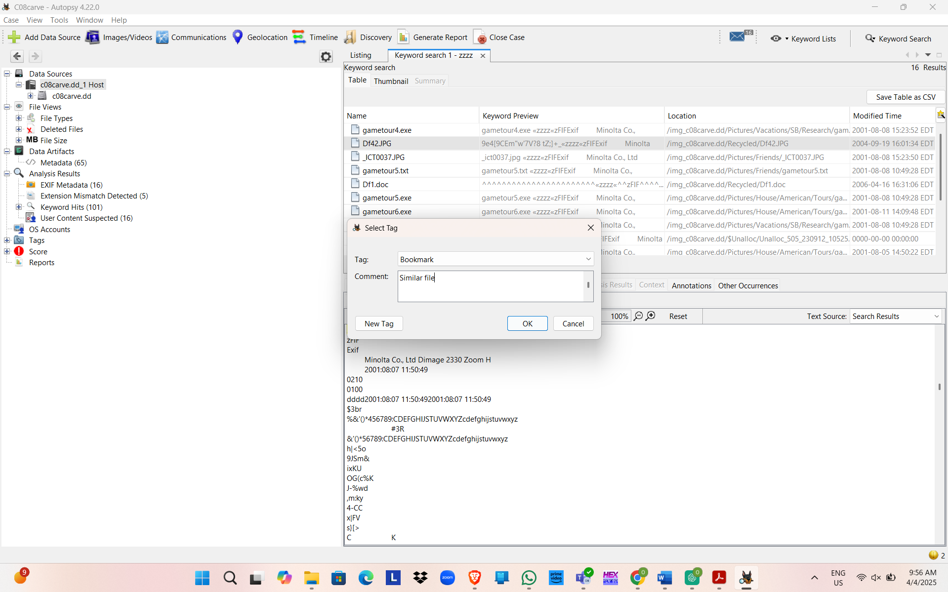
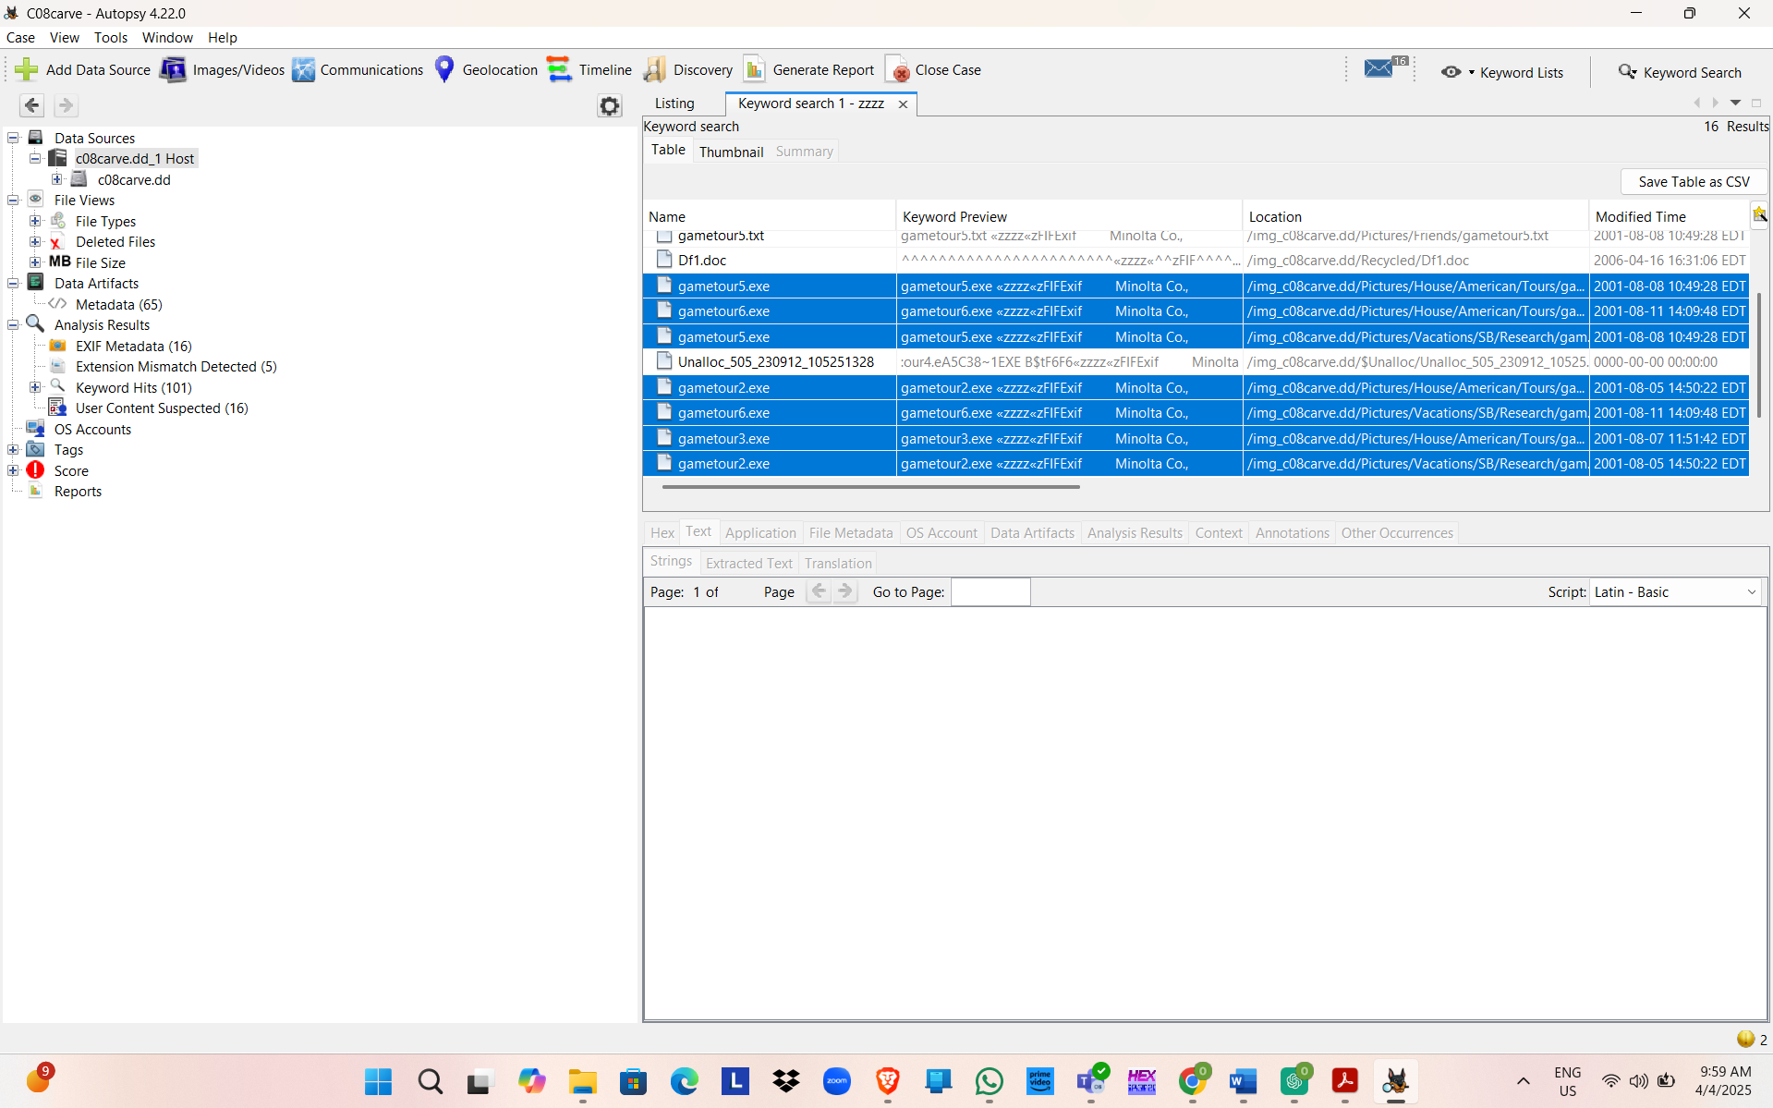
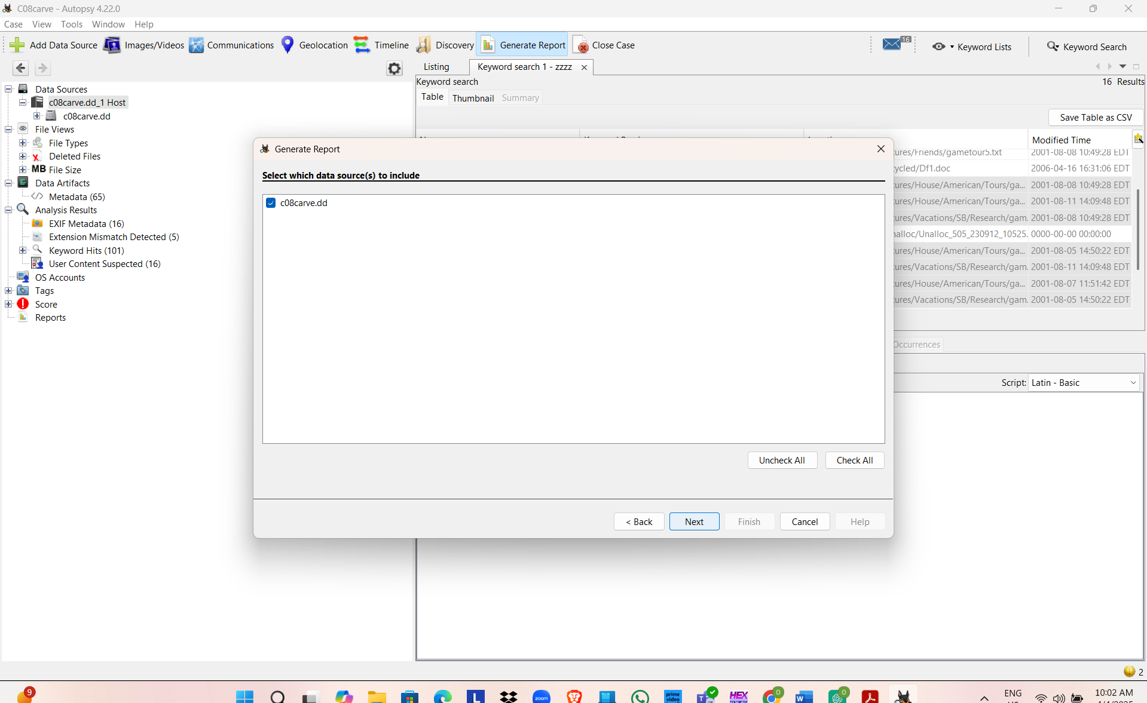
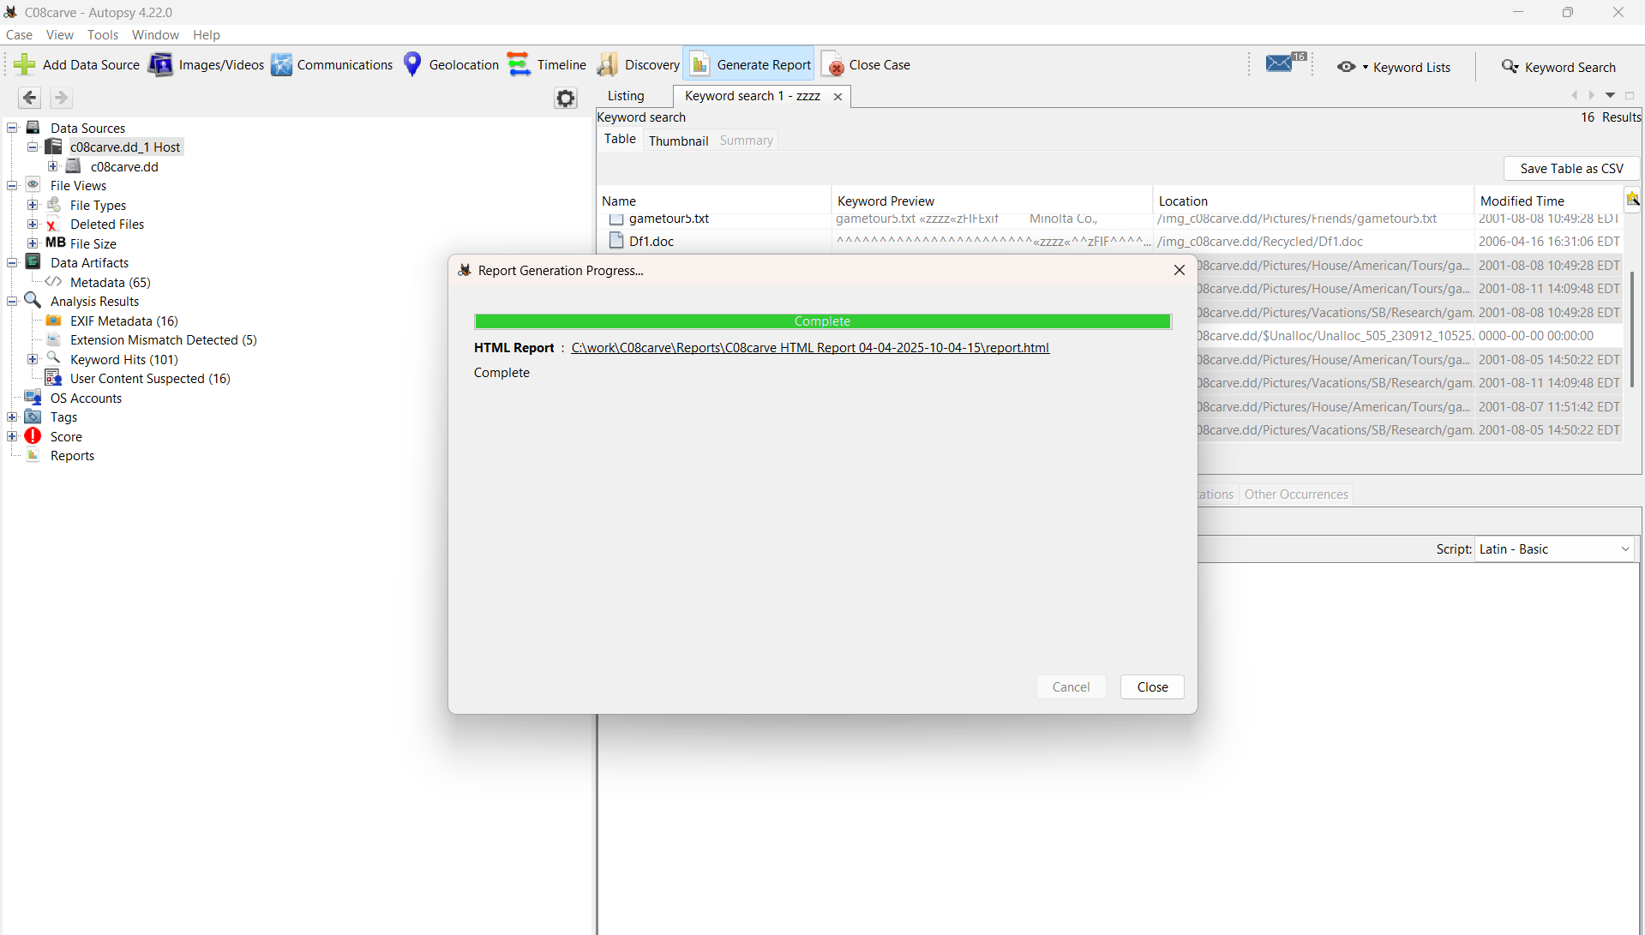

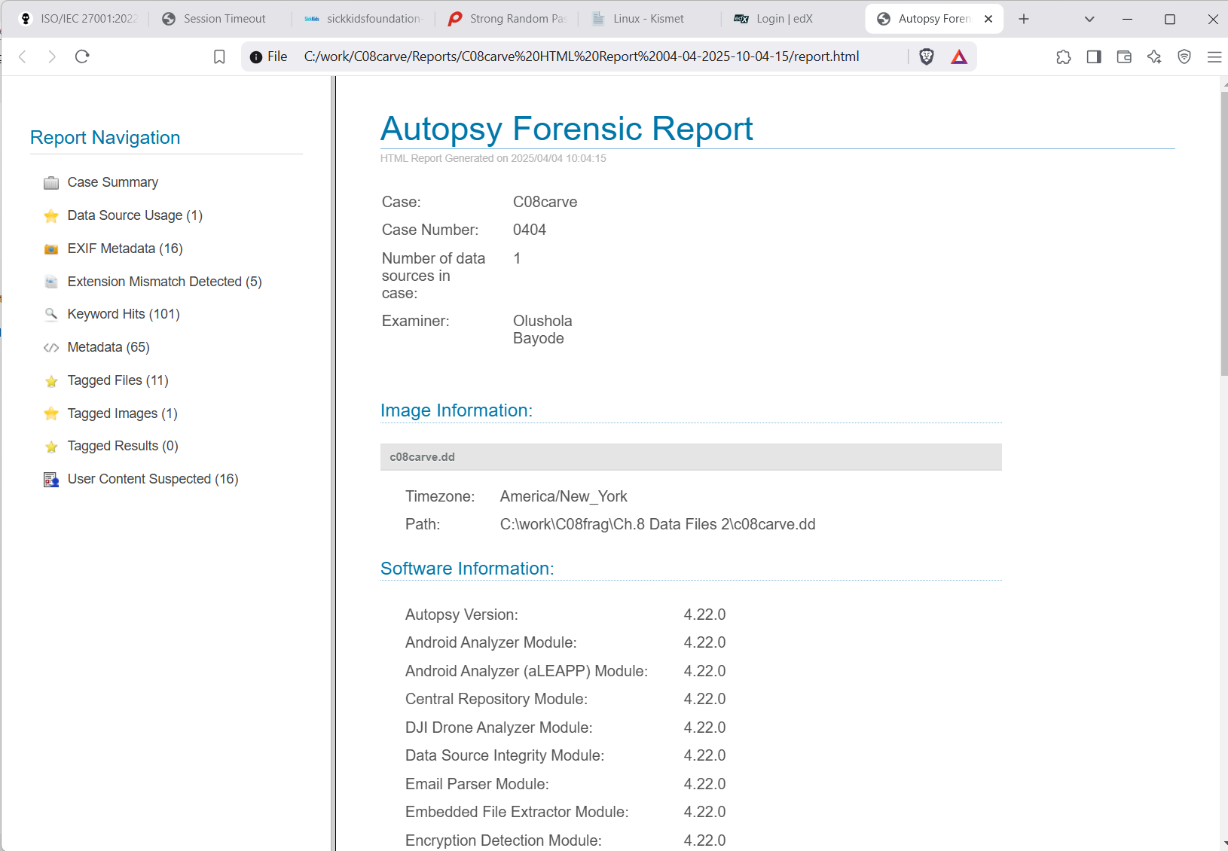

Hands-On Project 8-3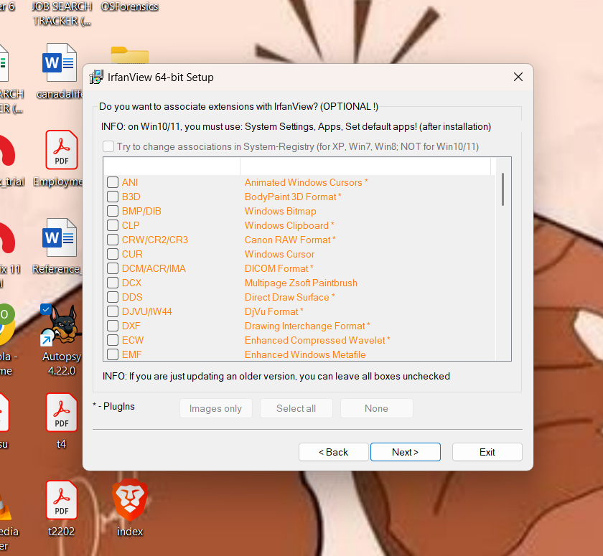

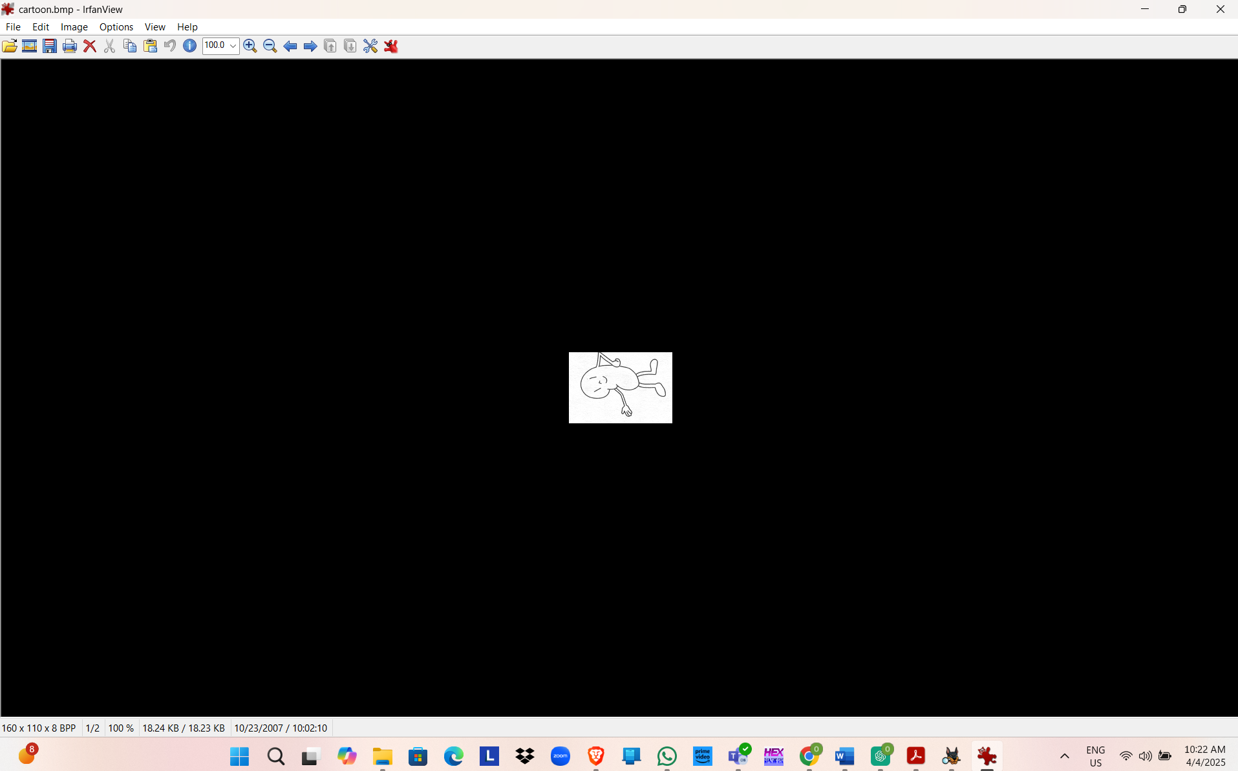
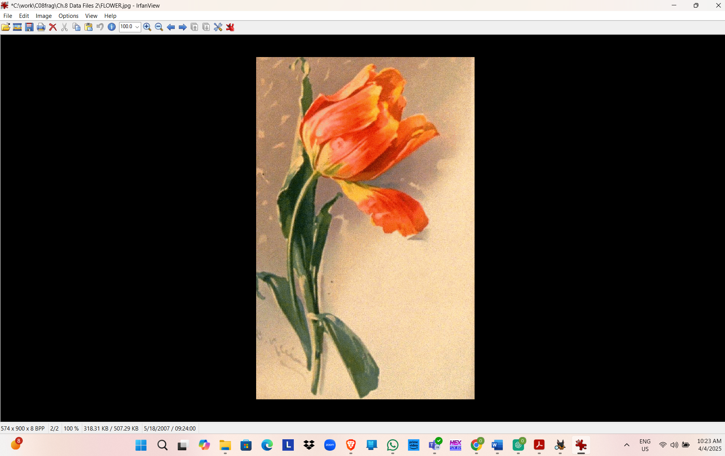

Hands-On Project 8-4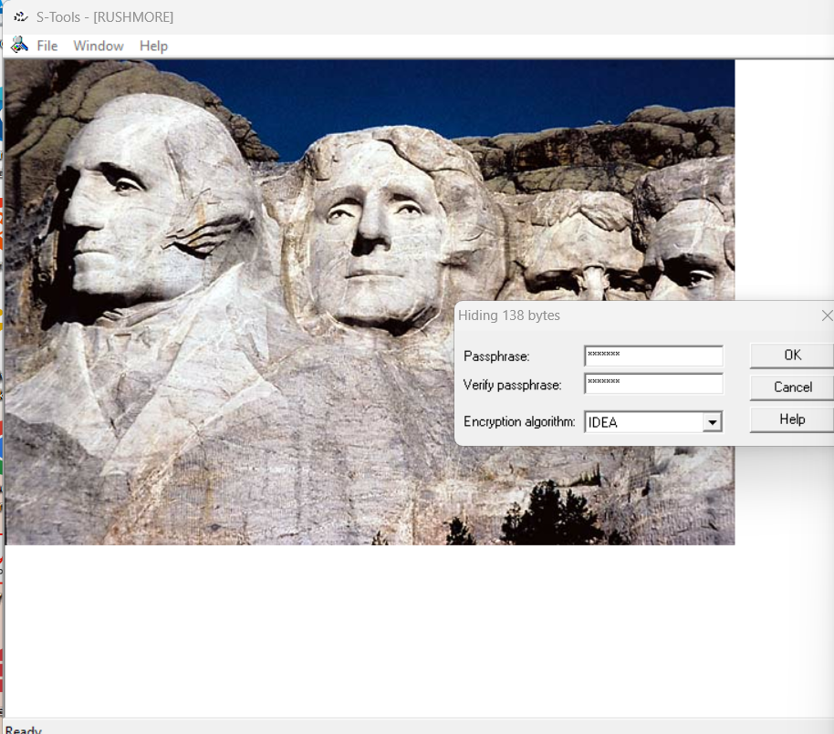
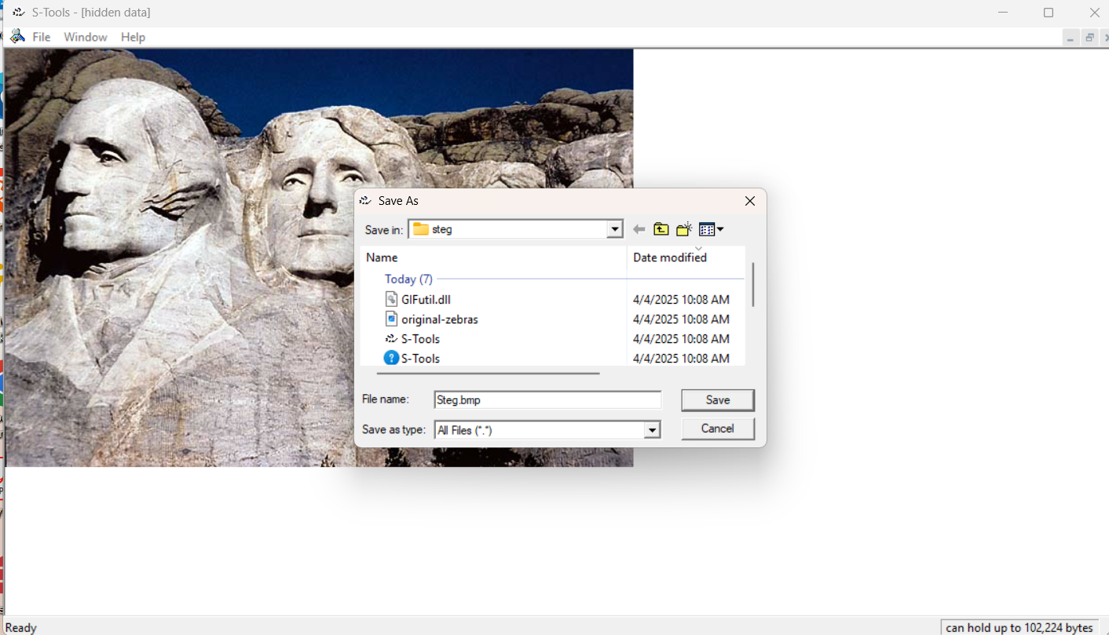
Hands-On Project 8-5
