**Course: CYB304**

**IT Security Forensics  
(Canadian Context)**

**Lab 1: Autopsy**

**Instructor:**

**Muhamma Saleem**

**Student Name: Olushola Enoch Bayode**

**Student ID: 23077087**

**Section: 3rd Semester**

**Activity 1:**

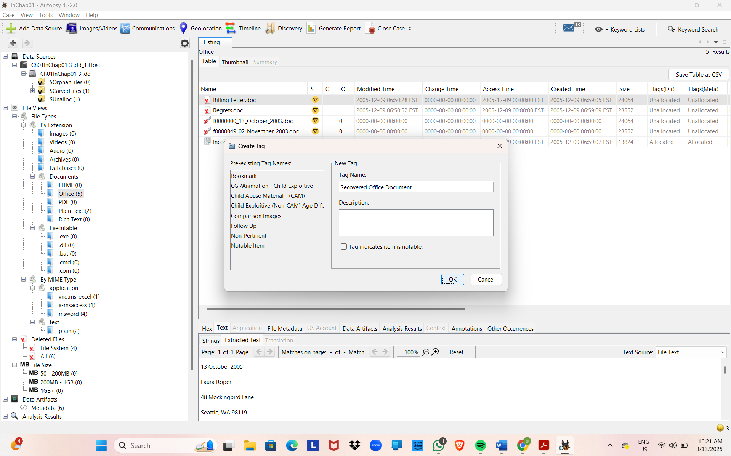

* **George got the disk through his USB drive, which he probably copied from the managers computer**
* **George performed his business during the work period**
* **George performed this task around 3pm, I retrieved it through the autopsy report.**
* **Data breach Policy: This is a case where a confidential, private or sensitively guarded is being exposed to the wrong person or have access to. In this case there is privilege escalation where non privilege person gets access to the data**
* **The word documents is used to create the documents sent by George.**