**Course: CYB302**

**Ethical Hacking  
(Canadian Context)**

**Lab4 : Vulnerability Analysis**

**Coordinator and Instructor:**

**Muhamma Saleem**

**Student Name: Olushola Enoch Bayode**

**Student ID: 23077087**

**Section: 3rd Semester**

**lsb_release -a**

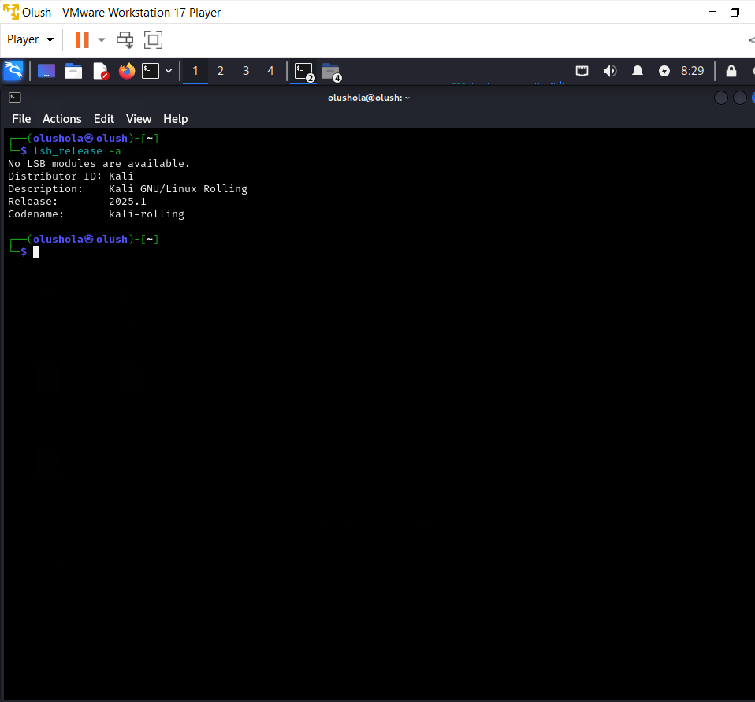

grep -vE "^#|^$" /etc/apt/sources.list

Sudo apt Update

**Activity 1:**

sudo apt isntall gvm

sudo gvm-setup (You must capture the password during this setup)

sudo gvm-check-setup (Take the screen shot)

**Activity 2: Vulnerability/Exposure Testing and Reporting (Linux)**

**Activity 3: Installing another Vulnerability Scanner (Nessus)**

Step 1: Obtain a Nessus Home Activation Code

Step 2: Download Nessus and Install It on Your System

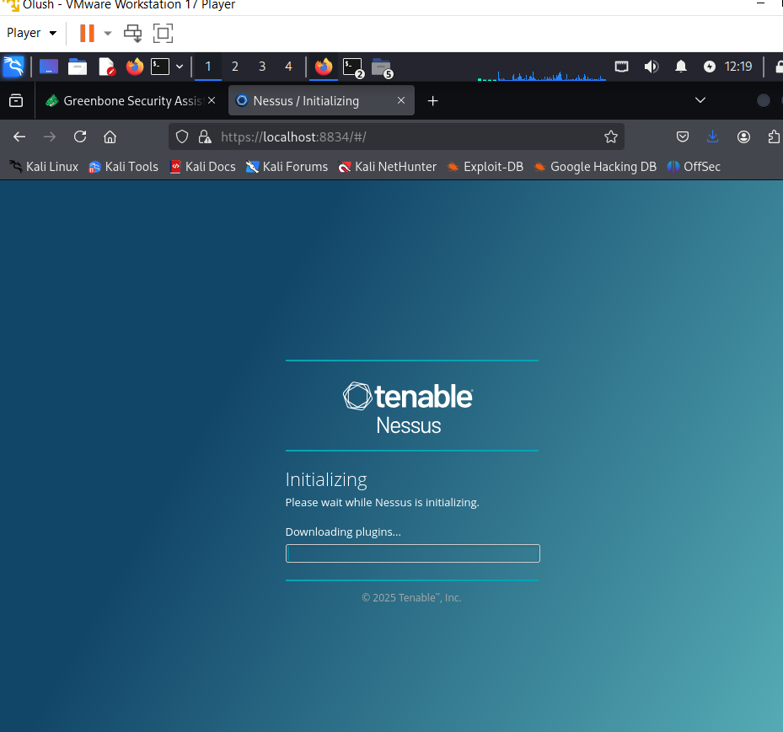

**Activity 4: Nessus Vulnerability Scanning**

